Geoffrey Ziobro
11/11/13
The Keys to Dan Brown’s Inferno
The Mysteries of Giorgio Vasari
While Giorgio Vasari is best known for his contributions as the art historian and author of Lives of the Most Eminent Painters, Sculptors, and Architects, he is also known for being an incredible architect and painter during the Italian Renaissance. Vasari has made a resurgence to popularity recently, when Dan Brown focused on Vasari’s masterpieces in his novel Inferno. Yet, from the inscription “cerca trova” on the painting Battaglia di Marciano, to the hidden passages of the Vasari Corridor, much of Vasari’s work remains unknown to the average tourist or resident of Florence.
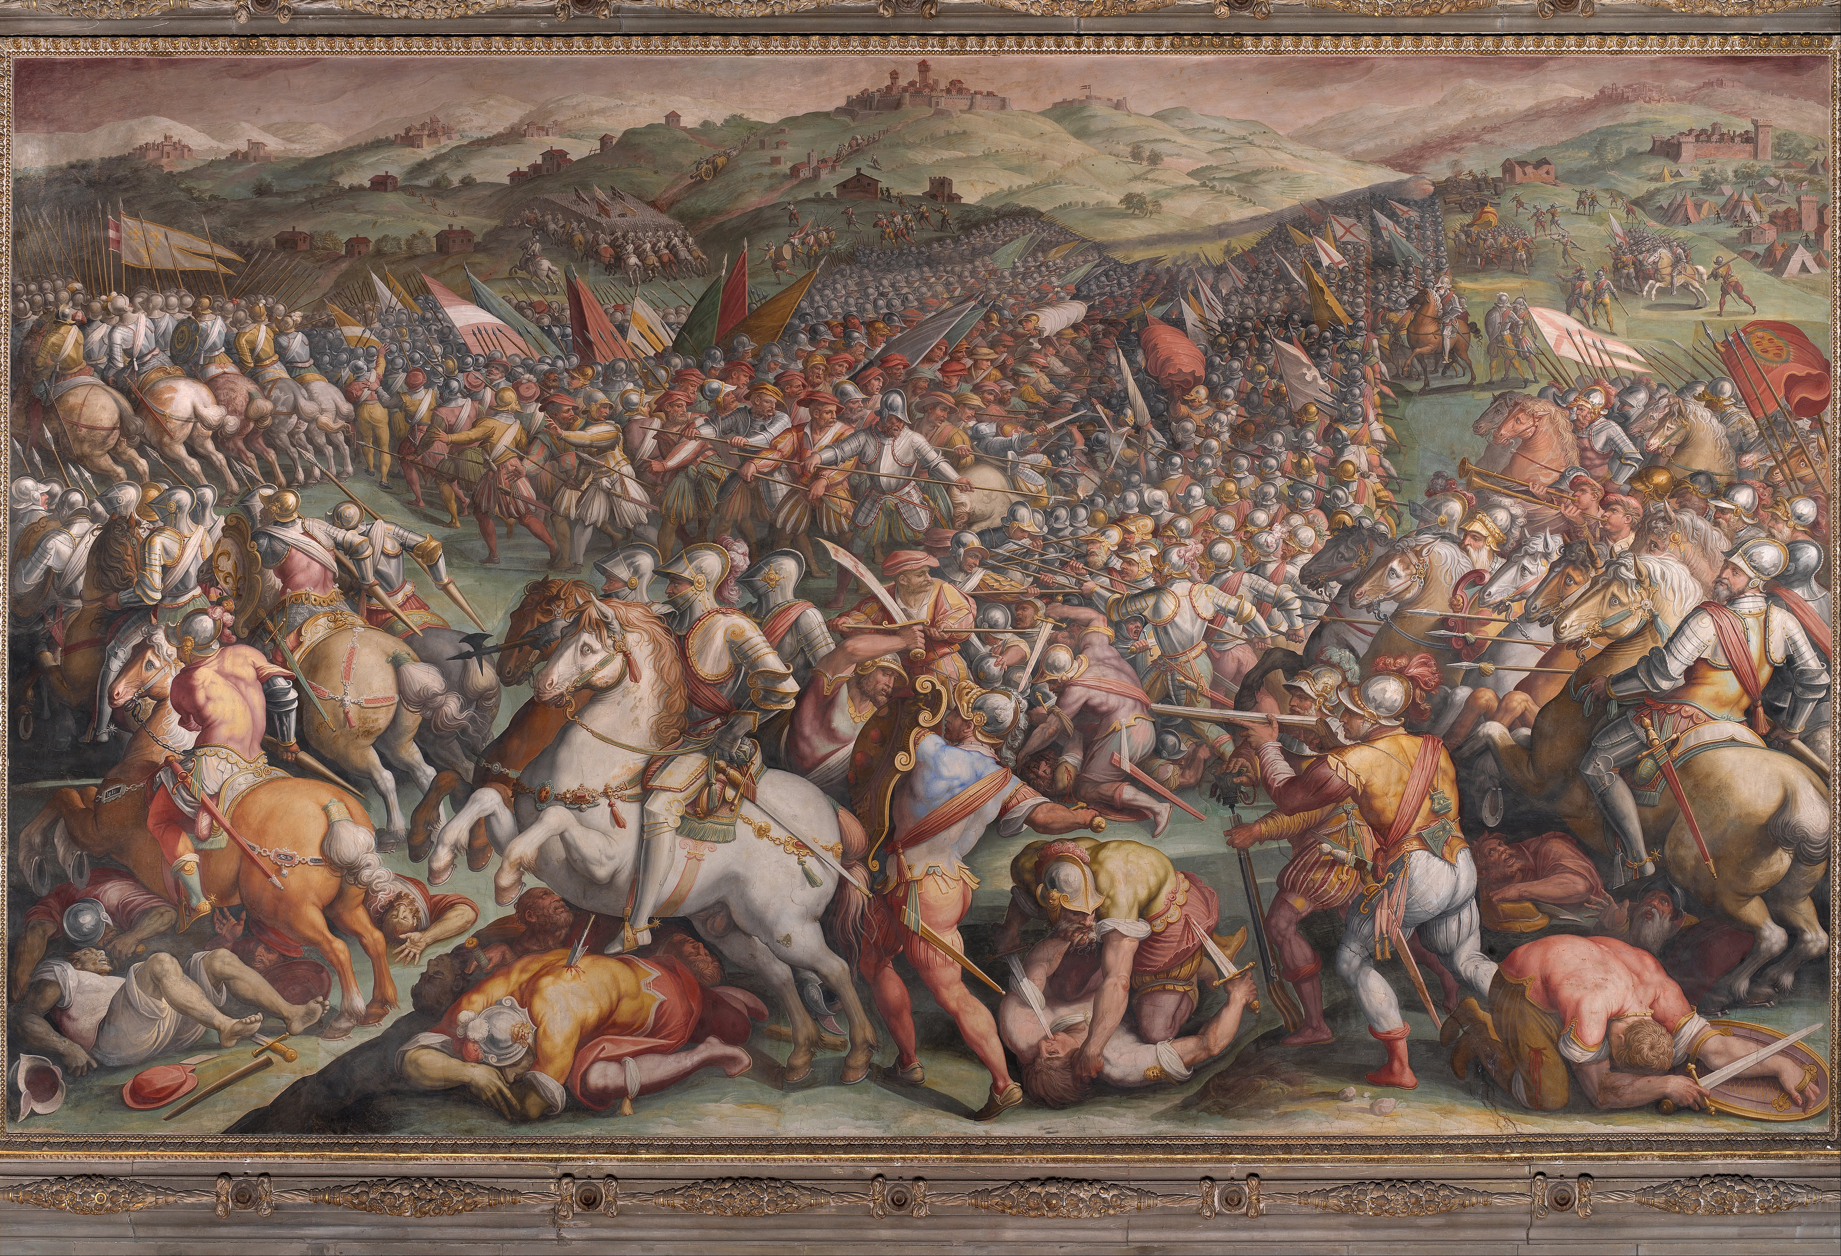
Why does Vasari’s work continue to be such a mystery hundreds of years after his death? Perhaps it is because of the other artists around him. With Renaissance men like Leonardo Da Vinci and Michelangelo captivating audiences, it is very easy for Vasari to be overshadowed. Now that historians and the public are rediscovering Vasari, they have been surprised by what they have found. Vasari has hidden secrets in his work in plain sight, but how has he been able to do it? His painting Battaglia di Marciano’s secret message has been generating theories about its meaning since the 1970s; yet the Italian government’s lack of cooperation by shutting down Seracini’s investigation into the fresco has allowed the painting to remain a mystery. Theories on the Battaglia di Marciano include speculation that Vasari purposefully used painting styles similar to those found on Da Vinci’s Battaglia di Anghiari, to indicate that Vasari covered the lost masterpiece (Arfaioli). Each day on the Ponte Vecchio, hundreds of people walk right under the Vasari Corridor, oblivious to the fact that they are passing by a piece of history. The passageway was built for Cosimo I in order to make travel from the Pitti Palace to the Uffizi easier. This amazing corridor contains hundreds of masterpieces, yet it still does not attract the same attention as other famous tourist destinations in Florence. Vasari created wonderful masterpieces that should rival the other elite Renaissance men, but he still does not compete with them in the public’s eyes. Despite being largely ignored in the past, the newfound interest in Vasari’s work just may be the attention he needs to join his legendary peers, but historians and tourists are still mystified by Vasari.
Figure 1: Battle of Marciano by Giorgio Vasari
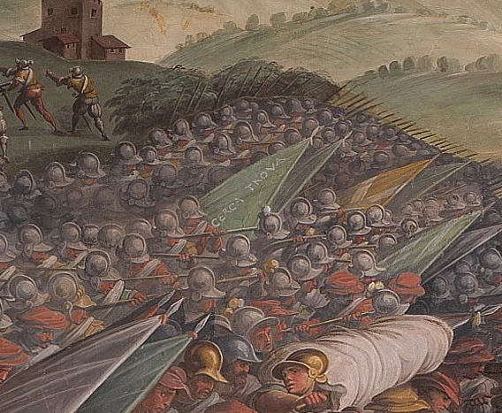
Originally, the murals adorning the Hall of Five Hundred were supposed to be completed by Michelangelo and Da Vinci in 1504, who lived from 1475-1564 and 1452-1519, respectively, but they were unable to complete the project. It is assumed that Michelangelo’s mural was destroyed when the Medici dynasty was restored in 1512, and Da Vinci’s mural was never accounted for (Boase 188). In the latter half of the century, Vasari raised the ceiling of the Hall of Five Hundred, and was commissioned to paint the frescos on the ceiling, and murals in place of the original Da Vinci and Michelangelo scenes. It is Vasari’s Battaglia di Marciano (fig. 1) that has drawn lots of attention recently in the Hall of Five Hundred, as many people have tried to interpret the inscription “cerca trova” (fig. 2) located on a green battle flag in the center of the painting. “In the 1970s, [...] Maurizio Seracini became convinced that the Mural ‘The Battle of Anghiari’ [...] was lurking behind the wall-sized Vasari”, and his hunch was triggered by the discovery of “cerca trova” (Donadio). This sparked the interest in the massive fresco by Vasari. More recently, in early 2012, Seracini has used cutting-edge technology to take a glimpse behind the Battaglia di Marciano. He discovered “a black pigment also used in the Mona Lisa”, suggesting that there is a potential Da Vinci painting shielded by the Battaglia di Marciano (Pogrebin). Nevertheless, there were still historians that believed the research was “not conclusive” (Poggrebin). Despite Seracini’s request to continue the search for the Battle of Anghiari, his efforts were indefinitely suspended when the authorities overseeing the project no longer wanted such invasive studies to be taking place. Seracini’s investigation of the Battaglia di Marciano drew the rest of the art world’s attention, along with the press, which has helped Vasari gain popularity with the public.
Figure 2: "Cerca Trova" on Battle of Marciano by Giorgio Vasari
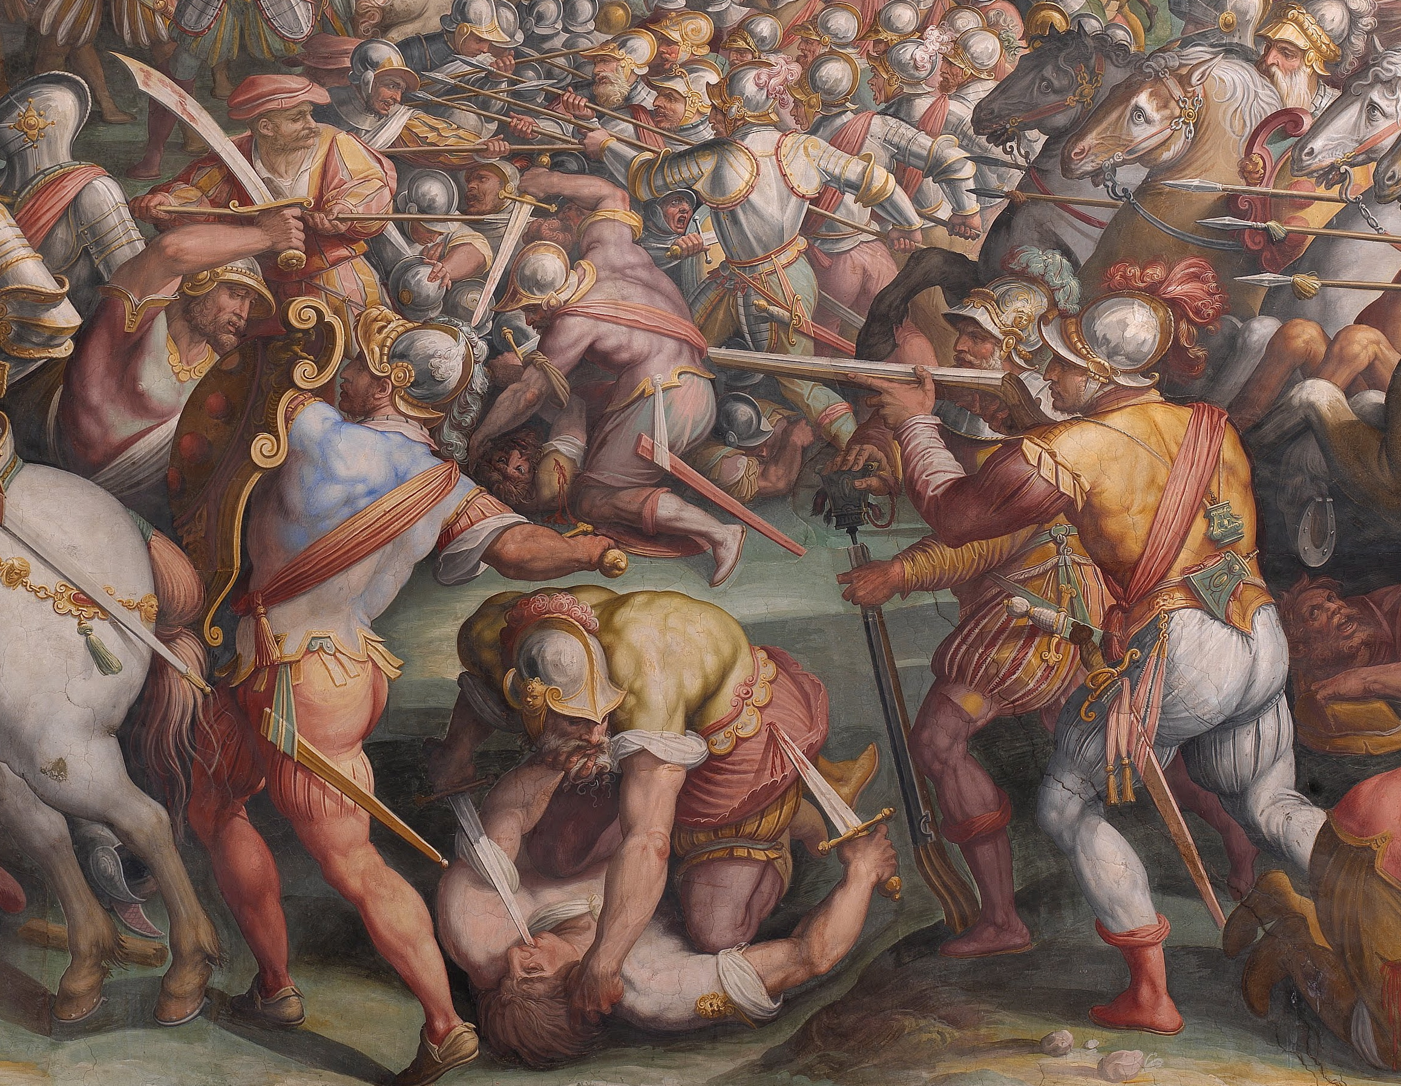
If Vasari actually was hinting towards the hidden Da Vinci masterpiece, then he may have left another clue besides “cerca trova”. Some scholars believe that the iconographies used by Vasari in Battaglia di Marciano are purposefully similar to those used by Da Vinci in the Battle of Anghiari. In the center of the foreground of the painting (fig. 3), it is noted that
Figure 3: Section from Battle of Marciano by Giorgio Vasari
“a bloodied storta [...] a by-then out-dated cavalry weapon emphatically and inconsistently held by a Franco-Sienese infantryman [...] placed on the vertical of the two figures in the center foreground who are locked in mortal combat” (Arfaioli 40).
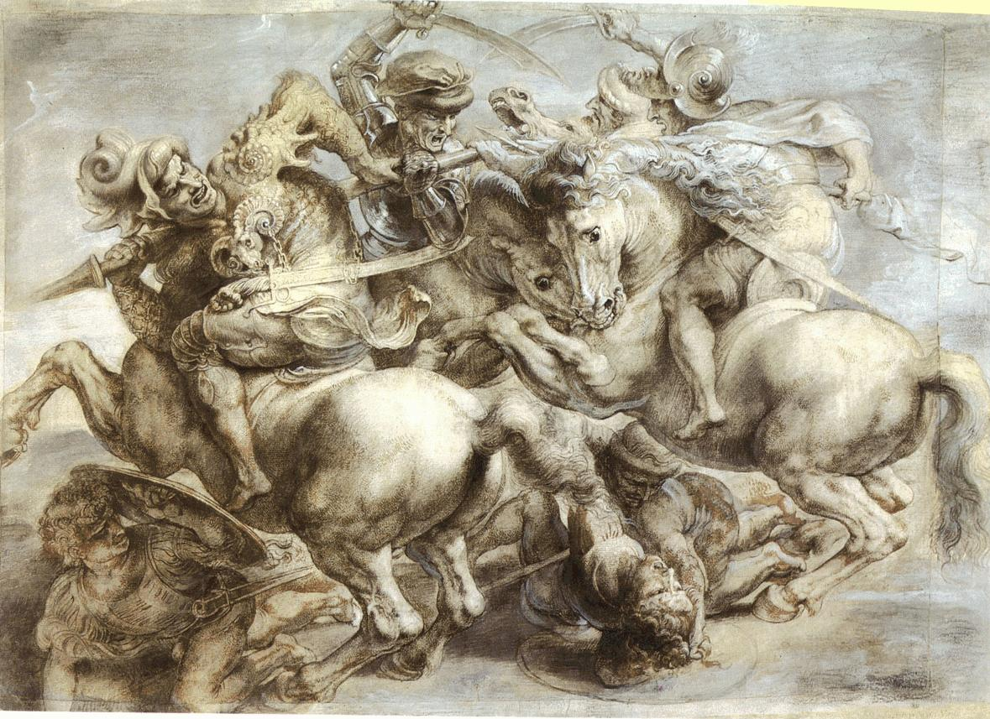
These characteristics are notable in the Battle of Anghiari, which depicts four horsemen in intense battle using similar storta swords to the one pictured in the foreground of Vasari’s fresco. It is not known exactly what Da Vinci’s Battle of Anghiari looks like, but Peter Paul Ruben’s copy of the fresco (fig. 4) is considered to be an accurate imitation of the lost painting (Art Resource). At the time of the Battle of Marciano, soldiers would most likely be fighting with stout, straight-edged swords rather than the curved storta (Arfaioli). Additionally, two soldiers are found on the ground underneath the cavalry, engaged in an identical position to the two soldiers in “mortal combat” in Battaglia di
Figure 4: Battle of Anghiari by Peter Paul Ruben
Marciano. The resemblance between the two scenes is remarkable, and it has also helped to draw notice to Vasari’s body of work.
Most of Vasari’s recent popularity with his fresco has been directly related to Leonardo Da Vinci. Besides the attention drawn to Battaglia di Marciano by Dan Brown’s Inferno, the quest for Da Vinci’s lost Battle of Anghiari has been the primary reason for a spotlight to be shown on one of Vasari’s massive paintings hanging in the Palazzo Vecchio.

One of Vasari’s greatest architectural feats is the corridor he built across the Ponte Vecchio. In 1564, Grand Duke Cosimo I commissioned Vasari to connect the Uffizi to the Pitti Palace, where Cosimo I lived, by a fully enclosed, aboveground passageway. The corridor runs above the Ponte Vecchio over the shops, and along the river where it intersects with the Uffizi. At the time, the Uffizi was where the Florentine government’s offices were. Additionally, the Vasari Corridor connects the Uffizi to the Palazzo Vecchio, which is where the Florentine government would assemble. Cosimo I commissioned the corridor in conjunction with the wedding of his son (Museums in Florence). The corridor is home to a collection of works that was started by Leopoldo de Medici in 1664. Originally, the collection was only self-portraits, but now has expanded to include many forms of artwork. Today, the corridor contains over 1,600 pieces (The Economist).
Back in 1973, the Uffizi opened the Vasari Corridor to the public after a long renovation and restoration process.
“However, no more than 300 person are admitted every week. The Uffizi, like all the other museums and galleries in Italy, suffers from a severe shortage of personnel and cannot spare the four or five men who would be needed to guard the entire twisting passageway system all the time” (Hoffman).
Understandably, being understaffed is a serious issue, and it puts the museum in a difficult position. The Uffizi cannot risk the theft of its precious artwork, so it is forced to choose which galleries to have open. It is much more advantageous for the main part of the Uffizi to be open than the Vasari Corridor, since the former contains more popular pieces, and it is also much easier to view the artwork in the Uffizi, due to its layout. In 2007, the Palazzo Vecchio bookshop offered a similar opportunity to tourists. They sold tickets for tours to pass through the Vasari Corridor, along with the galleries that it connects. With tours limited to 30 people per tour, and only a handful of tours each day, at most a maximum of 600 tourists could see the corridor each week. These exclusive tours were offered for a little more than a month, meaning that only a few thousand lucky tourists were able to view the incredible corridor (Globe and Mail). Unfortunately, the magnificent Vasari Corridor gets overlooked by tourists because it is so difficult to view, and even when there are tours offered it is with limited availability. The nature of the corridor offers no help to Vasari’s legacy in terms of growing to the same level of popularity as some of his contemporaries because of its lack of traffic through the corridor.
The Palazzo Vecchio is a common tourist destination in Florence, but still does not have the same appeal as the Galleria Dell’Accademia, which contains David by Michelangelo. Tourists can view other works by the great Renaissance artist in the gallery, as well as pieces by Boticelli and many other well known artists. For this reason, the Galleria Dell’Accademia is the “second most visited art gallery in Florence” (Indian Chief Travel Guides). The Palazzo Vecchio, which houses a large portfolio of Vasari pieces is ranked as the fifth most popular art gallery in Florence, but the art it contains still does not have the extraordinary reputation of works like David (I.C.T.G). The top ranked art gallery is the Uffizi, which contains a Part of the Vasari Corridor, but the passageway is usually only accessible by private tour (I.C.T.G.).
In 1559, Vasari was commissioned by Cosimo I to design the Uffizi, where the offices of the Florentine government were to be housed. By the end of the 18th century, the building had been transformed into a public gallery by grand duke Leopold I (Britannica). It now contains a diverse collection including works from almost all European art movements. The Uffizi is best known for its collection of Botticelli pieces, including Birth of Venus. Additionally, the gallery has pieces by Giotto, Da Vinci, Michelangelo, and Raphael on display, among others (I.C.T.G). It is the diversity and reputation of the works in the Uffizi that make it the most popular museum in Florence. Despite Vasari designing the building, his architecture is not the focus of the gallery, but the collection of art it now contains is the reason why tourists pay admission each day to enter the historic site.
The other two galleries ranked higher than the Palazzo Vecchio are the Museo Nazionale del Bargello and the Pitti museums (I.C.T.G). The Bargello was originally a prison, and in 1865 it was repurposed as a museum. The pieces contained in the gallery were produced by Michelangelo, Donatello, Benvenuto Cellini, among others (Britannica). The popularity of the artists whose works are in the Bargello and the diversity of artists rivals those in the Uffizi, and is the reason why the gallery is so popular with tourists.
Formally the Medici’s residence, the Pitti Palace now has six galleries located throughout the massive mansion. The Palantine Gallery is a collection of paintings from the 16th and 17th centuries, and the Gallery of Modern Art covers the 19th and 20th centuries of Italian art. The Royal Apartments display 19th century furniture, and the Museo degli Argenti is a large collection of the Medici’s personal belongings and keepsakes. Finally, the Costume Gallery exhibits how the Medici’s would dress when they were in power, and the Porcelain Museum is on the opposite side of the Boboli Gardens from the main palace (Visit Florence). The wide variety of art forms and movements on display at the Pitti Palace is unmatched in Florence, and for that reason it is one of the most popular museums in the city.
The Palazzo Vecchio’s contents do not have the same diversity or popularity as the four museums ranked above it. The Hall of the Five Hundred is dominated by Vasari’s frescoes, with a few other artists’ work sprinkled throughout. One of the other masterpieces of note in the Palazzo Vecchio is Genius of Victory by Michelangelo. Also, the gallery has a copy of The Lion by Donatello, and the original resides in the Bargello (Museums of Florence). The copy of the Donatello statue is a perfect example of why the Palazzo Vecchio is not a more popular gallery. If a tourist is a Donatello fanatic, it is more likely that they will visit the Bargello rather than the Palazzo Vecchio. If this occurs, then the tourist will not be exposed to Vasari’s huge frescoes or his architecture, and will miss the opportunity to form a positive opinion on Vasari’s works. Since Vasari’s masterpieces are the focus of the gallery, it is likely that only the patrons most interested in his work will visit the Palazzo. All four of the higher ranked galleries have such a wide variety of pieces by famous Renaissance artists that visitors are exposed to many more of the Renaissance greats. The problem with the Palazzo Vecchio is similar to the issue of the Vasari Corridor. They both have characteristics that make it less likely for tourists to view and appreciate Vasari’s work.
So why is Vasari’s work still a mystery after all of these years? The demand to learn more about his work has not been as strong as that of some of his peers who are considered to be in the upper echelon of renaissance men. Artists like Michelangelo and Da Vinci have drawn the attention of tourists and historians for years, and when their works are displayed in close proximity to each other, it is easy to compare and admire the pieces. Since Vasari’s work in the Hall of the Five Hundred does not have many popular artists’ pieces around it, his frescoes have not received the attention they deserve. The Vasari Corridor is in an even worse situation, since the foot traffic allowed through it is so limited. Since not as many people see Vasari’s pieces, he has not been explored at the same depth of his contemporaries, which is why “cerca trova” was only discovered recently. If Vasari actually hid the Battle of Anghiari, and left clues on purpose, the genius of Vasari may finally be realized. If not, we may never fully appreciate Vasari.

Works Cited:

Title: THE "INCONSISTENT KNIGHT": ICONOGRAPHIC AND MILITARY "MANIERA" IN VASARI'S "BATTLE OF MARCIANO"
Author(s): Maurizio Arfaioli
Source: Source: Notes in the History of Art, Vol. 30, No. 1 (Fall 2010), pp. 37-42
Publisher(s): Ars Brevis Foundation, Inc.
Stable URL: http://www.jstor.org/stable/23208529

"Bargello Museum." Encyclopaedia Britannica. Encyclopaedia Britannica Online Academic Edition. Encyclopædia Britannica Inc., 2013. Web. 04 Nov. 2013. <http://www.britannica.com/EBchecked/topic/53229/Bargello-Museum>.

“Best Art Museums and Art Galleries of Florence." Indian Chief Travel. N.p., 1 Aug. 2013. Web. 04 Nov. 2013. <http://www.indianchieftravel.com/en/italy/italy/art-florence>.

"Books and Arts: How They Wanted to Be Seen; Self-portraits." The Economist 26 May 2007: 108. Proquest. Web. 4 Nov. 2013.

"The Palazzo Pitti and Boboli Gardens." Visit Florence. N.p., n.d. Web. 04 Nov. 2013. <http://www.visitflorence.com/florence-museums/pitti-palace.html>.

"Palazzo Vecchio and Piazza Signoria - Florence." Museums in Florence. N.p., n.d. Web. 04 Nov. 2013. <http://www.museumsinflorence.com/musei/Palazzo_vecchio.html>.

"Travel Advisory Vasari Corridor." The Globe and Mail [Toronto, Ont.] 24 Sept. 1997: D4. Print.

"Uffizi Gallery." Encyclopaedia Britannica. Encyclopaedia Britannica Online Academic Edition. Encyclopædia Britannica Inc., 2013. Web. 04 Nov. 2013. <http://www.britannica.com/EBchecked/topic/612578/Uffizi-Gallery>.
"Vasari Corridor - Florence." Museums and Florence. N.p., n.d. Web. 04 Nov. 2013. <http://www.museumsinflorence.com/musei/corridoio_vasariano.html>.

"Battle of Anghiari." Art Resource | Fine Art Stock Licensing. N.p., n.d. Web. 11 Nov. 2013. <http://www.artres.com/C.aspx?VP3=ViewBox_VPage>.

Boase, T. S. R. Giorgio Vasari: The Man and the Book. [Princeton, N.J.]: Princeton UP, 1979. Print.

Donadio, Rachel. "Looking for Leonardo, With Camera in Hand." The New York Times 26 Aug. 2011: n. pag. Print.

Hoffman, Paul. "Florence Reopens Art-Filled Renaissance Corridor: Damaged in Action For Newlyweds View of the River." The New York Times 16 May 1973: 36. Print.

Pogrebin, Robin. "A Glimpse of Leonardo?" The New York Times 13 Mar. 2012: C3. Print.

