Greg Pil
Introduction to FYSE
Professor Beyer
Dan Brown’s Inferno
Allusion to Dante:
An Analysis of the novel and the Dust Cover.
Inspiration is a strange concept. Merriam- Webster’s Dictionary describes inspiration as “something that makes someone want to do something or that gives someone an idea about what to do or create.” The etymology of the word means “divine guidance” illustrating how nobody understood how inspiration occurred. In literature many writers have inspired by other great works. In the past 2000 years the Bible has been one of the most influential works in the Western hemisphere. One historical work deeply inspired by the Bible is Dante’s Inferno. In the poem, Dante travels through hell where he is introduced to numerous famous, some infamous to be more precise, historical and mythological figures enduring punishment for the crimes they committed when they were alive. Just as the Bible inspired Dante in the Inferno, his poem also inspired Dan Brown in his Inferno. Throughout the novel, Dan Brown uses allusions to Dante and Dante’s Florence to pave the setting for the audience. Even before the Prologue, Brown writes a Fact Page where he proclaims, “all artwork, literature, science, and historical references in this novel are real” (Brown, 3). This paper focuses on the cover of the editions of Brown’s Inferno and the art situated on them affirming the influence of Dante throughout the novel.

Book dustcovers have a huge influence on what the audiences think about the book. Although many people spew the axiom, “You can’t judge a book by its cover,” a book’s cover has significant impact on its audience. One image, the book cover, captures and conveys the essence of an entire book. Because of this idea, the book covers of Inferno all have a reference towards Dante and Florence (News). In addition, in every single book cover, a landscape of Florence is used. For the Slovene edition of Inferno, only a landscape of Florence is illustrated in the dust cover demonstrating the importance of Florence to Dante. During a Question and Answer session, Dan Brown says
“No city on earth is more closely tied to Dante Alighieri. Dante grew up in Florence, fell in love in Florence, and began writing in Florence. Later in life, when he was exiled for political reasons, the longing he felt for his beloved Florence became a catalyst for The Divine Comedy.” (Brown)

It is to those who betrayed him and exiled from Florence that Dante gave the most severe punishments in his poem, Inferno. For Dante, exile from Florence was a form of punishment worse than death. The exile stripped him of part of his identity and his heritage. Desperately, Dante attempted to appease the Ghibellines to overturn the punishment by defending that all his actions were for the good for Florence. In addition, he sent a canzone to Florence with one line of the poem proclaiming, “forgiveness is the most beautiful victory” (Barbi, 19). When the Holy Roman Emperor Henry VII of Luxembourg marched down to Italy with an army, Dante was full of hope that Henry VII would be a rex pacificus, peaceful king, who would restore harmony between cities and factions and reinstate the exiles in their homelands (Barbi, 24). In his determination to make Henry become Emperor of Italy, Dante wrote a scathing letter demanding that he retake Florence from the Black Guelph. He also was furious when Florence decided to battle against Henry, insulting the Florentines. (Bemrose) Consequently, when Baldo d’Aguglione gave amnesty to most of the White Guelphs in exile and allowed them to return back to Florence, Dante was not among those pardoned. Later in his life, Dante desperately hoped that he would return to Florence. However, Dante never managed to return to his beloved city. It would take over seven hundred years after the death of Dante for Florence to repeal his exile. Ironically, Florence would fail to take back the remains of Dante from his burial site in Ravenna, forcing the tomb built for him in Florence to remain empty. While Dante resides in Ravenna, his death mask has been brought back to Florence.

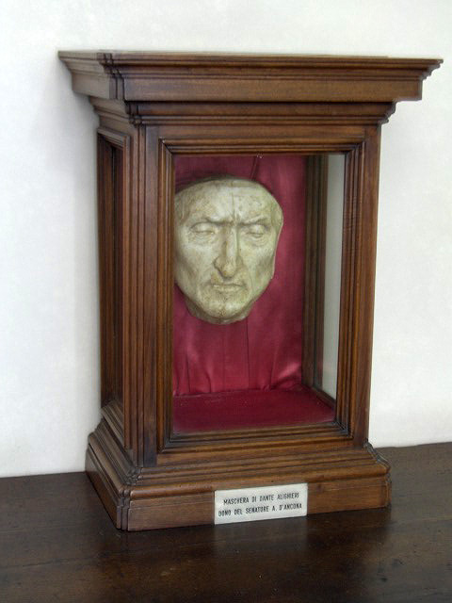
Interestingly, the Greek and British edition of Inferno uses the death mask of Dante for the book cover. Dante’s death mask is located as the novel states in the Palazzo Vecchio in a small andito, corrider, on the second floor, between the Apartments of Eleanor and the Halls of Priors (Dante Death Mask). Previously, this death mask was considered to be the actual death mask, carved directly from the face of Dante. However, recent studies suggest that the mask was probably
Figure 2: Dante’s death mask
carved in 1483 by Pietro and Tullio Lombardo 162 years after Dante’s death. A reason why people did not believe that the mask was the true mask was because of the nose of the mask. A hooked nose is a sign of intelligence and mischief, and throughout the year Dante’s nose has become more and more hooked in representations such as Botticelli’s portrait of Dante (Madeau). In 2007, scientists made a reconstruction of the face of Dante. In 1921, Professor Fabio Frasseto took measurements of Dante’s skull and secretly, without the knowledge of the caretakers of the remains, a plaster model. Rather than the aquiline nose that he was famous for, Dante had a pudgy nose (After 700 years, Dante gets nose job).
Figure 2: Replica of Dante’s face
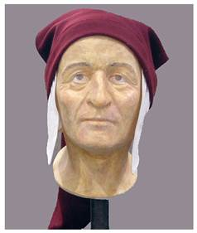
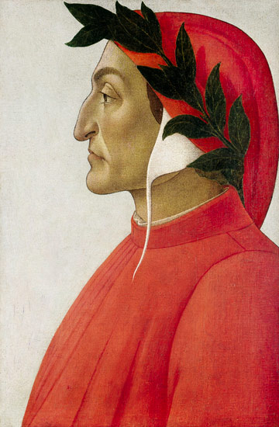
In many editions of the novel, a portrait of Dante is placed in the center of the dust cover. However, the orientation of the portraits differs in some editions. In the English and Lithuanian version of the book, the portrait of Dante by an anonymous artist is looking towards the left. However, in the Arabic version of the book, a different portrait of Dante is used, the famous portrait done by Sandro Botticelli (left).
Figure 3: Portrait of Dante by Sandro Botticelli.
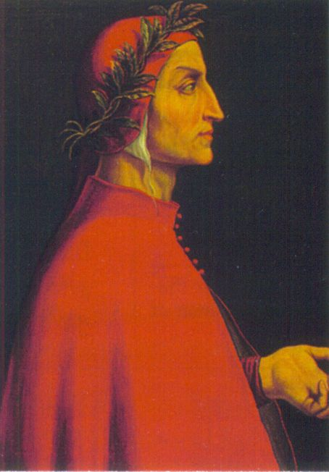
Both of theses portraits were painted way after the death of Dante. In both of theses portraits, the artists give Dante a laurel wreath on his head in recognition of his skill and influence in the arts. Both of theses portraits were actually painted years after the death of Dante. The different portraits were used due to the different sides that each portrait showed, Botticelli’s showed the left side of Dante’s face and the anonymous artist’s showing the right side of Dante’s face because the English language is read from left to right while the
Figure 4: Portrait of Dante
Arabic language is read from right to left. In each of theses cultures, because of how the language is read, the eye looks at the book cover differently. An English speaking person would start from the left and go to the right while an Arabic speaking person would be the vice versa. Dan Brown places emphasis on Dante’s nose knowing that the nose is draw inaccurately by Botticelli and the anonymous artist. The last thing that the readers will see in both book covers before starting the novel will be the famous aquiline nose of Dante.

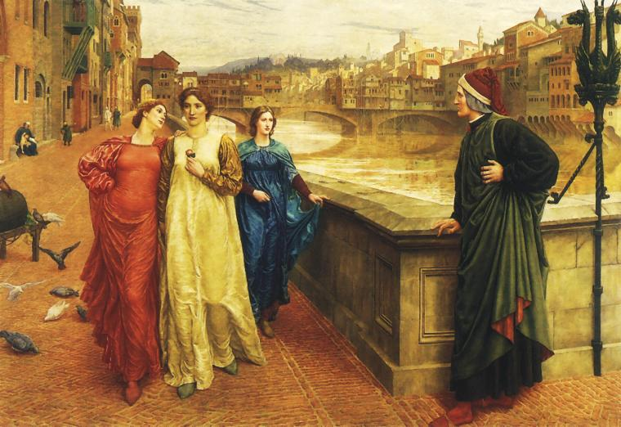
In addition to his famous nose, Dante has made one woman famous to the world. Throughout his life, Dante has only loved one woman, Beatrice. Dante only wrote about one woman, never writing about his wife or children. Beatrice appears as a character in Dante’s two greatest works- La Vita Nuova and the Divine Comedy showing the influence that she had in the two moments they met. The Czech book cover uses Henry Holiday’s painting, Dante and Beatrice, for their book cover. A scene in La Vita Nuova influences this painting when Dante describes his second meeting with Beatrice by a street. La Vita Nuova is a series of poem describing Dante’s love for Beatrice. It is a biography of each time, two times actually, he actually saw her. Dante is believed to have taken
liberties with the details in the text as in the La Vita Nuova, it is nine years between the two encounters they have met. From the age of nine when he first met her, Beatrice has been the woman he has idolized and worshipped. Because of Dante’s works, Beatrice herself has become a heroine. At her tomb in Santa Margherita Dei Cerchi Florentine, people have left letters in hopes that Beatrice will help them just as when she helped Dante in Inferno. As Robert Langdon did in the Inferno, Dan Brown himself wrote the opening sentence from Homer’s great epic poem, The Iliad, “Sing in me, Muse, and through me tell the story”, asking for assistance to finish Inferno.
Figure 5: Henry Holiday’s painting, Dante and Beatrice

From the beginning of Chapter One of Inferno, Dan Brown uses parallelism to connect both his Inferno and Dante’s Inferno together. Robert Langdon is trapped in a nightmare where the “river whose churning waters ran red with blood [and] a sea of corpses” lies everywhere (Brown, 9). Throughout this passage, the motif of death is repeated over and over again in an attempt to recreate hell in Robert Langdon’s nightmare. From the Tania cloth, to the shroud, to a veil, clothes wore during a burial are emphasized. Even the Lapis lazuli amulet is correlated with death as ancient civilizations buried their dead with the gem, lapis lazuli. The royal Sumerian tomb of Ur has over 6,000 lapis lazuli sculptures while lapis lazuli was used in the mask of King Tutankhamen (Lapis Lazuli: Stone of the Ancients). Additionally, thousands of the bodies were still alive dying “unthinkable deaths [and] writhing in agony” in Langdon’s nightmare (Brown, 9). Robert Langdon describes how the bodies were killed, “consumed by fire, buried in feces, devouring one another” (Brown, 9). Each of theses deaths are punishments that are described in Dante’s Inferno. The Third Circle is where gluttons are punished by being forced to lie in a vile slush or buried in feces, the Sixth Circle is where heretics are punished by being trapped in flaming tombs, and the Ninth Circle where Lucifer trapped in the frozen lake devours the betrayers.

When Robert Langdon awakes from his nightmare full of Dante’s allusions, he does not remember anything that has happened for the last three days. Robert does not know where he is, what happened to him, or even what time it is showing how he is both lost literally and lost in time. Brown introduces Robert Langdon as one who is lost from his path. Similarly Dante also “went astray from the straight road and woke to find myself alone in a dark wood” (Dante.i.1). In order to guide them back to the right path, the two protagonists have a guide to show them where to go. Although it was Virgil who helps Dante travel through hell, it is Beatrice who oversees the both of them. Virgil is used to help Dante travel from each circle to the other by navigating and convincing the guardians of each circle to let them pass. When Virgil could not get past the Gate of Dis, the two of them were stuck there with the Three Infernal Furies. However, Beatrice managed to send a “heavenly messenger” to help the two poets pass through the gate as well as scatter the hellish monsters surrounding the two. In addition, in Dante’s time of need when Dante is lost and being hunted by the three beasts of Worldliness, it is Beatrice who sends Virgil to help Dante get away from the beasts. Similarly, in Brown’s Inferno, Elizabeth Sinskey is the guide for Robert Langdon. Both Sinskey and Beatrice are interconnected as angels to their respectively followers. Elizabeth Sinskey shown to be “radiating a white light” (Brown, 10), illustrating a sense of holiness in her. In order to further deepen the relationship between the two, Brown makes Sinskey not have any children as Beatrice allegedly died before having any children as well. When Robert Langdon wakes up from his dream, he does not remember anything that happened to him for the last two days except for Sinskey saying the phrase, “Seek and ye shall find” (Brown, 9). Langdon first begins to travel through Florence in order to save Sinskey and “do exactly what she keeps telling you to do, ‘Seek and ye shall find’” (Brown, 116). Sinskey was the guiding light for Robert from the very beginning. In addition, Sienna is the character that acts as Virgil. Throughout the novel, Sienna helps Langdon get out sticky situations. Both Virgil and Sienna are there to help their respective underlings continue on with their journey.

The ending of the novel also parallels the ending of Dante’s poem as the protagonists of both literatures manage to escape “hell”. The ancient cistern of Istanbul is “a large underground space with columns… built in the sixth century to house the city’s water supply” (Brown, 399). Robert Langdon must travel down the earth’s surface into the cisterns of Istanbul where he meets the ‘evil’ which changed” who we are, who we’ve always been, at the most fundamental level” (Brown, 439). The evil that erupted out of the water completely changed the face of humankind in the novel. Now, the plague in Brown’s novel has made one third of the entire human population become infertile. Dante traveled to the center of the Earth where he encounters sin and the devil itself. Both of these underground caverns in each of the works have a body of water, let it be man-made or god-made. At the center of the frozen lake in Dante’s poem, Satan is stuck gnawing at the other sinners. Just as in Brown’s novel, the plague changed the nature of humankind, Satan, in Dante’s poem, also completely changed the nature of humankind. Satan is actually the original sinner, not Eve. Satan was formerly an angel who tried to usurp God. After he failed, Satan manages to cause the fall of man by convincing Eve and Adam to eat the apple leading to the original sin for every human born. By the time both return back to the surface of the Earth, both stop and stare up to the skies to reflect upon the horror they saw. In fact the final word of both Dante’s Divine Comedy and of Brown’s novel is “stars”.

From the beginning of the novel, the book cover hints to the knowledge needed to fully understand Brown’s Inferno. Each of the artworks for the book covers has some inaccuracy in them from the nose in the death mask and the portraits to the La Vita Nuova. By finding out why Dan Brown placed each object where he did or wrote about each object allows for a greater understanding of the novel for the audience. This compels the reader to look beneath the surface of the novel. Cerca… Trove.

Works Cited
"After 700 years, Dante gets nose job." msnbc.com. N.p., n.d. Web. 10 Nov. 2013. <http://www.nbcnews.com/id/16580287/>.
Brown, Dan. Inferno. New York: Random House, 2013. Print.
"Classical Literature and Poetry." : The Inferno: Canto XXXI, by Dante Alighieri. N.p., n.d. Web. 10 Nov. 2013. <http://www.dantealighierithedivinecomedy.com/2010/06/poetry-summary-inferno-by-dante_820.html>.
"Dante Death Mask - Florence Dan Brown Inferno." Florence Inferno. N.p., n.d. Web. 10 Nov. 2013. <http://www.florenceinferno.com/dante-death-mask/>.
"Dante's Death Mask." Wikipedia. N.p., n.d. Web. 10 Nov. 2013. <http://upload.wikimedia.org/wikipedia/commons/e/e2/Dante.deathmask.jpg>.
"Lapis Lazuli: Stone of the Ancients." Lapis Lazuli: Stone of the Ancients. N.p., n.d. Web. 10 Nov. 2013. <http://www.gemselect.com/other-info/about-lapis.php>.
"News." Dan Brown. N.p., n.d. Web. 10 Nov. 2013. <http://www.danbrown.com/news/>.
"Portrait of Dante." Wikipedia. N.p., n.d. Web. 10 Nov. 2013. <http://upload.wikimedia.org/wikipedia/commons/6/6f/Portrait_de_Dante.jpg>.

Alighieri, Dante. Inferno. Ciardi ed. New York: Penguin Classics, 1954. Print.
Barbi, Michele. Life of Dante. Berkeley: University of California Press, 1954. Print.
Bemrose, Stephen. A New Life of Dante. Exeter (GB): University of Exeter Press, 2000. Print.
Nadeau, Barbie. "Dan Brown's 'Inferno' Sparks Dante Fever in Florence." The Daily Beast. Newsweek/Daily Beast, 30 May 2013. Web. 10 Nov. 2013. <http://www.thedailybeast.com/articles/2013/05/30/dan-brown-s-inferno-sparks-dante-fever-in-florence.html>.

