Middlebury College Museum of Art Permanent Gallery Highlights Tour Visual Descriptions (Beta Version)

Audio guide available online at:
- go/visualdescriptions/
- http://sites.middlebury.edu/museumvisualdescriptions/
[Thank you for visiting the Middlebury College Museum of Art. This student-made document has been constructed to provide information on visual detail, historical context, and artistic significance of 7 key pieces from the Museum collection.

The guides are primarily designed for use by visually impaired Museum guests, however sighted visitors may also benefit from using the guides to direct close study of the collection.

This document is a temporary, beta version; any feedback about your experience with the guides is greatly appreciated and can be submitted online at go/visualdescriptions.

Audio guides, electronic text transcripts, and a downloadable Word version of the guides are also available at go/visualdescriptions. Please type “go/visualdescriptions/” into the search bar of an electronic device to access the website.]

1. Winged Genie Pollinating the Date Palm. Carved from alabaster by Ancient Assyrian artisans in the 9th century B.C.E.
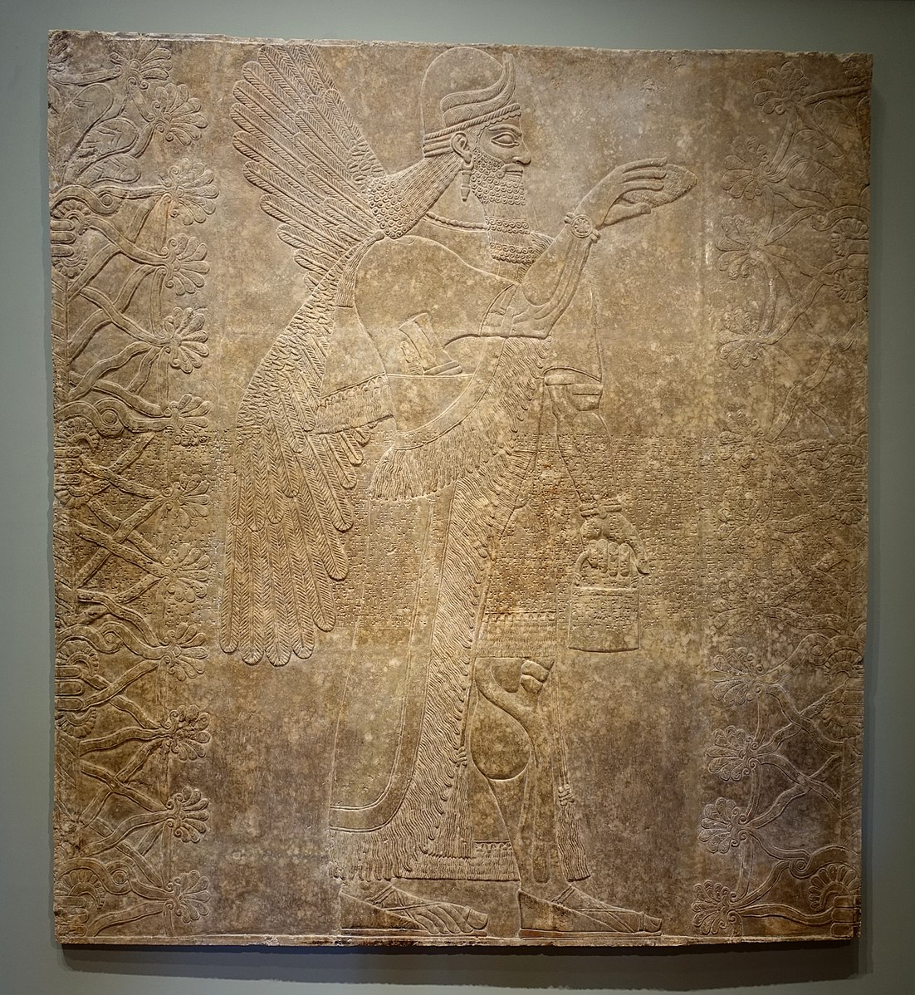
Winged Genie Pollinating the Date Palm is a large, square relief mounted to the wall beside the Museum front desk. Audio guide length: 5 minutes, 14 seconds.

This square wall carving is titled Winged Genie Pollinating the Date Palm. It is very large: 94 inches tall and 90 inches wide. It was made in ancient Assyria between 883 and 859 B.C.E., during the rule of King Ashurnasirpal II.

It is made of alabaster, a soft, grey stone that is easy to sculpt. Artisans sculpted this work in a style of carving known as low relief: the features of the sculpture rise only a few millimeters from the smooth stone background. Although most of the fine detail of this piece seems to project very slightly toward the viewer, a band of wedged-shaped characters is carved into the stone midway between the sculpture’s top and bottom. This writing—Akkadian cuneiform—details the wealth, power, and military success the King brought to his Kingdom.

Most of this relief, however, is occupied by an image of a winged man, seen often in Assyrian art. He is slightly larger than life, and we view him from a profile perspective as if he is standing next to us. He is carrying a bucket in his left hand, while his right hand holds a pinecone-shaped object and reaches across his chest towards a large plant. (It is thought that he is hand-pollinating this plant—a date palm—by shaking pollen from the pinecone onto the flower.)

The winged man’s chest is oriented forward toward the viewer, but his face and feet are turned toward the flowering tree. To understand his pose, try this: keeping your chest squared forward, turn your feet and head 90 degrees to your left. Imagine reaching your right arm across your chest towards a flower a foot and a half from your face. How does this pose make you feel? Off balance? This is because the relief was created in a flattened perspective common in early artworks.

[If you would like further extended description and analysis of this highly detailed sculpture, please continue listening or reading.]

This carving is one of many reliefs that decorated the walls of King Ashurnasirpal’s royal palace. Visitors would have passed hundreds of intricately carved, painted stone reliefs such as this one on their way to the palace throne room. The relief portrays a winged man, possibly modeled after King Ashurnasirpal II himself. He is performing a fertility ritual by pollinating a date palm. While this image carries symbolism of creation, writing boasting the exploits of the King overlaps the middle of the carving—a dark reminder of King Ashurnasirpal II’s violent reign.
The man in this relief is identifiable as a genie, a minor deity who symbolizes protection and divine control. His beard and long hair are elaborately styled in a pattern alternating between straight sections and tight, round coils, and he is dressed in a tight-fitting short sleeve shirt under a long, tasseled robe that opens up to expose one muscular leg.

He wears thick wedge-shaped sandals on his feet. These sandals still bear traces of black paint. We can immediately identify the figure as a powerful and divine force. Feathered wings spread open from his back. He wears a horned headdress worn by the divine. He is extremely muscular, carries a knife and sharpener, and dons lavish jewelry. Most important are his bucket and pinecone, which symbolize his power over agriculture.

Date palm trees flank the genie on both the right and left. The center of the trees are column-like trunks, but these are barely visible, cut off by the end of the relief, showing that this is just one section of a larger image. Extending from the sides of the trunks are thick tendrils that weave together in a grid-like pattern. Shell shaped flowers bloom from tendril intersections on the outer edges.

As you come even closer to the relief, you realize that something has been written across the center. The writing is in Akkadian cuneiform, a system made up of wedge-like carved hatchings. Part of the writing says “I am Ashurnasirpal… the fierce dragon, the conqueror of all cities and mountains to their full extent, the king of rulers…who forced into compliance the relentless, fierce kings from the East to the West, at his very approach.” This writing shows that King Ashurnasirpal II was a fearsome leader. The image of a deity performing a fertility ritual, contrasted with the frightening writing that praises the King as a powerful conqueror, show two opposing pictures of Ashurnasirpal II—as a ruler who is both a creator and a destroyer.

2. Attic Black-Figure Eye Cup. Crafted out of clay in Ancient Greece in the 6th century B.C.E.

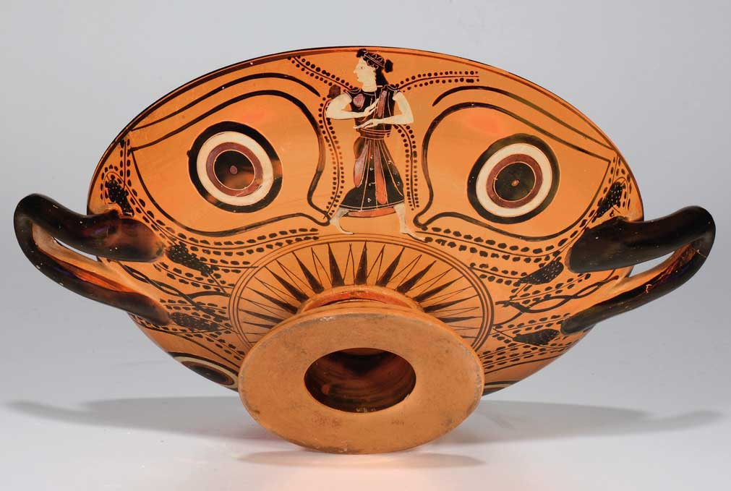

Attic Black-Figure Eye Cup is located in the Antiquities gallery on the first floor of the Museum. Audio guide length: 3 minutes, 40 seconds.

This Attic Black-Figure Eye Cup is a wine cup from ancient Greece. It was made around 510 B.C.E. The piece is made of terracotta, a red baked clay, painted in red, black, and white. The top half of the cup forms a wide, shallow bowl with thick, looped handles. The bottom half is made up of a short stem with a flared base. It is very symmetrical—a clue that it was created on a potter’s wheel. It is quite large—about one foot wide and four inches tall.

The bottom of this cup is decorated with designs common in Greek pottery. Pairs of rings dominate either side of the cup. The rings alternate black, white, red, and black again in a pattern also similar to a bulls-eye. A geometric starburst pattern circles the stem, and twisted lines surrounded by black dots circle the handles. These tendrils and dots together resemble abstract grape vines.
On either side of the outer walls of the cup are realistic, human-like figures. On one side is Hercules, the Greek hero. On the other side is an image of a woman energetically clapping her hands in dance. She is a Maenad, a female follower of the god of wine.

[If you would like further description and analysis of this cup—including a hidden surprise—please continue listening or reading.]

Hercules is painted in black and wears a lion skin. He is kneeling and pulling back an arrow, preparing to shoot. On the other side, the skin of the dancing Maenad is painted white and she wears a black, draped robe with red folds. The abstract grape vine patterns and image of a Maenad link this cup to the Dionysian revels, rituals involving intoxicants, music, and dance to induce a trance-like state.

Cups like this one were often used during banquets. At these events, philosophers would gather to talk and drink wine. Friends would pass this wine cup from person to person, drinking from the same vessel. When a guest held the drink in his hands and looked inside the cup, all he would see is a simple design of orange and black rings in a bulls-eye pattern. Only when he lifted the cup up to his lips would the intricate design on the bottom become visible to other guests.

Concealed among the designs on the bottom of the cup is a hidden surprise—a cartoon-like face! When the cup is lifted, the bulls-eye ring designs transform into the bright whites of eyes, red irises, and staring, black pupils. The shape of the eyes is enhanced by swooping lines that evoke eyelids and brows. The looped handles on either side of the cup become large ears, and the vessel’s hollow base forms a round, gaping mouth. Combined together, the face resembles theatrical masks from ancient Greece. When a party guest drank from the cup, the mask would cover his face—a humorous sight for the other friends.

The design of this cup can be understood as a metaphor for its use. The cup’s design is very simple from the perspective of the person drinking the wine. The decorations on the bottom of are meant for others’ amusement, demonstrating the social, interactive function of wine in ancient Greece.

3. Untitled. Painted by American artist Walter H. Williams, Jr. in 1951.
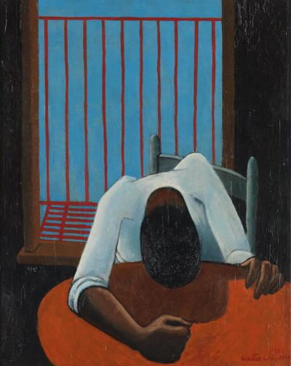

Untitled, by Walter H. Williams, Jr. is located in the American/European gallery at the center of the first floor. Audio guide length: 2 minutes, 51 seconds.
This untitled painting portrays a seated Black man with a bowed head. The piece was made by the American artist Walter H. Williams, Jr. in 1951. It is an oil painting on canvas, 30 inches tall and 24 inches wide.

In this painting, a downcast apartment resident sits behind a circular, red table in a dark room. We view him as if we are standing across from him on the other side of the table. His head is bowed down over the table covering his face. His shoulder blades jut above his back at sharp angles. He wears a white shirt with sleeves rolled to the elbow. His left hand clutches the table, and his right hand is clenched in a fist. Behind the man, a window frames a clear sky, but this blue sky is blocked by the bold, red bars of a fire escape.

[If you would like further description and analysis of this painting, please continue listening or reading.]

The painting is made in a jarring, abstract style, with strong colors, crisp lines, and little shading. The oil paint is thickly layered, particularly on the black background and the man’s black hair. The style of the work is influenced by cubist designs, painted from multiple perspectives. We view the man as if we are across from him, yet the red table tilts forward towards the viewer, spilling off the canvas. The unusual sense of perspective in this painting creates a compressed space. The man appears as if he is tightly wedged between the window and the table.

The claustrophobia of this work is especially meaningful in the context of the painter’s life. Walter H. Williams Jr. went to art school on the GI bill after serving in World War Two. Although he had a successful career in New York, he experienced exclusion on the basis of racial prejudice. This eventually led him to emigrate to Denmark. His later works frequently depict black children frolicking in fields with birds and butterflies—a stark difference from the confined feeling of this piece.

The abstract style of the painting provides rich opportunities for interpretation. Because we cannot see the man’s face it is difficult to pinpoint his emotions. It is possible that he is slumped in defeat or despair. It is also possible that his posture shows tension and fury. Optimists may sense a glimmer of resolve in the man’s clenched fist, which seems to anticipate the raised fists of Civil Rights and Black Power movements of the next decade.

4. Bimbo Malato (Sick Boy). Sculpted from plaster and wax by the Italian artist Medardo Rosso in 1893.

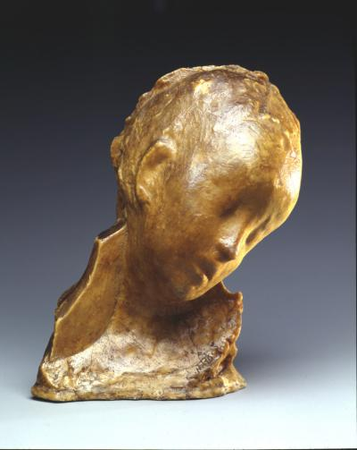

Unfortunately, Bimbo Malato (Sick Boy) is not currently on display in the Museum. Thank you for your understanding. Audio guide length: 2 minutes, 24 seconds.
This sculpture is called Bimbo Malato, Italian for Sick Boy. It portrays the drooping head and neck of a sick child. The sculpture is made of wax filled with plaster and was created in 1893 by the artist Medardo Rosso. It is slightly smaller than life sized, about 10 and ½ inches tall, 9 and ½ inches wide, and 7 inches deep.

At first glance, this piece looks similar to marble portraits of Ancient Roman leaders. A closer look, however, tells a much different story. Instead of marble, the piece is made from a slippery, yellowing wax, creating a feeling of disease. Rather than a strong pose gazing ahead, the young boy is slumped over, too weak and sickly to hold up his head. The child’s head is bent to his left—the viewer’s right. He has little to no hair, his eyes are closed, and his mouth is slightly parted. The piece’s waxy material combined with the child’s wilted pose creates the feeling that he is melting.

[If you would like further description and analysis of this sculpture, please continue listening or reading.]

The back of the sick boy’s head and his collarbone descend into rough, brown bumps. A jagged background juts out from his neck on the viewer’s left side, creating the sense that the image was chipped away like a half-finished stone sculpture.

Historically, sculptures have been made to remember important people and events. These images were often preserved in long-lasting material like bronze and marble. Medardo Rosso, the artist of Sick Boy, did the opposite. He often made artwork of people who were not typically associated with power, such as elderly people, children, and the poor. The sick child in this piece is probably based on a real person Rosso met in a Paris hospital. Rosso’s use of fragile material and vulnerable subjects to convey fleeting moments made him an important rule-breaker in the history of sculpture.

5. Camel and Rider. Made out of clay and paint by a Chinese artisan working during the Tang Dynasty, which lasted from the 7th to 10th century.
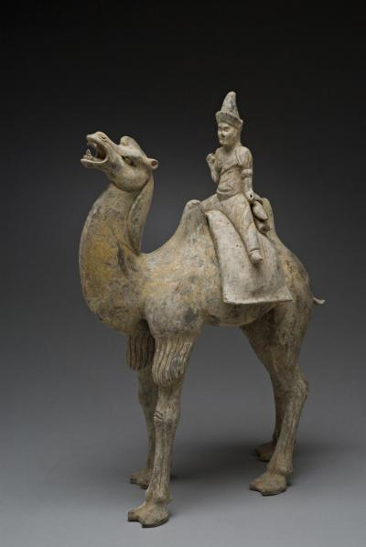

Camel and Rider is located in the Robert F. Reiff Gallery of Asian Art on the second floor of the Museum. Audio guide length: 2 minutes, 22 seconds.
This sculpture portrays a man seated atop a camel. It is made of terracotta, baked clay, and is covered in faded yellow and black paint. It was made during the Tang dynasty, between 618–907. It is about 23 inches tall, 16 and ½ inches wide, and 8 and ½ inches deep, about the same height as from the floor to your knee or mid-thigh. The piece offers a glimpse into what life along the Silk Road may have been like.

In this sculpture, a Silk Road trader sits between two camel humps. He is wearing loose pants, a shirt with rolled up sleeves, and a pointed hat. He sports a beard and broad, bold facial features. The clothing and physical features of this rider identify him as a trader from Central Asia. He sits atop a cloth, with two rolled fabrics stored behind him.

This trader rides a two-humped Bactrian camel, native to central Asia, Mongolia, and northwestern China. The camel’s long legs steadily step forward and its head is dramatically reared back. Its mouth is open wide, revealing sharp teeth and a curled tongue. This impressive piece at once captures the realities of everyday life for traders, while also portraying the whimsical notions associated with camels during the Tang Dynasty.

[If you would like further description and analysis of this sculpture, please continue listening or reading.]

The Silk Road was a trading route over 4,000 miles long that linked China to the Mediterranean. It helped spread culture and civilization across the two continents.

Silk Road traders often carried silk, tea, salt, sugar, and spices. These rolled fabrics tucked behind the trader may be silks intended for market. The trader has holes in his hands, indicating that he may have once held reigns or a whip made of perishable materials like leather or wood.

6. Shamaness Haniwa. Sculpted in clay by a Japanese artist in the 6th century.

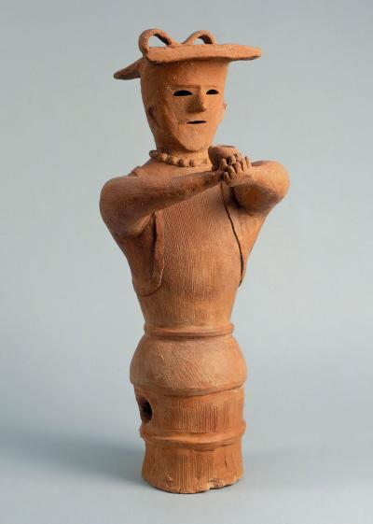

Shamaness Haniwa is located in the Robert F. Reiff Gallery of Asian Art on the second floor of the Museum. Audio guide length: 2 minutes, 13 seconds.
This sculpture portrays a woman with stylized, geometric facial features. It was made of terracotta, a rusty red baked clay, by an artisan working in the 6th century, during Japan’s Kofun period. This woman is 30 inches tall, about the height from the floor to mid-thigh. She is only sculpted from the waist up. From the waist down, this sculpture has a cylindrical base meant to be buried below ground.

This woman is constructed quite simply, with a flat, square hat, hollow, almond-shaped eyes, a triangular nose, a thin slit for a mouth, and no hair. She is wearing a sleeveless tunic with lining around the edges. She also wears a beaded necklace resembling semiprecious stone necklaces found in tombs from the same time period. Her round arms circle forward to present a bowl in a gesture of offering.

These accessories and bowl help us identify this woman as a shamaness. Chinese and Japanese histories describe Kofun period shamanesses not only as religious figures, but also as political and military leaders.

[If you would like further description and analysis of this sculpture, please continue listening or reading.]

In Japan’s Kofun Period, wealthy persons’ tombs were marked by hollow cylinders made from clay slabs called Haniwa, which literally means “clay circle.” Haniwa take the form of houses, animals, military equipment, warriors, and humans. These clay sculptures were believed to serve the deceased in the afterlife. Human haniwa have simple costumes and mask-like faces.

Shamaness haniwa are often shown seated or buried to the waist, perhaps indicating their close connection to the world of the deceased below them. This rare sculpture invites us to consider both the spiritual leadership that women have provided throughout history, as well as the ways in which we honor and serve the deceased.

7. Two-Way Mirror Curved Hedge Zig-Zag Labyrinth. Fabricated using glass, steel, and shrubbery to the specifications of American artist Dan Graham in 1996.
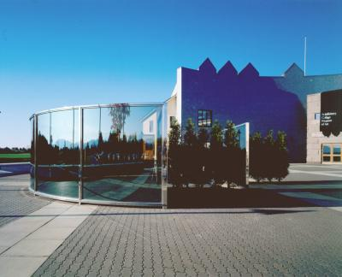
Two-Way Mirror Curved Hedge Zig-Zag Labyrinth is an outdoor sculpture located on the patio behind the Mahaney Arts Center. Audio guide length: 3 minutes, 5 seconds.

Two-Way Mirror Curved Hedge Zig-Zag Labyrinth is a large, outdoor sculpture made of glass, metal, and cedar hedges. The piece was made in 1996 by the American artist Dan Graham. It is 7 and 1/2 feet tall, with a radius of 15 feet. The sculpture consists of a series of connected walls forming a semi-enclosed space. You are welcome to touch this sculpture with care, smell the hedges, and enjoy the echoes produced when you speak inside of the sculpture.

To understand the shape of this sculpture, imagine the circle of a clock. A glass wall traces the rim of the clock from 12 to 6. The second half of the sculpture cuts diagonally across the clock from 12 to 9. This second half is made up of two right angles, which create a W- or M-shaped zig-zag pattern. Each turn on this zig-zagged wall alternates between glass and cedar hedges. The height of the glass and hedges is about the height of a typical room. Stepping into the interior of the sculpture feels similar to standing in a room with glass windows, but this feeling is countered by the open sky above and the natural hedges.

[If you would like further description and analysis of this sculpture, please continue listening or reading.]

One way to interpret this piece is to consider the materials used to make it. This construction is created with a combination of industrial and natural materials. The glass and metal components in this work are the same used in large skyscrapers and urban architecture. These industrial materials are juxtaposed with cedar tree hedges that have a rough, piney texture.

This sculpture was designed specifically for its site on the plaza of the Mahaney Arts Center. Unlike covered pavilions often found in gardens and parks, Graham’s roofless sculpture does not have any apparent practical function. Here, public space is used to invite viewers to actively engage with art. The more time one spends with this piece, the more ways of experiencing it appear. The curvature of the glass windows distorts your reflection, stretching it apart and bending it together again, like a carnival fun house mirror. Looking through the glass at different angles offers framed views of both the Mahaney Arts Center and the pastoral Vermont landscape. The pavilion’s industrial materials create an echoing sound, and even the smell of cedar contributes to the viewing experience. Through this interactive work, Dan Graham invites us to consider our own relationships with the built and natural environment.

[This concludes the visual descriptions highlights tour. Please remember to return this guide after use. Thank you for visiting the Middlebury Museum of Art, and enjoy the rest of your visit.]

