History
Department
Newsletter

May 19, 2020
Letter from the Chair
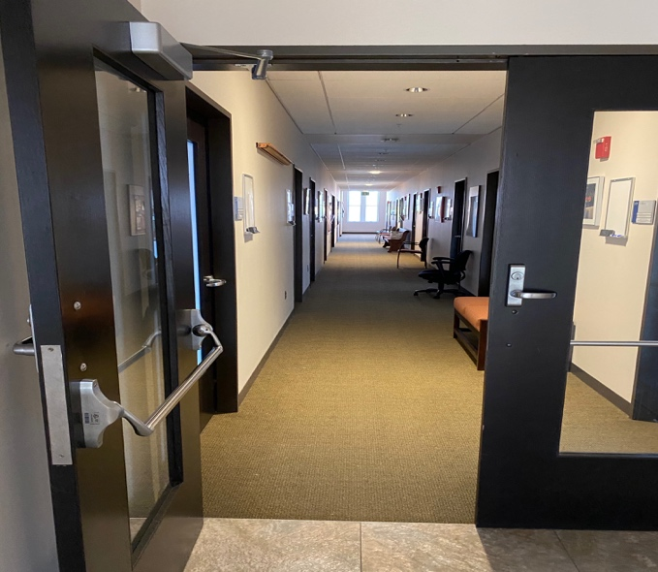

A final note from the outgoing chair Professor Darién J. Davis.

Dear history majors and minors,

Congratulations to all history seniors for the completion of their degrees, and congratulations to all students on completing the academic year 2019-2020. Thank you for your patience and your engagement through our online transition.

“Congratulations to all history seniors for the completion of their degrees, and congratulations to all students for completing the academic year 2019-2020.”
This year was challenging, but we also achieved a great deal. We worked diligently to implement the final stages of our optional senior program, to reform HIST0600, and to help implement the newly approved track in the History of Science, Medicine, and Technology (HSMT). The History faculty will continue to work with students well into the future to build an intellectually vibrant community.

It has been my pleasure serving as chair. I leave you in good hands with the next chair, Professor Paul Monod. I wish you all a great summer.

Congratulations, Class of 2020!

Gigi Alper | Hannah Hagerty | Olivia Miller
Kaihalani Bradley | Richard Holley | David Packer
Gareth Cordery | Carolina Hutt-Sierra | Celia Ripple
Francis Cosolito | Isabelle Lee | Grant Schultz
Samuel Cottle | Téa Levy | Caleb Turner
Naomi Cutler | Monty Liu | Angus Viebranz
Perry DeLorenzo | Carter Massengill | Angus Warren
Adrienne Goldstein | Max McCulloch | Martin Williams
 |  | Victoria Yeh

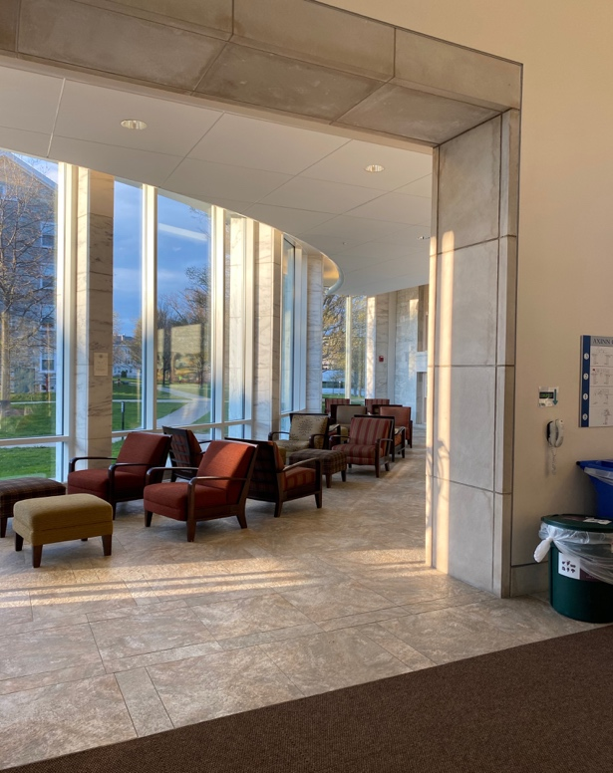
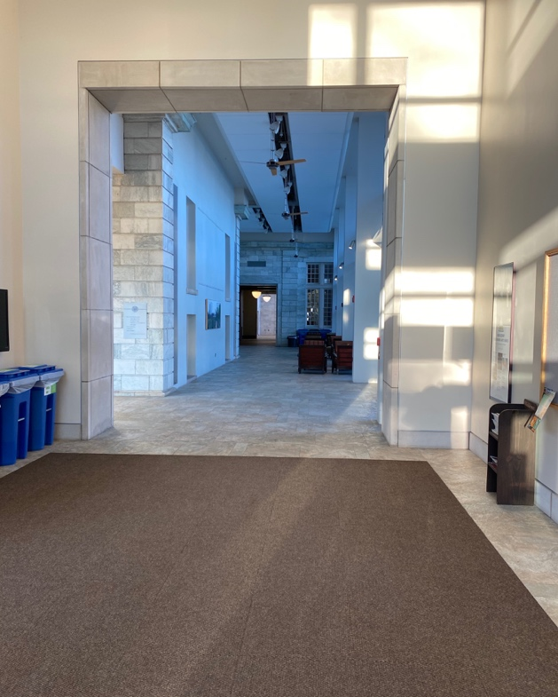
Axinn hallway
Afternoon sunlight in the Axinn Winter Garden

You can visit the Metropolitan Museum of Art online
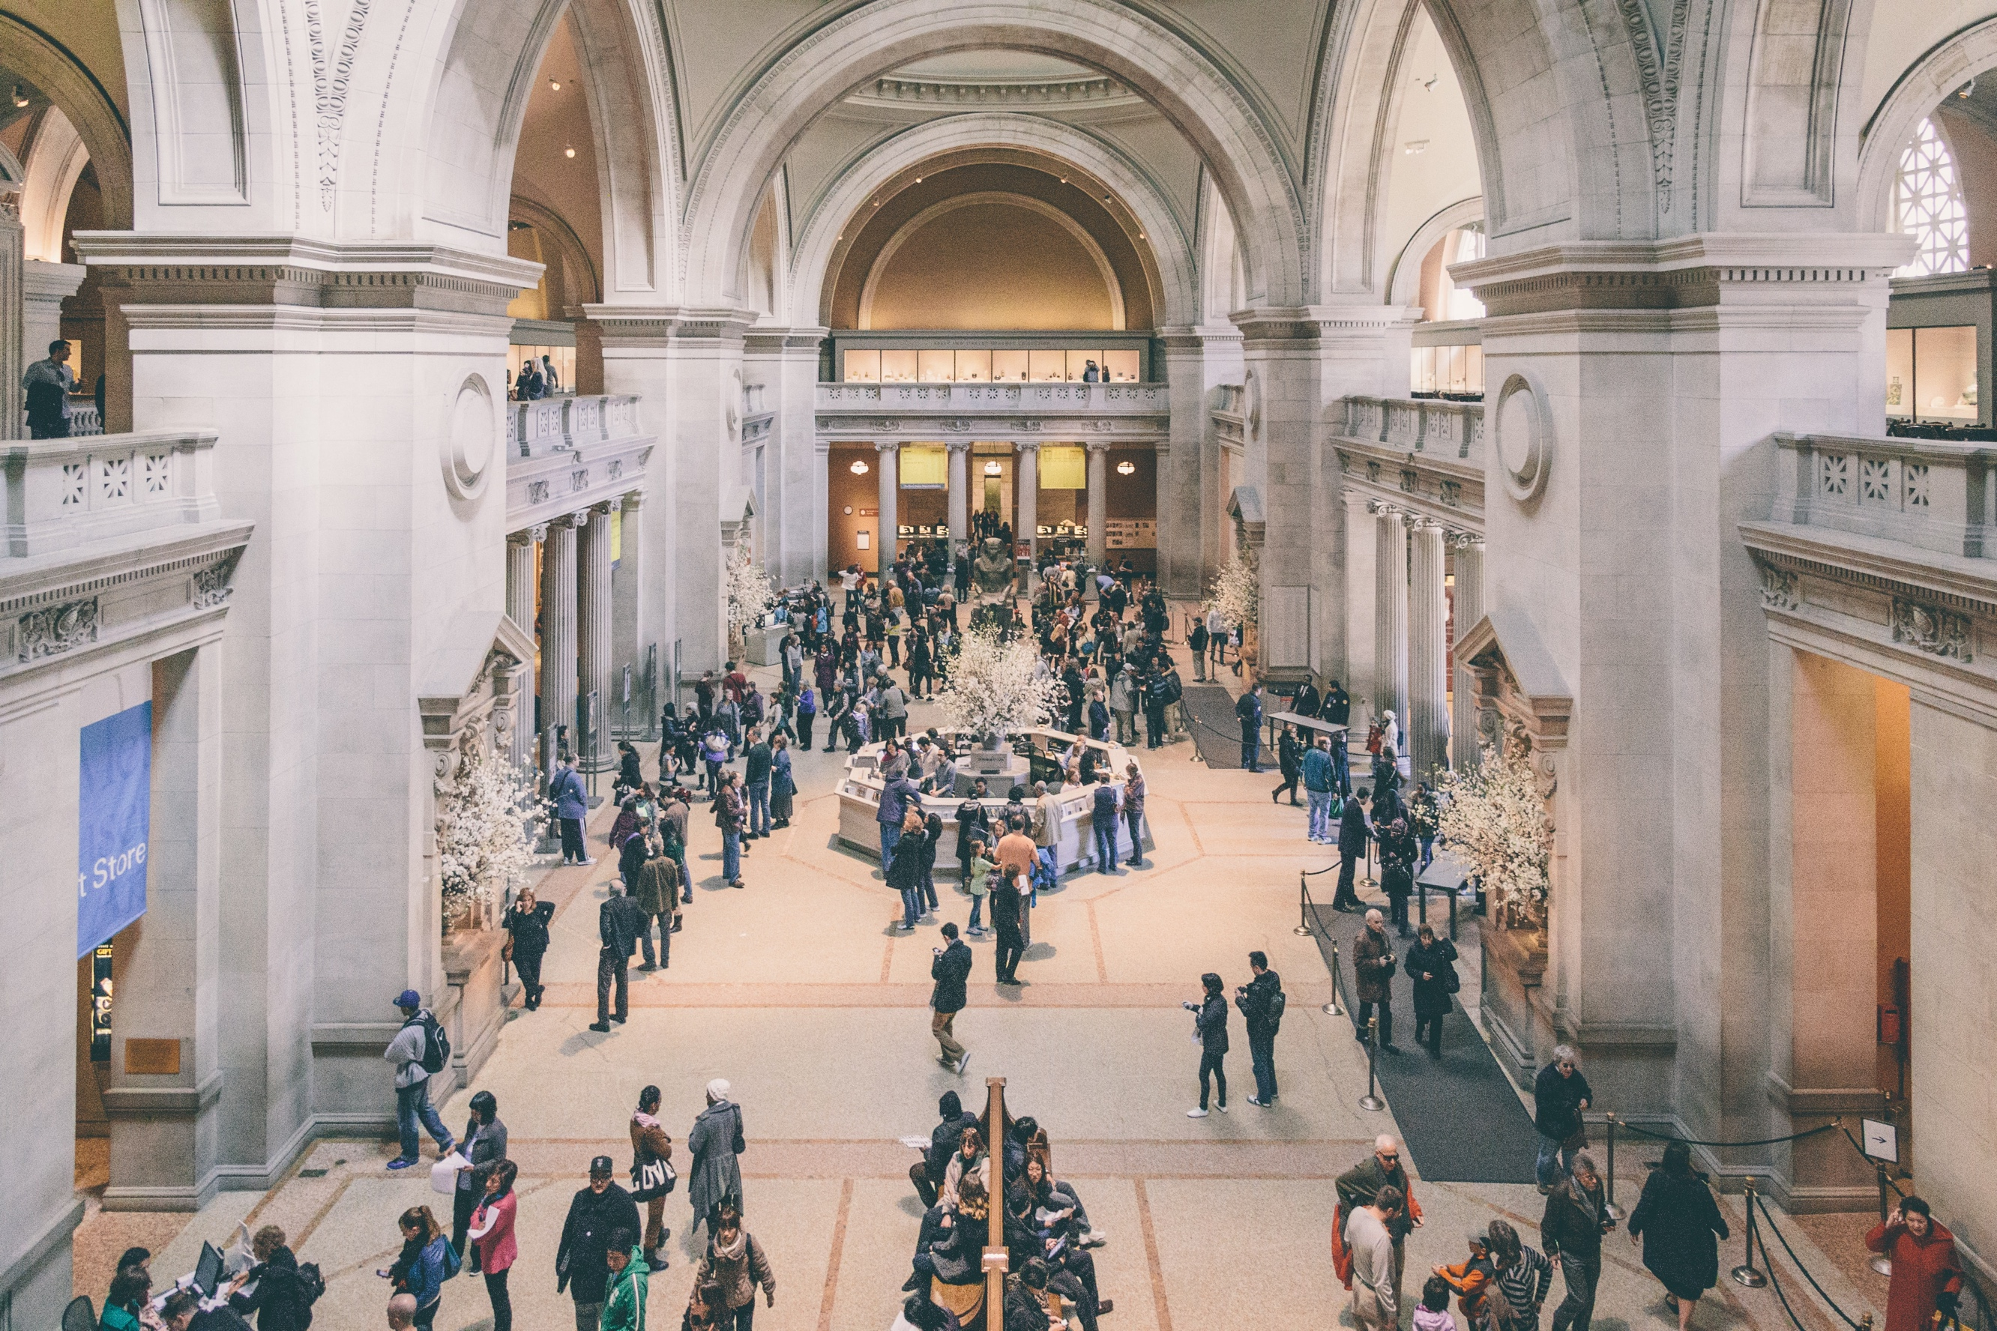
- The Louvre (France)
- National Museums of Kenya
- Vatican Museums (Italy)
- Museum of Islamic Art (Qatar)
For more on the pieces you can see in the virtual tour check out their website here.
- Tokyo National Museum (Japan)
- Hubei Provincial Museum (China)
- Pergamon Museum (Germany)
- Museum Nasional Indonesia
- Rijksmuseum (Netherlands)
- The British Museum
- National Museum of African American History and Culture
(The museum website is above, but you can find some exhibits through Google here.)
- Museo de Arte de Lima (Peru)
(No virtual tour, but an amazing collection)

Google offers an in-depth virtual tour of the palace of Versailles
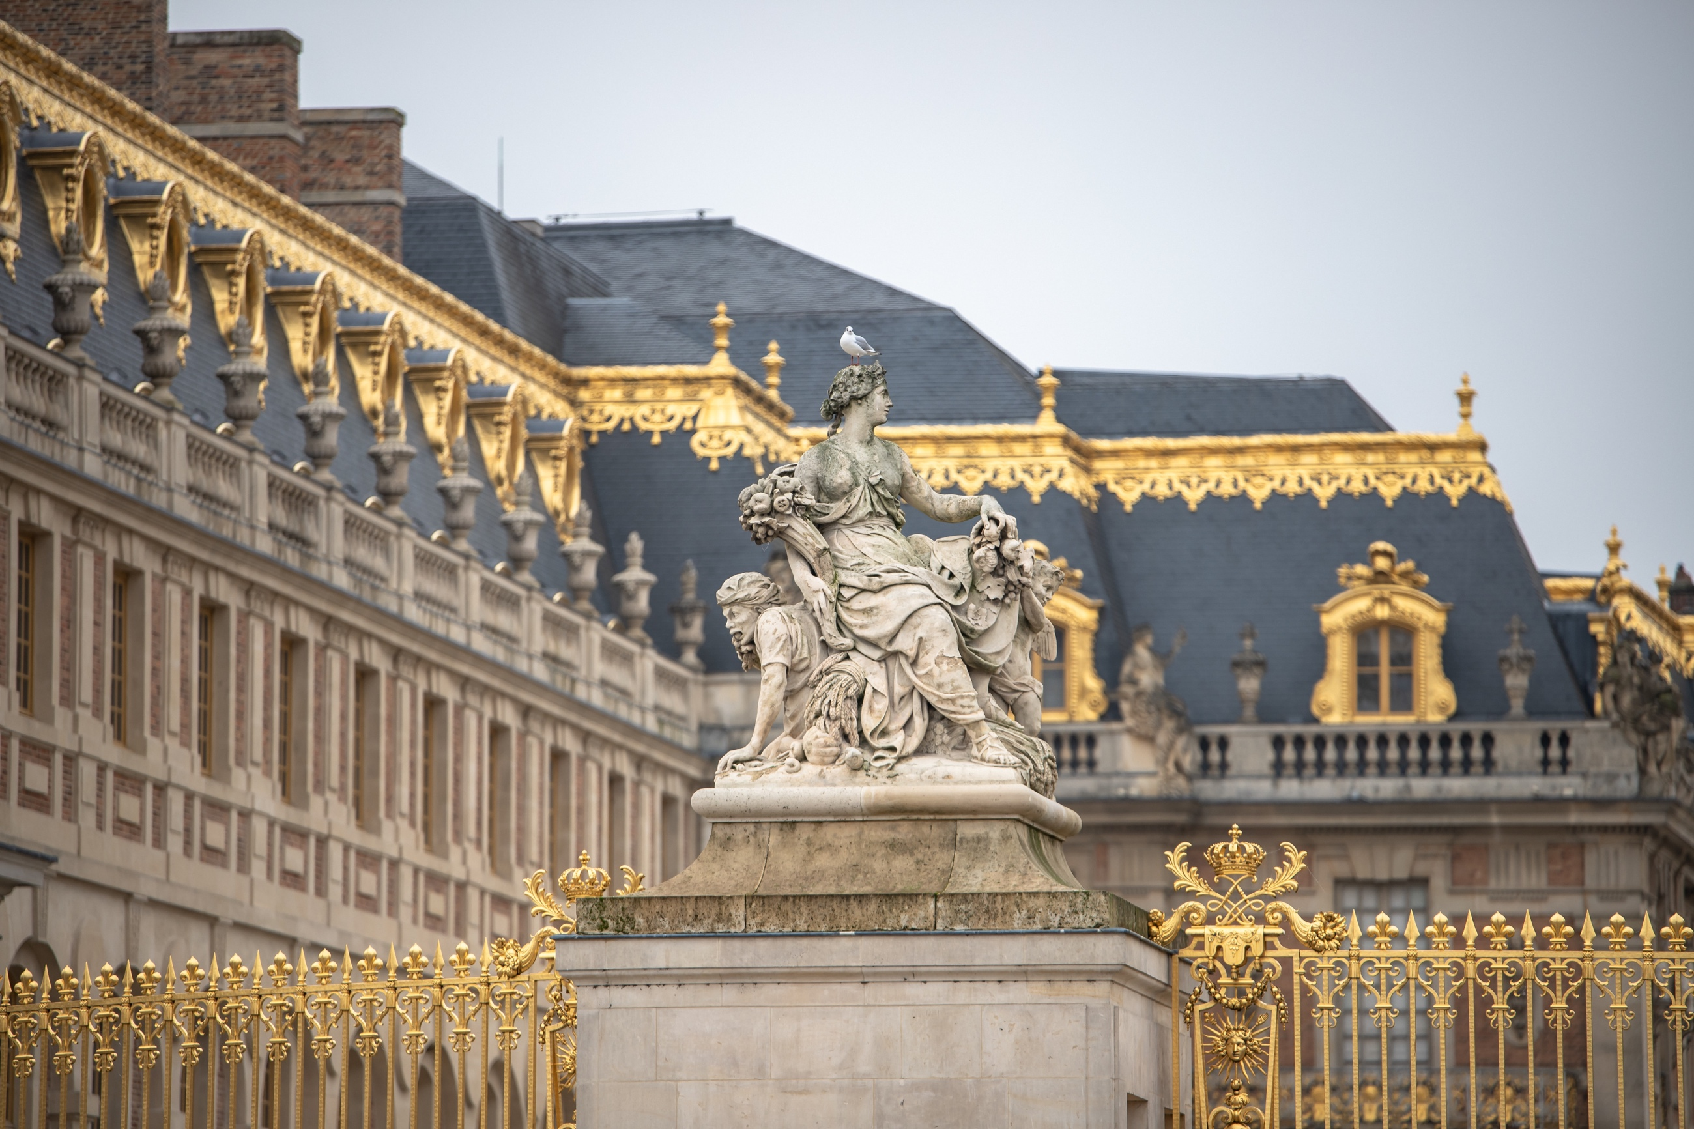
- Versailles Palace (France)
- Schönbrunn Palace (Austria)
- Stonehenge (England)
- Taj Mahal (India)
- Acropolis (Greece)
- Museu Imperial (Imperial Palace, Brazil)
- Citadel of Qaitbay (Egypt)
- Chichen Itza (Mexico)
This page shows artifacts and exhibits for the site; scroll down to virtually explore it.
- Pompeii (Italy)
- Historic Monuments of Ancient Kyoto (Japan)
- St. Paul’s Catacombs (Malta)
- Archaeological Survey of India
Hundreds of street views of Indian temples, tombs, forts, and other historic sites

Once again, Google Arts and Culture has a wonderful collection of monuments and buildings you can tour through street view here. This is a list of some of them, along with other virtual tours of historic places offered independently.

Tour historic places from your house
2
Many museums have virtual tours or views of their collections available through Google Arts and Culture here (double click on this text box as if to edit the text and then click the link). Some museums also offer virtual tours or access to their collections independently. Here are just a few museums you can visit online!

Visit museums virtually
1
If you’re looking for something fun, relaxing, and history-related to do, there are a surprising number of options online. Even though it’s difficult to visit museums and historic sites in person right now, there are many ways to engage with these places right from wherever you are. You can also get involved in online transcription projects, browse document collections, find historic recipes, and more!
Fun Things to Explore Online
- Smithsonian Transcription
- National Archives Transcription
- By the People
The Library of Congress’s digital transcription program (includes foreign language documents and the opportunity to “tag” documents to organize them)
- From the Page
A website for crowdsourcing transcription, it provides documents you can choose to transcribe page by page.

Participate in a transcription project
3
Middlebury’s Special Collections is looking for interviews, photos, journals, art, social media posts, and many more types of sources that reflect what it life is like during this pandemic. For more information, see their call for submissions here.

- Old Bailey Online
A collection of all the transcripts of criminal trials in London, 1674-1913.
- Illuminated Manuscripts
800 illuminated manuscripts from England and France
- Historic Newspapers
This search engine allows you to search across several thousand free newspaper archives from the United States, Australia, New Zealand, and Mexico.
- Dictionary of Victorian London
Eclectic collection of bizarre tidbits about Victorian London, taken from primary sources, organized by topic
- Recreate Historic Landmarks/Events in Minecraft
Check out this museum’s recreation of the Great Fire of London in 1666 and this recreation of medieval Oslo created by Norwegian university students for inspiration!
- Historic Recipes
If you are interested in recipes for research, or to try out at home, Old Sturbridge Village Historic Recipes contains a collection of early 19th-century American recipes which have been adapted for modern cooks. For more cookbooks and recipe collections from the past, check out this article on historic recipes on the internet from Mental Floss.
Document your experiences
5
Other fun things you can do
4
Many museums and archives are seeking online volunteers to transcribe documents, if that’s something that interests you! You can choose from a wide variety of different collections spanning different time periods and languages.

There are lots of opportunities to read and transcribe documents online. Some options include ship logs from New England whaling vessels (From the Page) and Spanish legal documents 1300-1800 (By the People).
