For my independent study, I decided to look at nutrition. I was actually approached by Mera Corlett of the Blue Apple Players. The Blue Apple Players is a program that uses drama to drive social and academic growth. They aim to team build and empower youth by giving them the confidence they need to handle various social scenarios. The summer program that I visited was a General Mills grant sponsored program that aims to instruct youth on four types of wellness: physical, emotional and mental, spiritual, and social. My challenge was to lead a 2-hour session about my vision of wellness with this group. On Friday, July 12th I went to Hazelwood Middle School in New Albany, IN to meet with the Blue Apple Players.

I honestly didn’t know what to expect. Most of the underprivileged groups in Louisville live in the West end. So when I went out to Hazelwood, I didn’t know what I would see or how I could connect this to the food system.

My program focused on the four areas of wellness through four different activities. The first activity focused on physical wellness, which I divided into dietary and physical activity. I asked various questions related to diet and moved into an activity called “decision alley.” Students separated according to their favorite food group (veggies, fruits, grains, protein, and dairy) and drew pictures of a food from these groups. Then, students lined up in 2 lines to mimic aisles of the grocery store. One student would walk down the aisle and choose three other foods to complement their food. We would then assess what type of meal they had made and see how we could make a more balanced meal and better options.

I found that kids like bad food. Buttermilk was chosen for almost every meal and other students drew foods like chicken tenders, pepperoni, and burgers. Beans and whole grains were almost never selected for a meal, and vegetables were often overlooked. Furthermore, students in my vegetable group didn’t know what carrots looked like or how to draw their favorite vegetable such as lettuce! In order to address some of these issues we discussed healthy alternatives to the junk foods selected such as turkey sausage over pepperoni and skim milk instead of buttermilk.

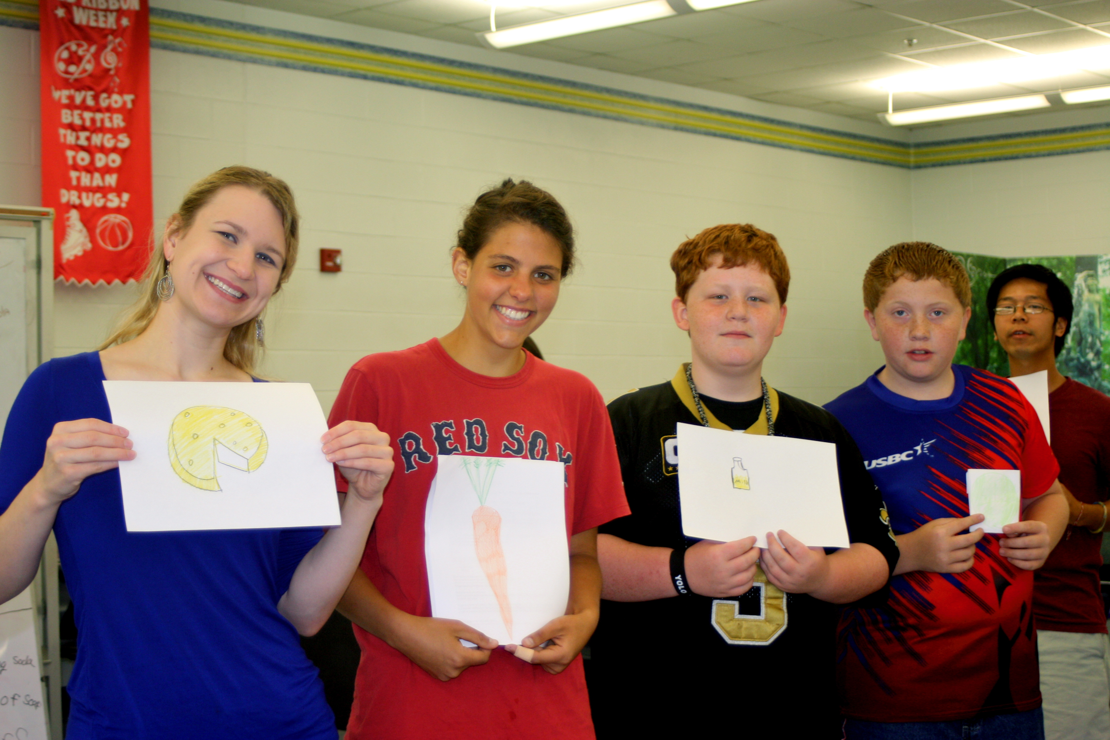
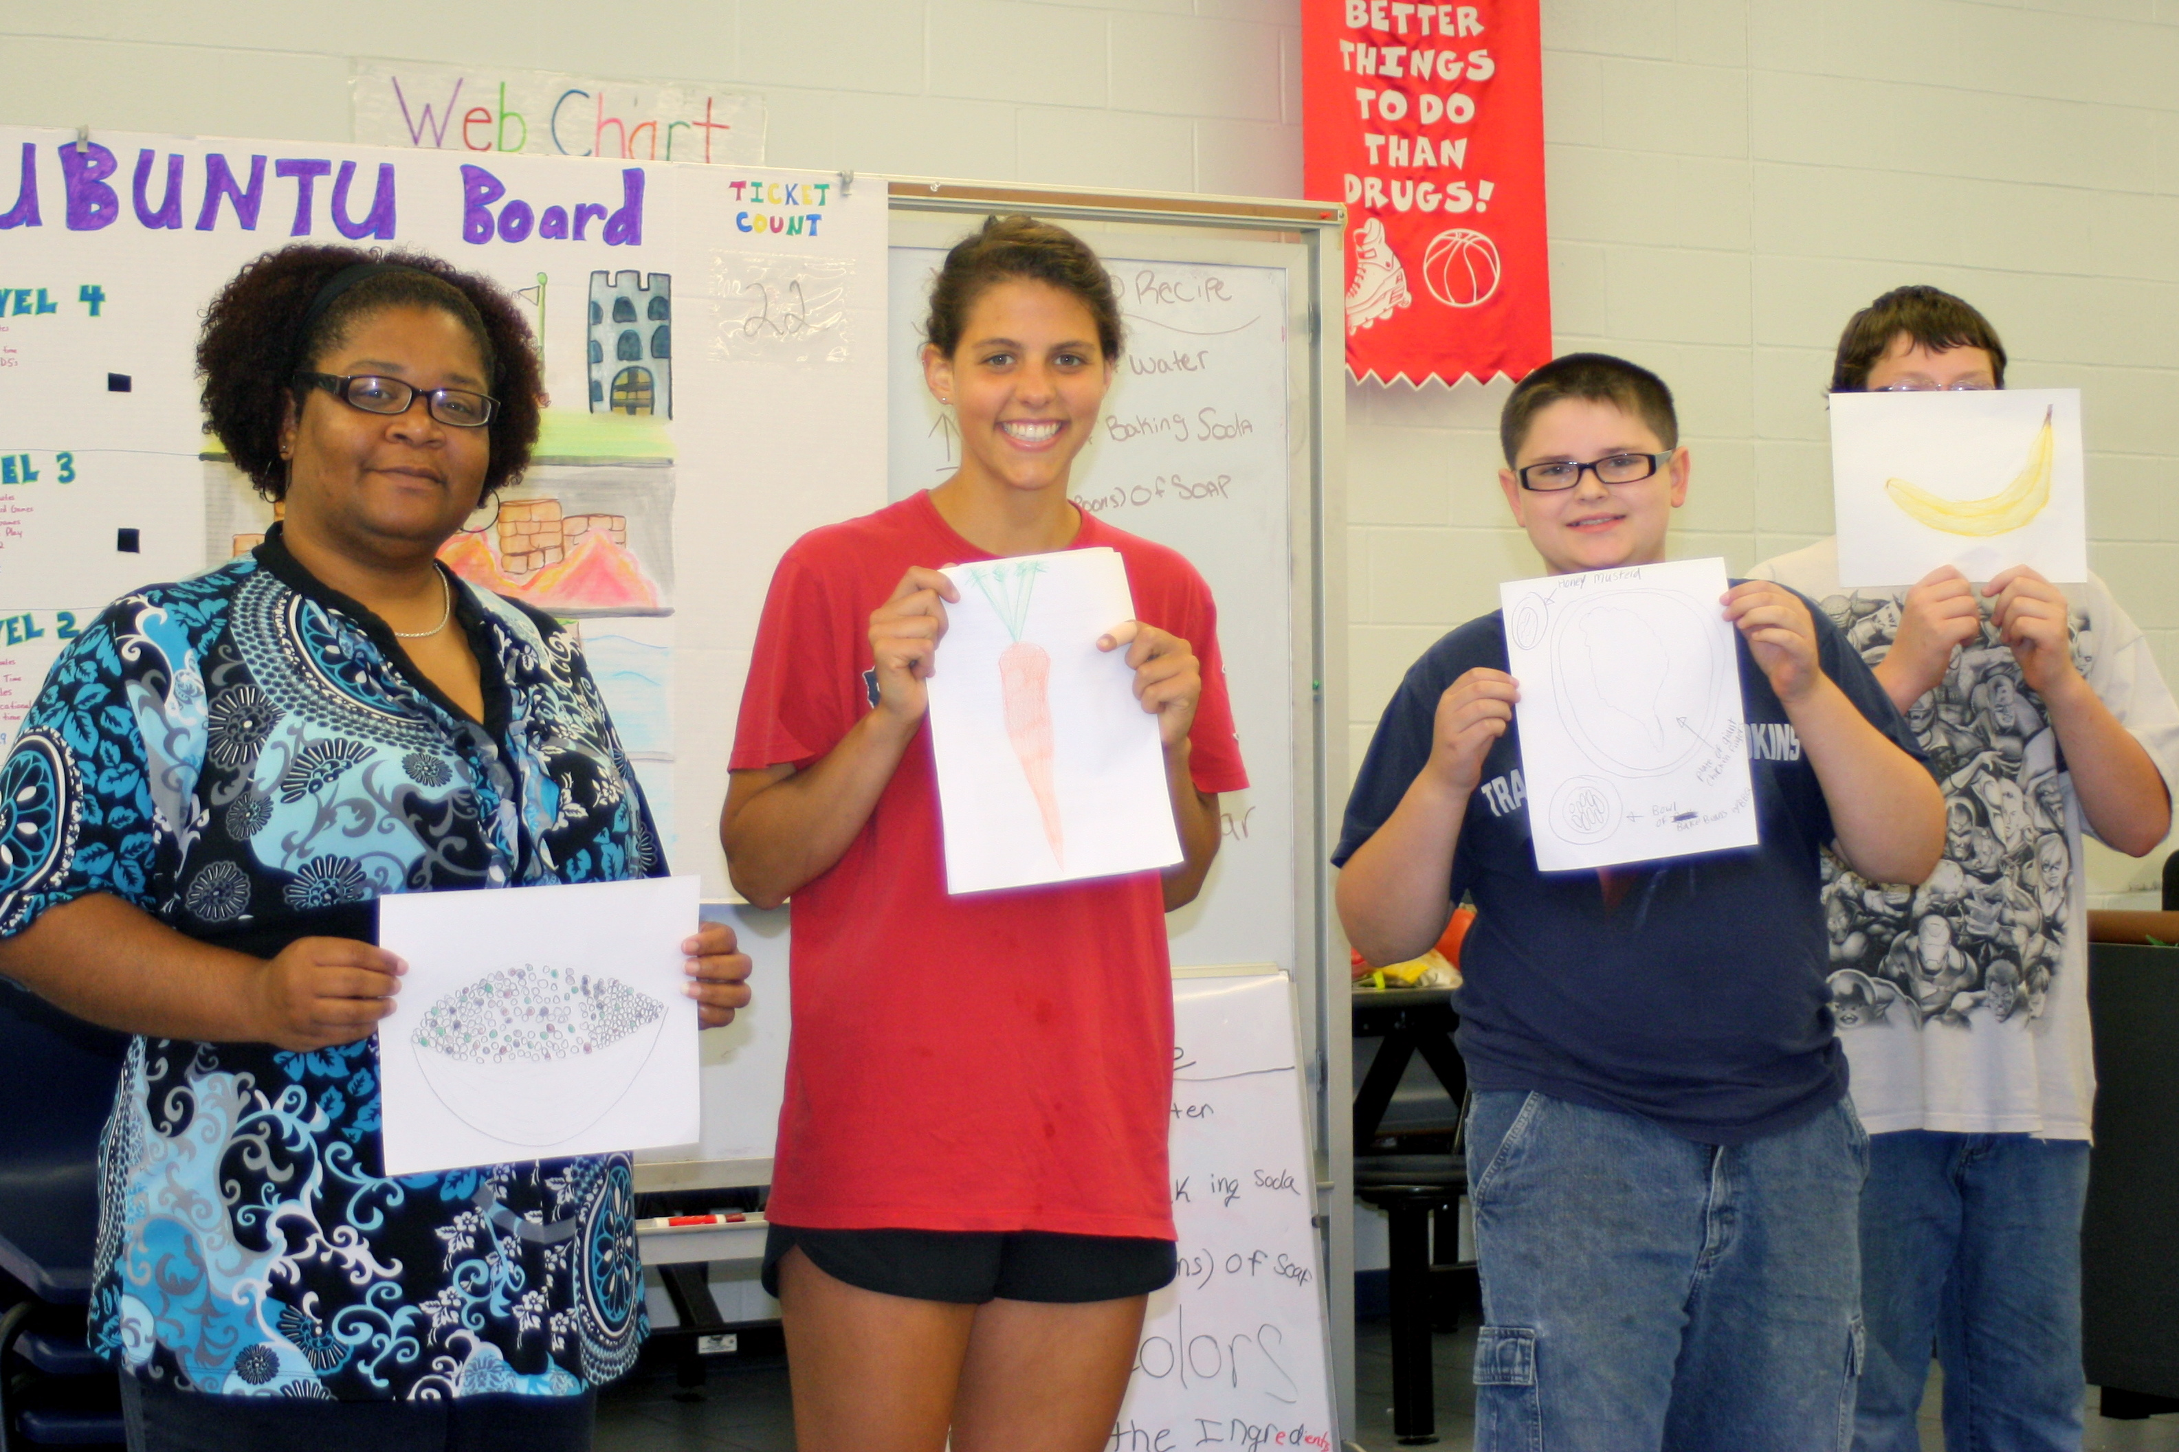
Jimmy, one of the counselors of the program, informed me that many students come from underprivileged families that do not necessarily emphasize nutrition. He believed students were very receptive to decision alley, as it tackled issues with shopping in the grocery store and food marketing. A lot of the students have social and behavioral issues, so getting mobile to learn was an effective way for them to retain the information. Jimmy also said that students were able to learn on their own, as they were making the choices for a meal and to see how to make a well rounded diet.

He saw this through another activity they did later on. Students were asked to build a city given only land, water, and natural resources to start. After my lesson, Jimmy said “it was evident that many of them valued the green space available in their cities in order to farm and make food available, and the ones without markets definitely made that addition.”
Students were learning how to opt out of the corporate food system by creating their own gardens!

After the dietary and nutrition piece we moved into exercise. For this, I decided to teach a little yoga as it could also play into spiritual wellness.

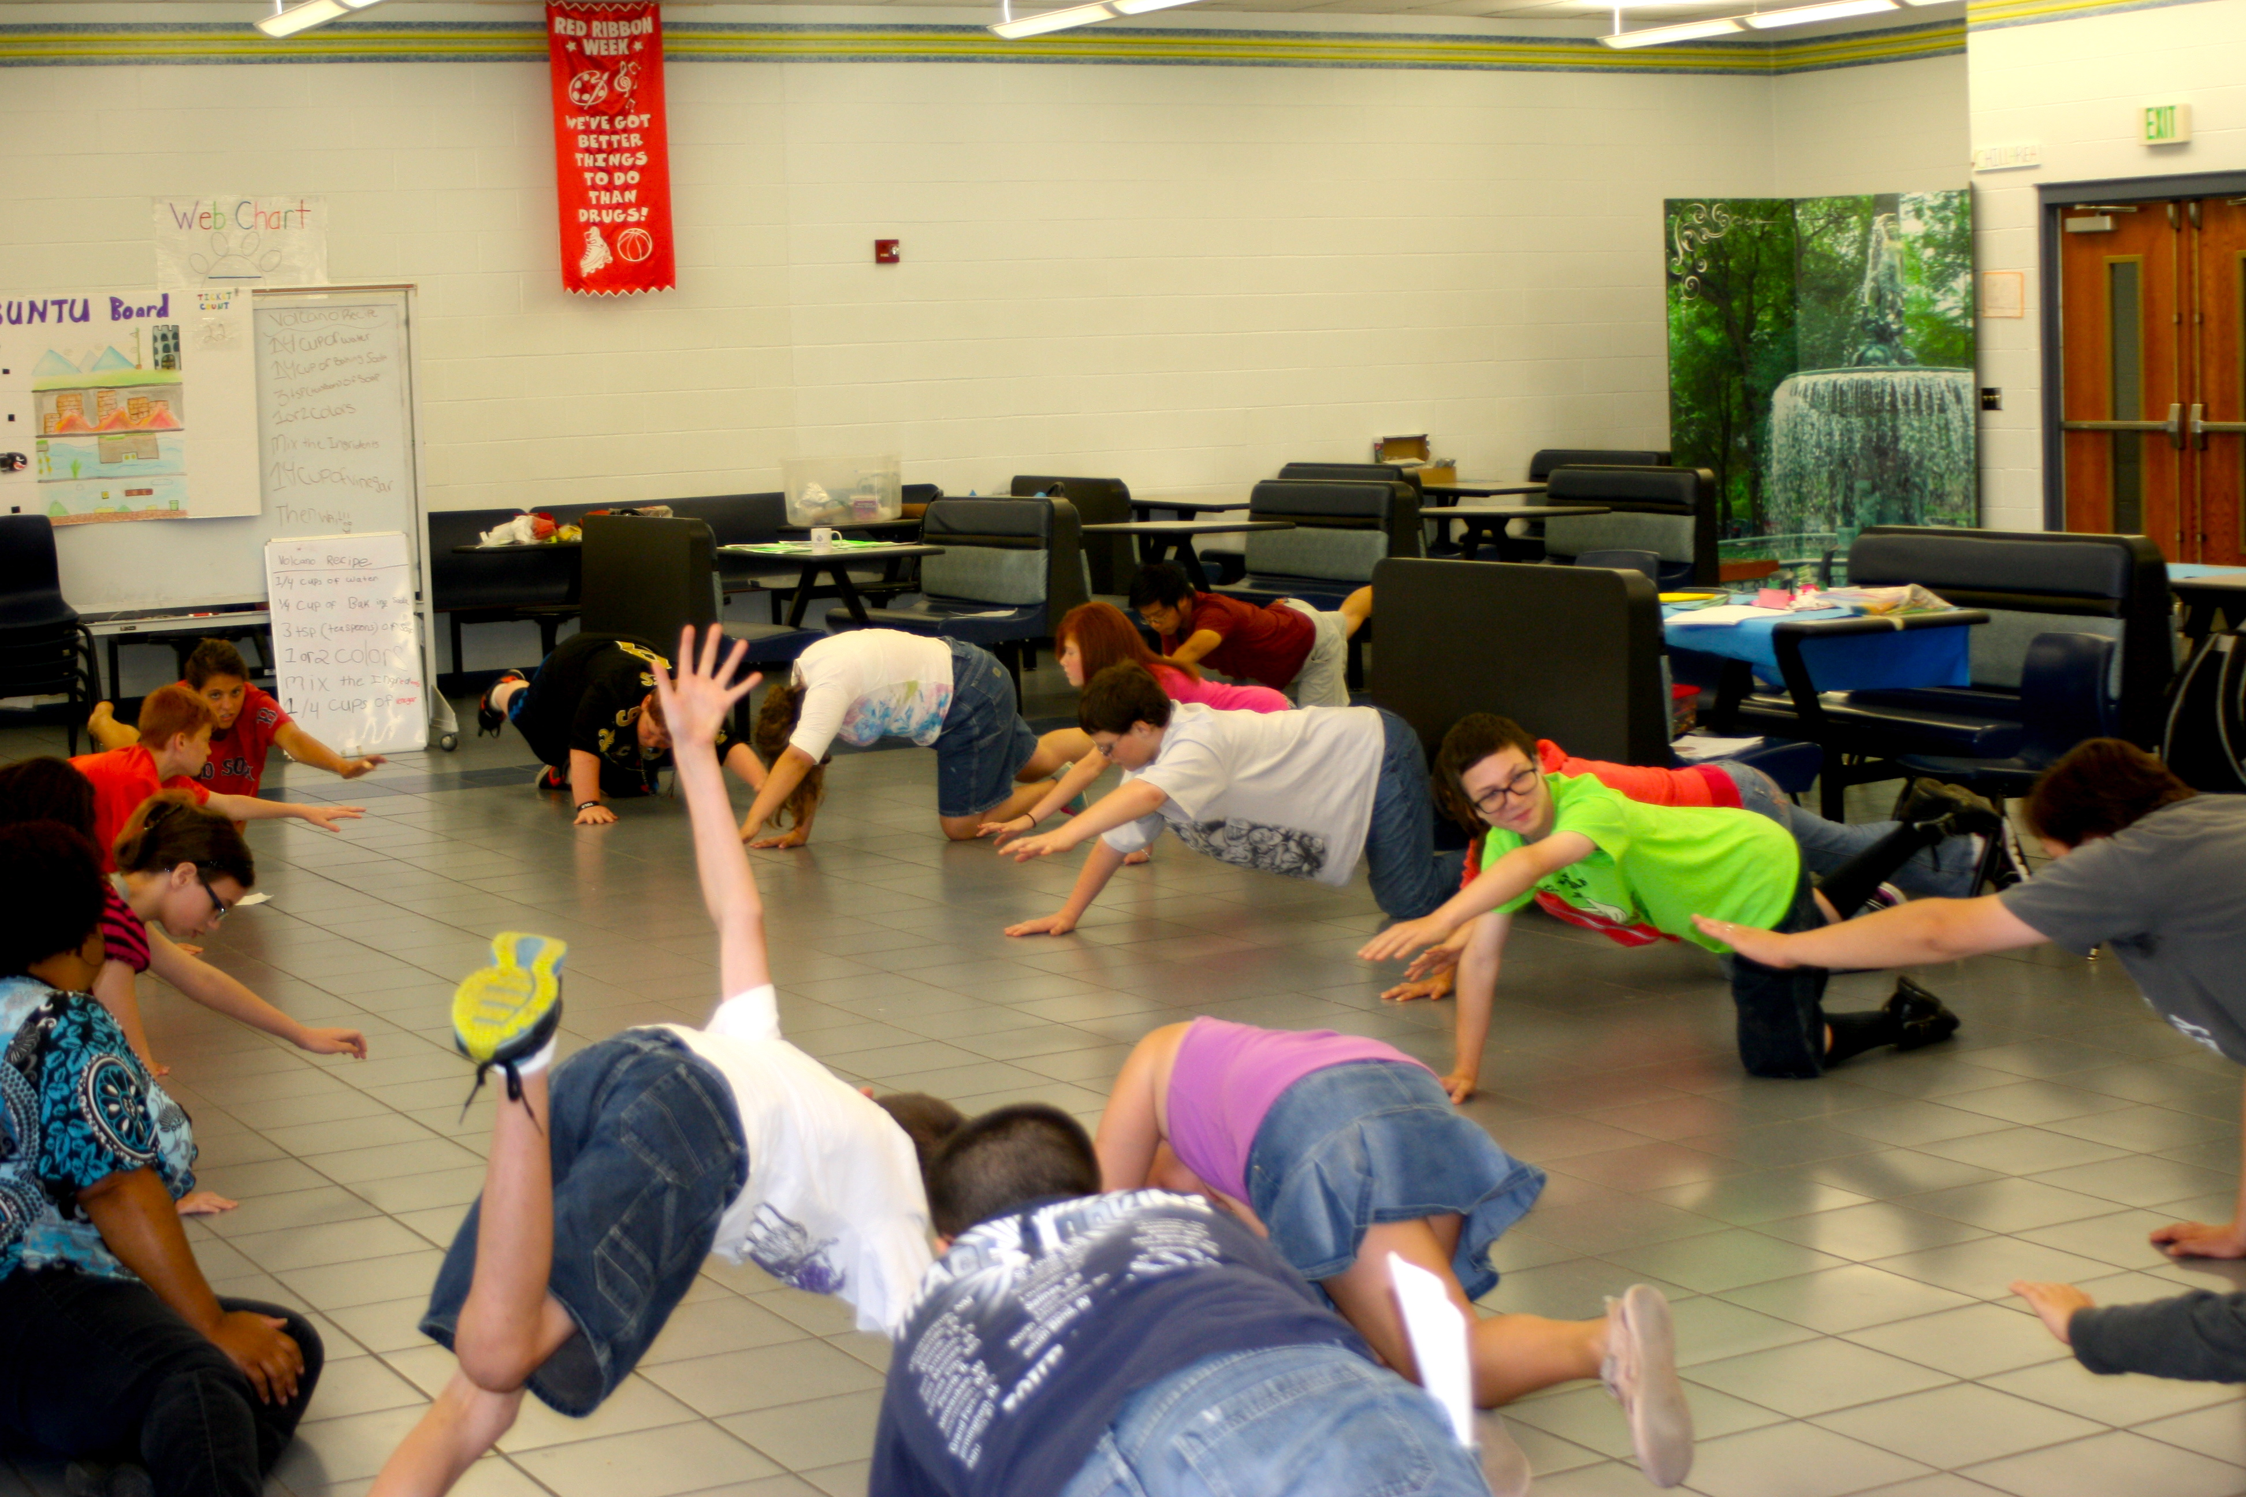

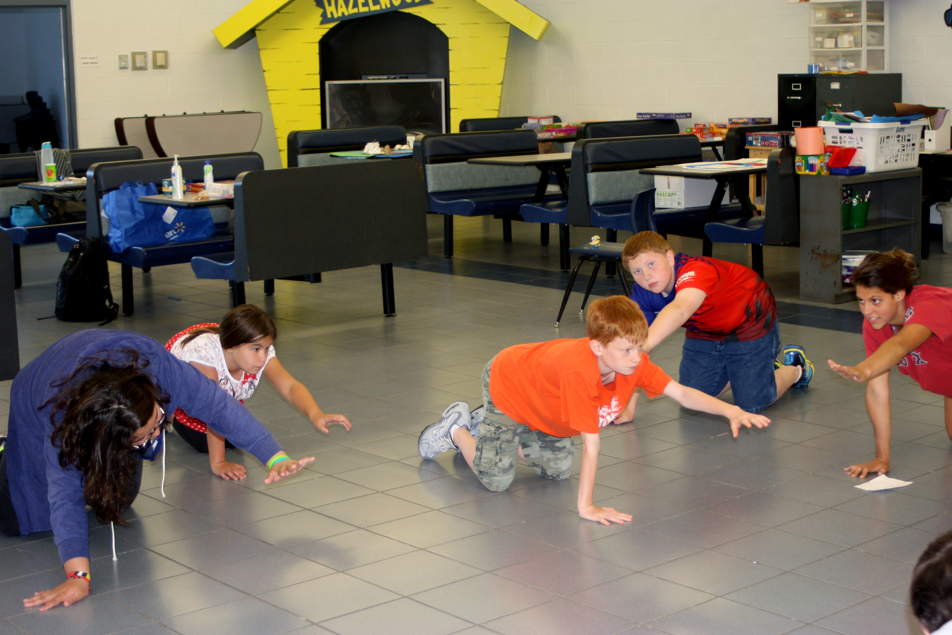

We then moved onto social wellness, where we did an improv activity. This activity aimed to address issues with social gatherings and bad food choices that happen at social gatherings. We had various groups of students go up and plan out an improv scene that takes place at a party. Whenever something bad happens, someone in the audience says “freeze” and goes up to take the place of a character. They can either make the situation better or worse.

Students had to work together to address some of the different unhealthy food pressures that manifest themselves at social gatherings. I found that they were very aware of the healthier choices, and often ended scenes with everyone making a salad—which demonstrates the knowledge of making food on their own. However, this isn’t always the case when parents are in charge of food choices. I hope this lesson gave students the confidence to buy their own food and make their own healthy food choices apart from social and familial pressures.

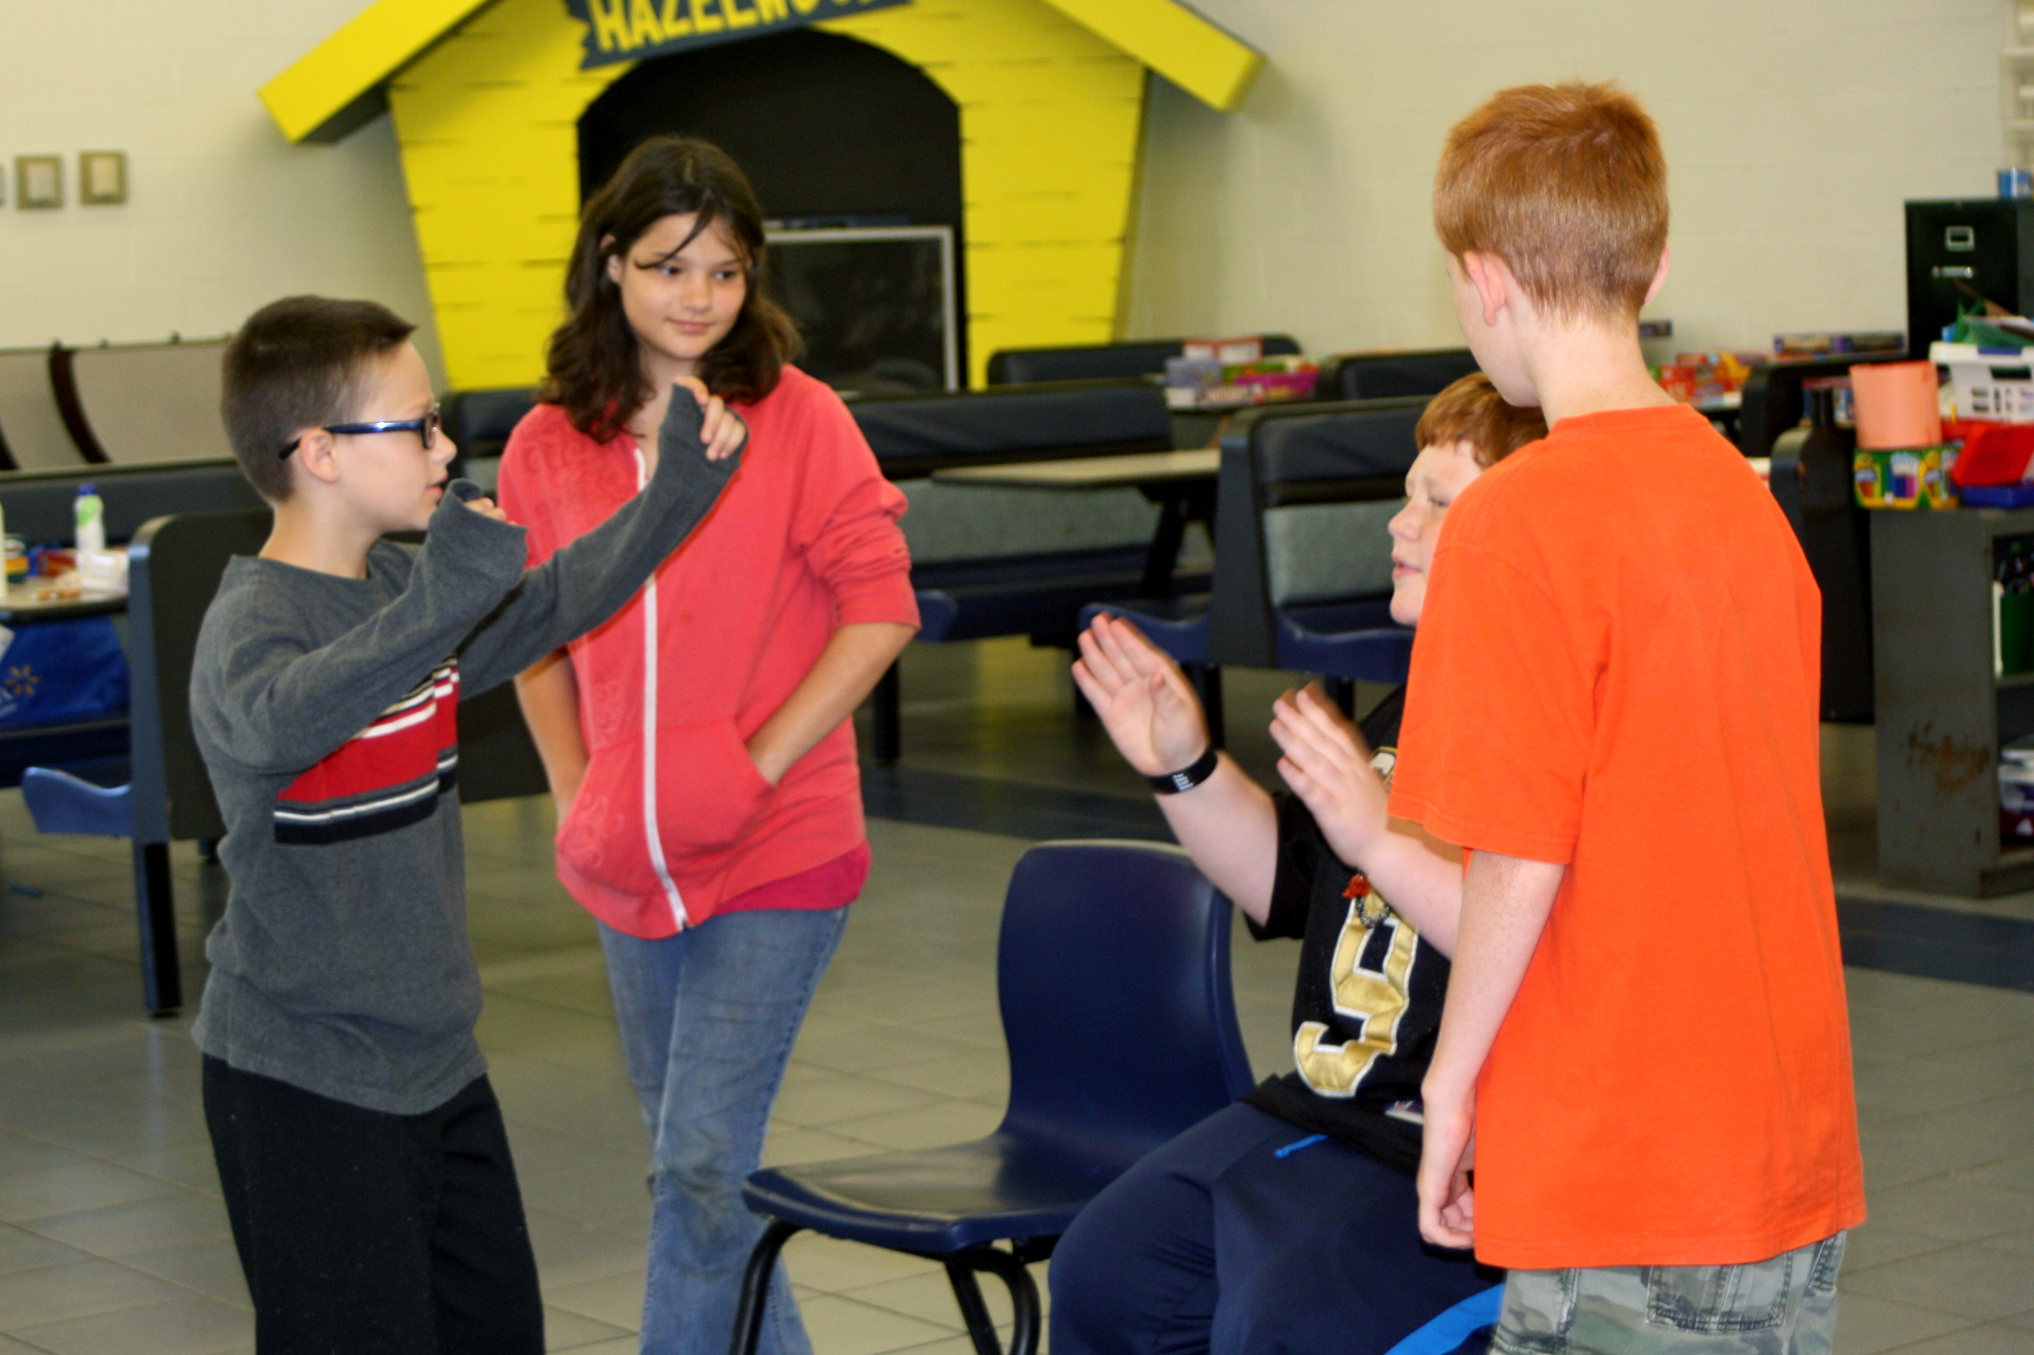

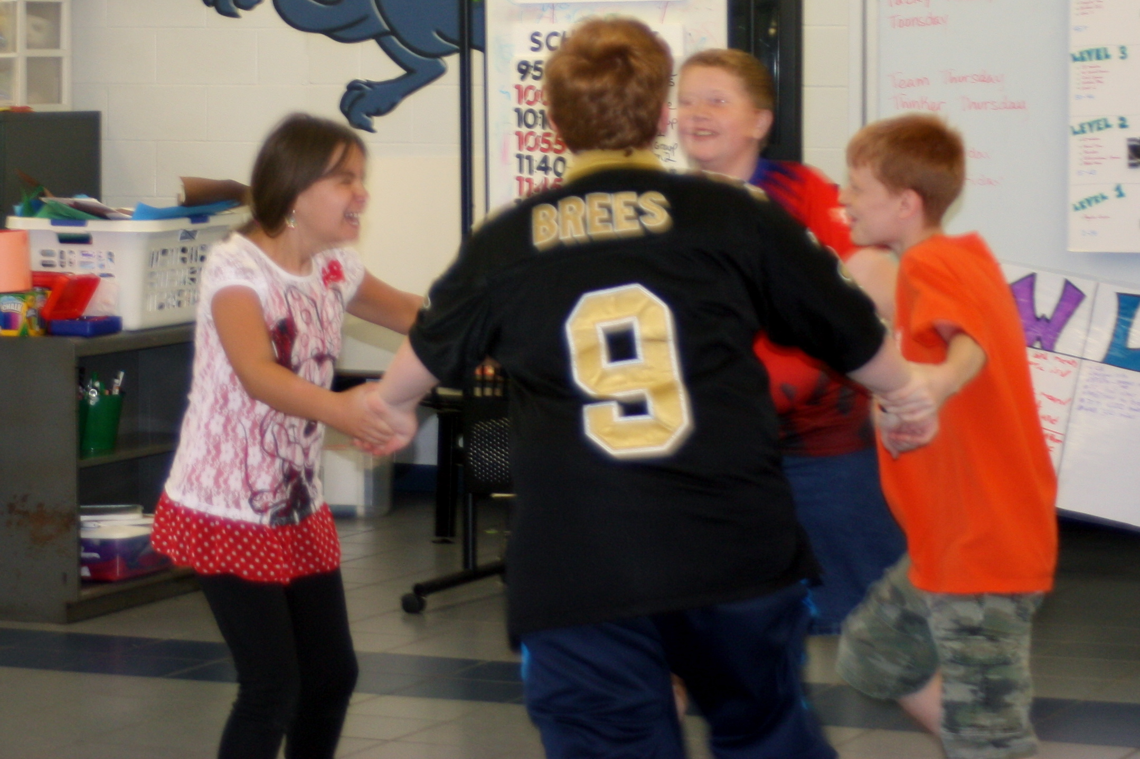

I thought this camp was about drama, and incorporating food and drama was a challenge in itself for me. However, that wasn’t the case at all. This activity was about tackling issues with food and nutrition on a familial and social level and dealt with how to convey this information in an effective educational manner. These students just needed alternative methods to learn about nutrition, food, and the food system. For them, physical representations and social dramas are the best way to learn about these subjects. So it tackled nutrition education from a new lens: drama.

It also challenged existing notions of authority. This activity allowed students to gain autonomy in their food choices. It gave them the time and scenarios to practice taking ownership of their dietary consumption habits. This is the most important thing when dealing with parental pushback. Like Joe’s students said, they just need their space and time to cook without their parents influencing their decisions. This day was like a mini practice round for these students.

It also looked at the local food system in a completely new light: social. We haven’t talked much about the social arena that is food. Louisville has such a strong food community because of the social events surrounding its local food—such as eating out with friends at harvest, getting the entire community involved at Fresh Stops, working together on volunteer work days, and even going to food trucks at Foxhollow Farm. There is a huge social component to the local food movement, one that also requires a special way of acting and one that isn’t always innate for young people. For example—working at FLP I learn that students don’t appreciate farming and consider farm labor a menial job. Therefore, these students were able to practice acting appropriately around food in social settings and learned to appreciate their food. This was a huge accomplishment for this group, as some of them struggle social skills. I would call this challenge the social challenge of local food. How do we participate in the local food arena while also making good social choices?

How can we better address the issue of social pressures and food? Mera also mentioned to me that social issues also created unhealthy relationships with food such as eating disorders. She didn’t know how to tackle this issue, so I decided to think of some solutions to this issue.

I think local is a good way to think about food because it seems to be inherently healthier and tied to community. You can create strong and healthy relationships with food and others by getting closer to your food source and understanding that food is meant for health and should be appreciated in a healthy manner.

