Every piece of clothing we wear — from a pair of everyday jeans, your favorite little black dress, a put-together suit jacket or blazer to a stunning couture dress on a red carpet or a costume piece on stage — comes from pattern making. Pattern making is the art of translating the design of a garment to a real piece of apparel that fits a human body. By either drafting pattern pieces on paper (AKA flat patterning) or manipulating a piece of flat fabric to fit the curve of a human figure (AKA draping), pattern makers are able to create any style and type of garment based on a design.

This past summer, I was interning with the Middlebury College Costume Shop under the guidance of the Shop Director Carol Wood. Starting from the very basics, I learned the drafting and draping skills for skirts, bodices, collars, and sleeves. I cannot go over everything I’ve learnt during the intense eight weeks, but I do want to share a little bit about how I put the skills I learned into use and made a flamenco skirt for a fall faculty show, The Orphan Muses.

All pattern making starts with a design. In this case, the designer is professor Mira Veikley of the Theatre Department. After studying the design Mira came up with, Carol and I decided that the “Spanish skirt” in the script would be similar to a flamenco skirt. Though seemingly complex, the anatomy of this skirt can be broken down to three doable parts: draping a pencil skirt that is used as the core body of the skirt, inserting gores to add volume and flare to the skirt, and layering ruffles on top of the skirt.

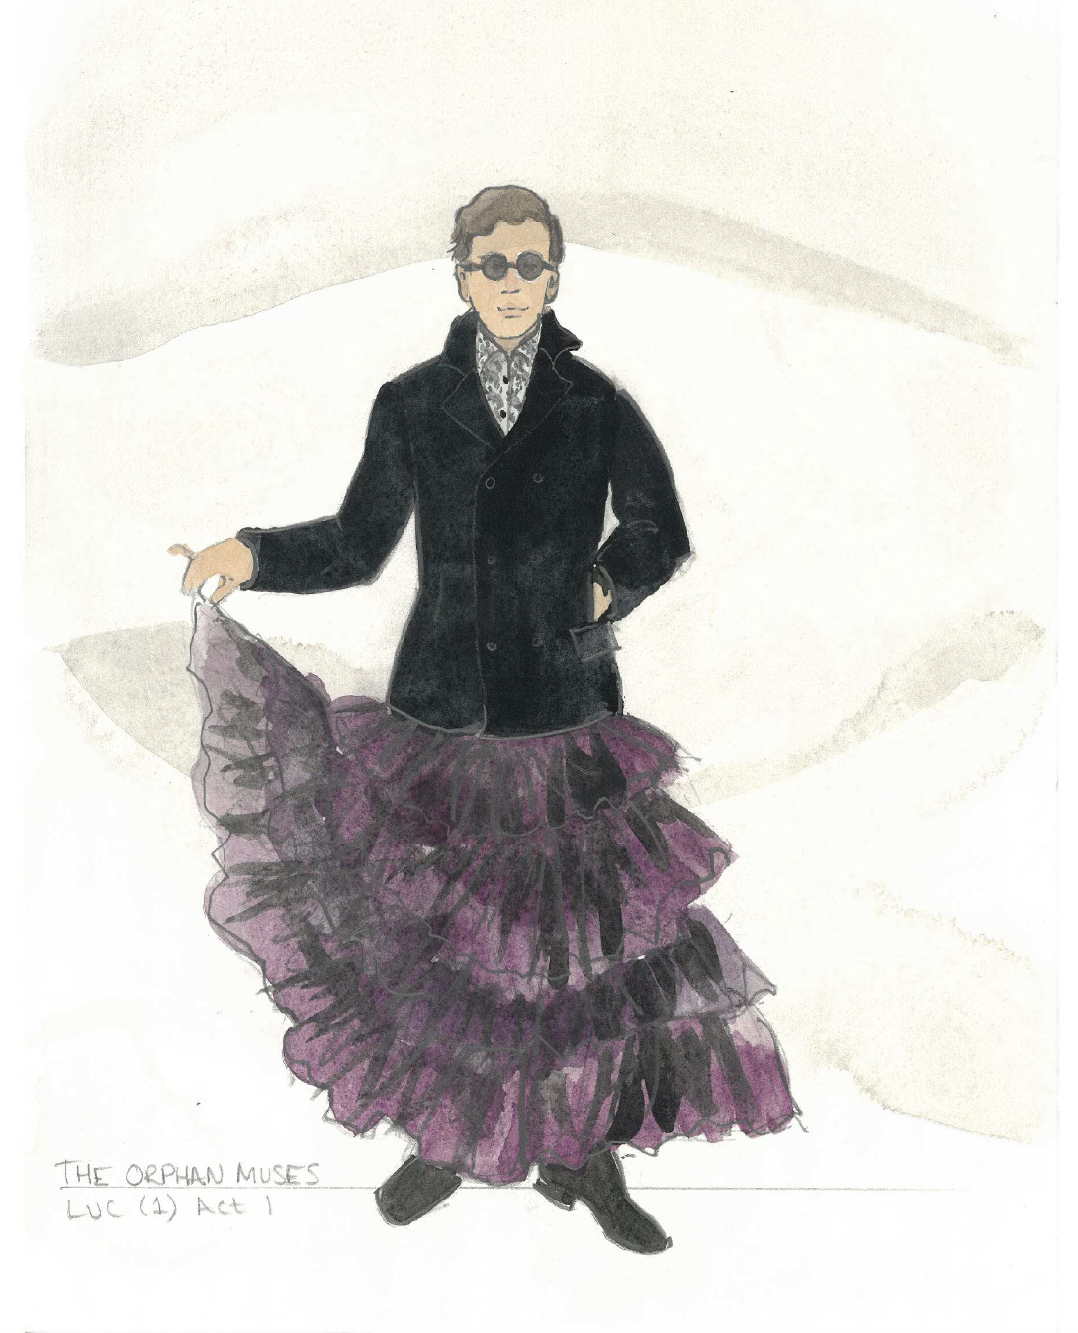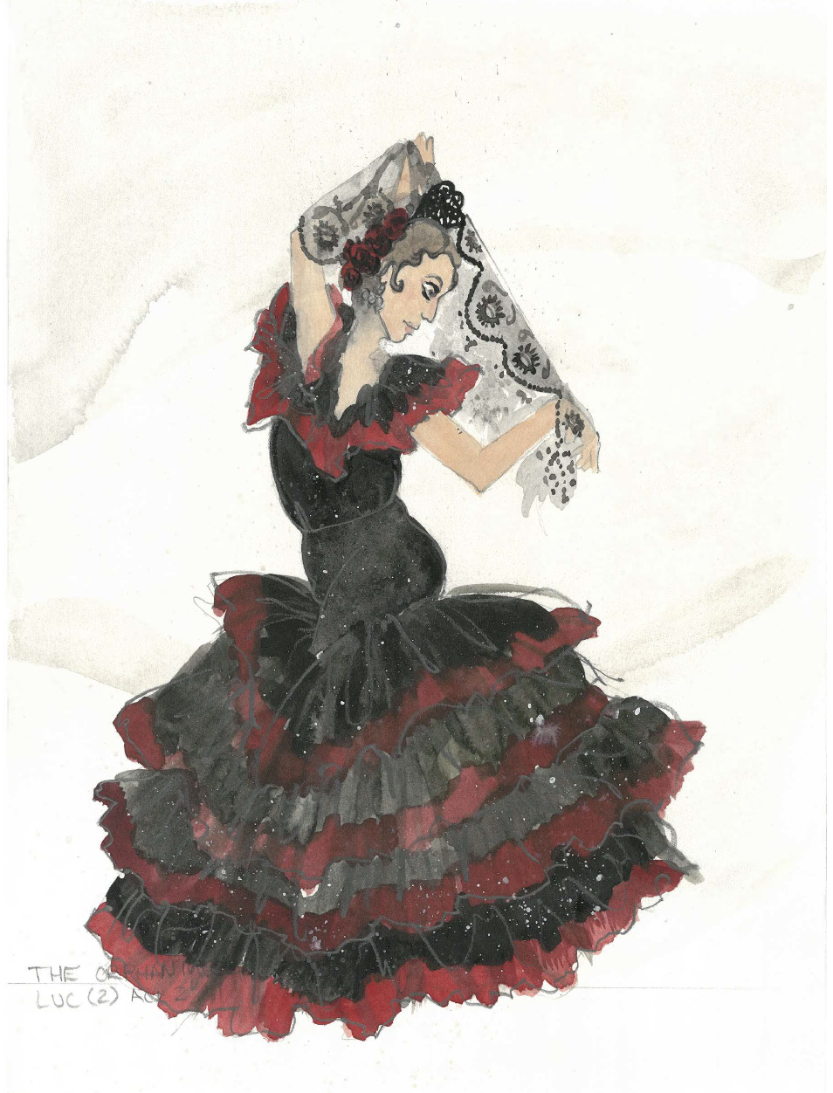
The Orphan Muses, Directed by Cláudio Medeiros, Costume Designs by Mira Veikley for Middlebury Department of Theatre, Fall ’21

Before we started on anything else, the most important aspect of preparation called for padding the dress form, so that the skirt could be draped on to a figure that had the same key measurements as the actor. Because dress forms are mass produced, they cannot accurately represent each individual’s body. For a better fit, the dress form is padded with cotton and shoulder pads to mimic the actual body measurements, especially hip and waist, of the actor who is going to wear the skirt.

I started by draping a pencil skirt because the upper half of the Spanish skirt is tightly fitted to the body like that of a pencil skirt. By manipulating two pieces of muslin fabric in the front and back, I created half of the skirt, which could then be copied for the other half to make a complete skirt. After taking out the darts (folds sewn into or taken out of the fabric to provide shape for the garment), I was left with four pattern pieces for the pencil skirt: center front, side front, side back, and center back.

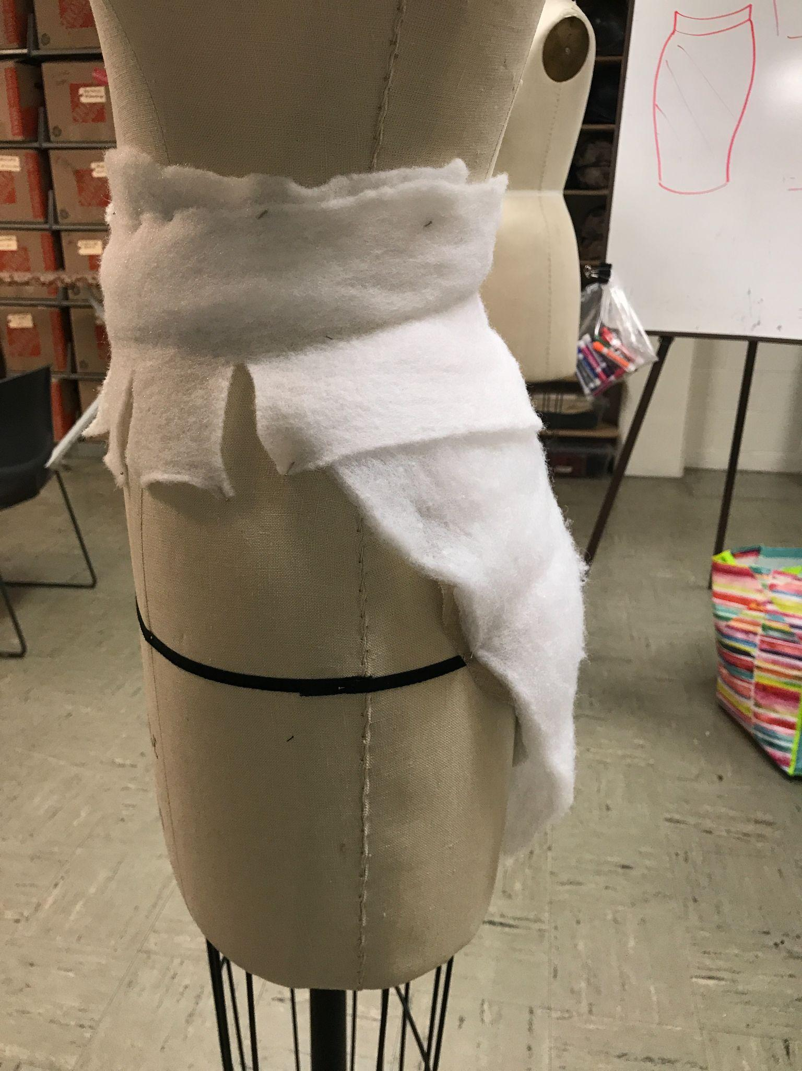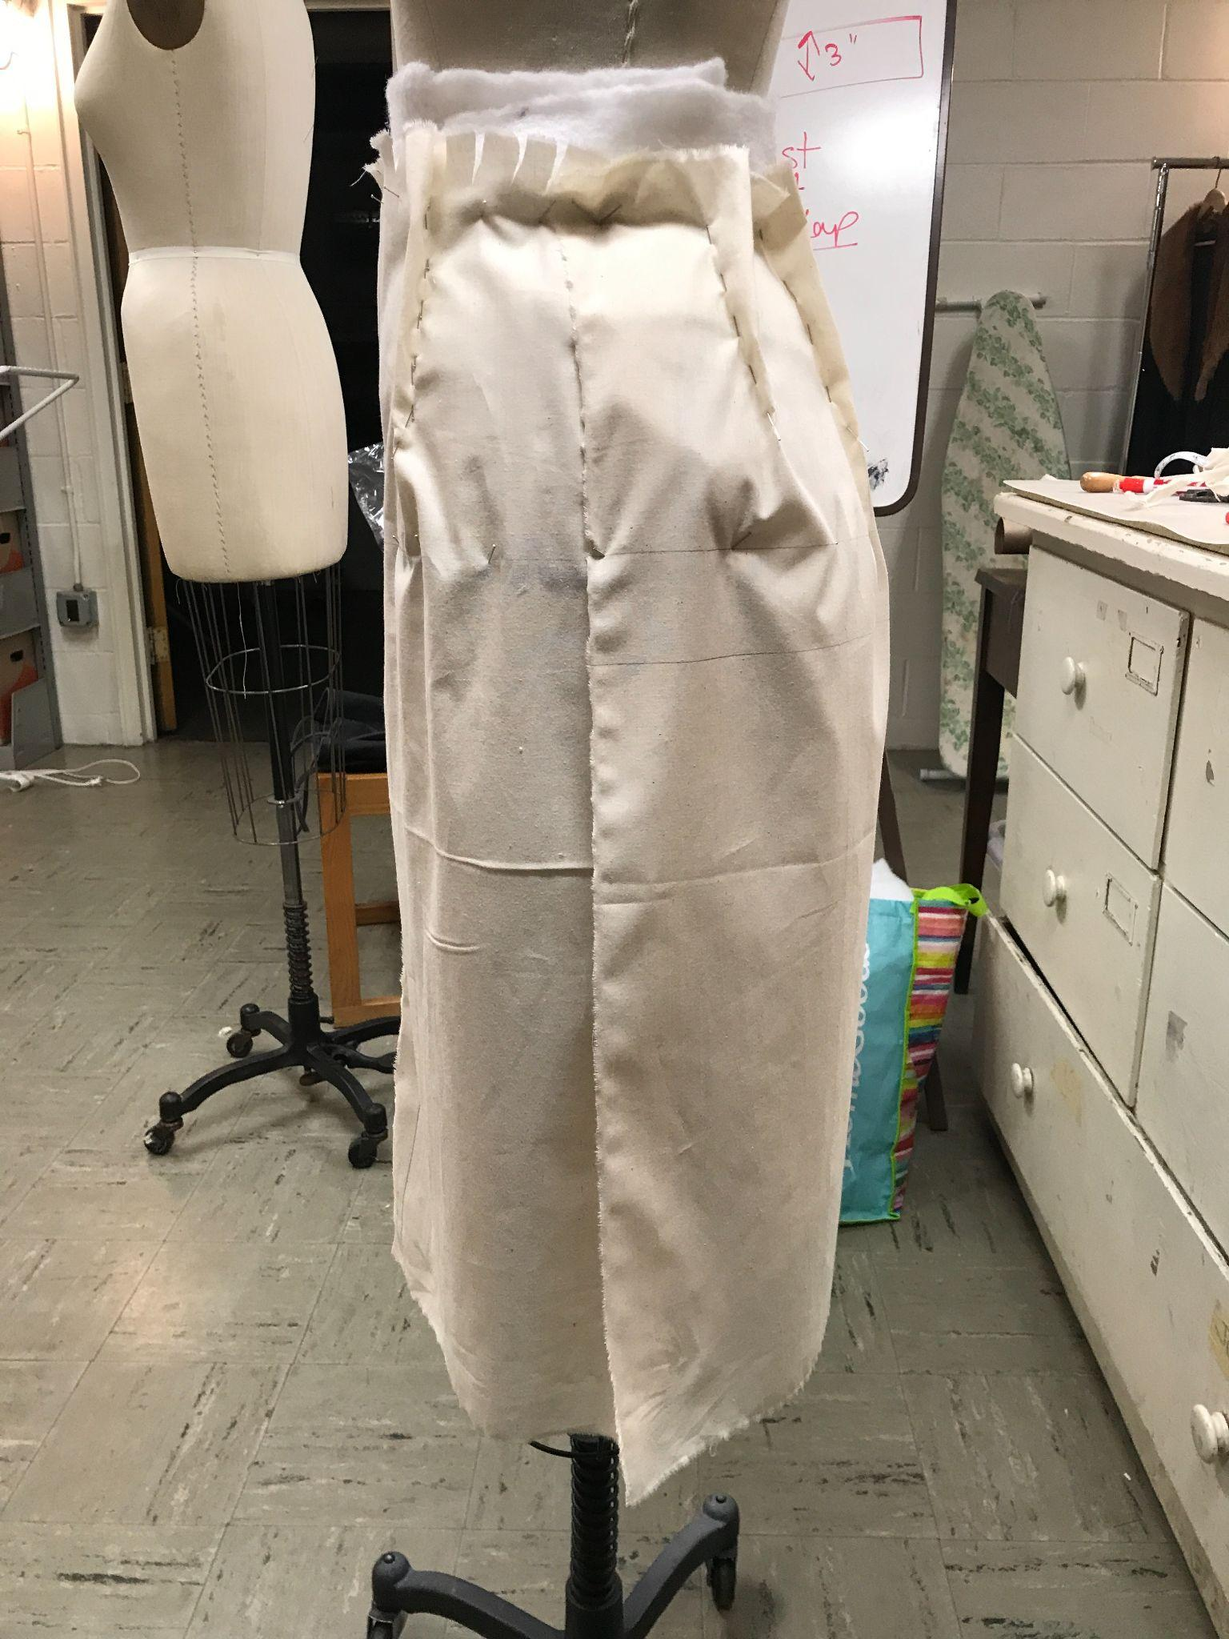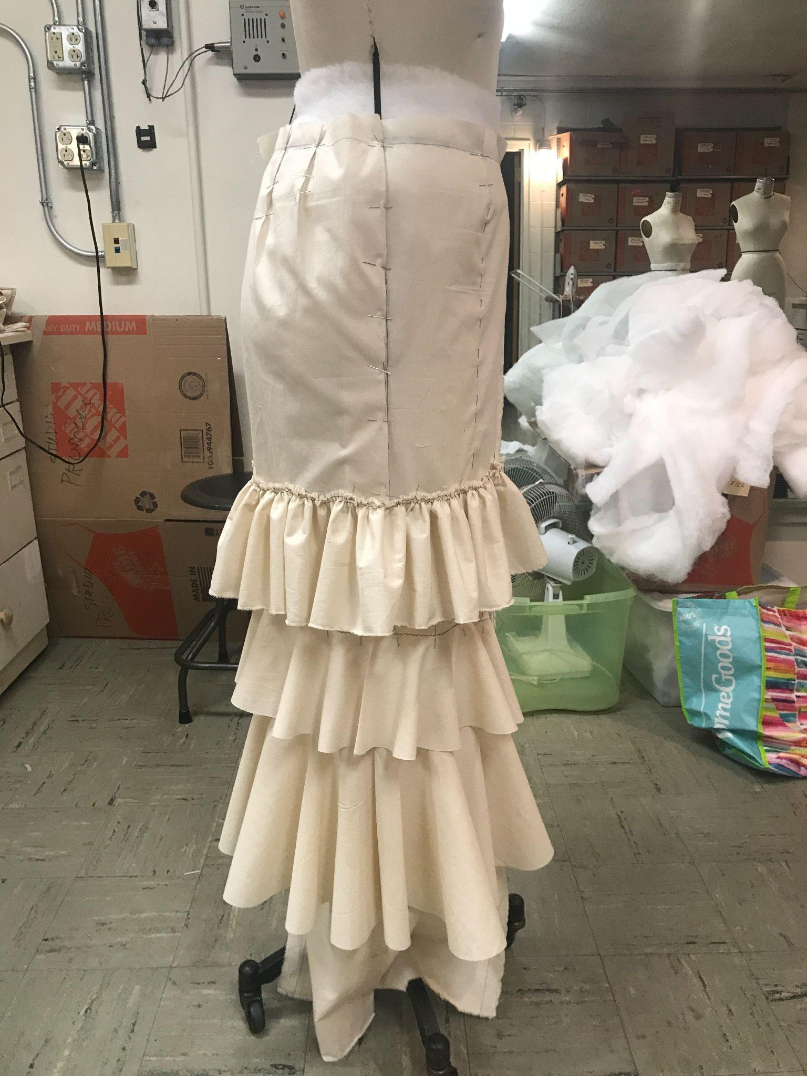

Next, I needed to tackle the ruffles on the skirt. There are two primary ways to make ruffles (as shown below). The first one is cutting fabric into strips, stitching threads to one end, and then pulling the threads to make gatherings. I call the second method “donut ruffles” because the ruffle is made by cutting through a donut-shaped fabric and then opening it up. As shown in the following pictures, the top layer is made by the gathering method, and the bottom two layers are “donut” ruffles. The choice between using either the former or the latter method described is a matter of practicality. Making garments is no more artistic than it is practical. Oftentimes, time and budget can impact design choices. In this case, we decided to go for the second ruffle because it was less demanding in terms of our schedule and looked better on the skirt, though it consumed more fabric than the gathering ruffle.

A gore is a piece of fabric in a triangular shape. Eight gores were inserted into the bottom half of the pencil skirt (one between each pattern piece) to increase the volume of the skirt, which allowed the bottom half of the skirt to open up like a circle skirt.

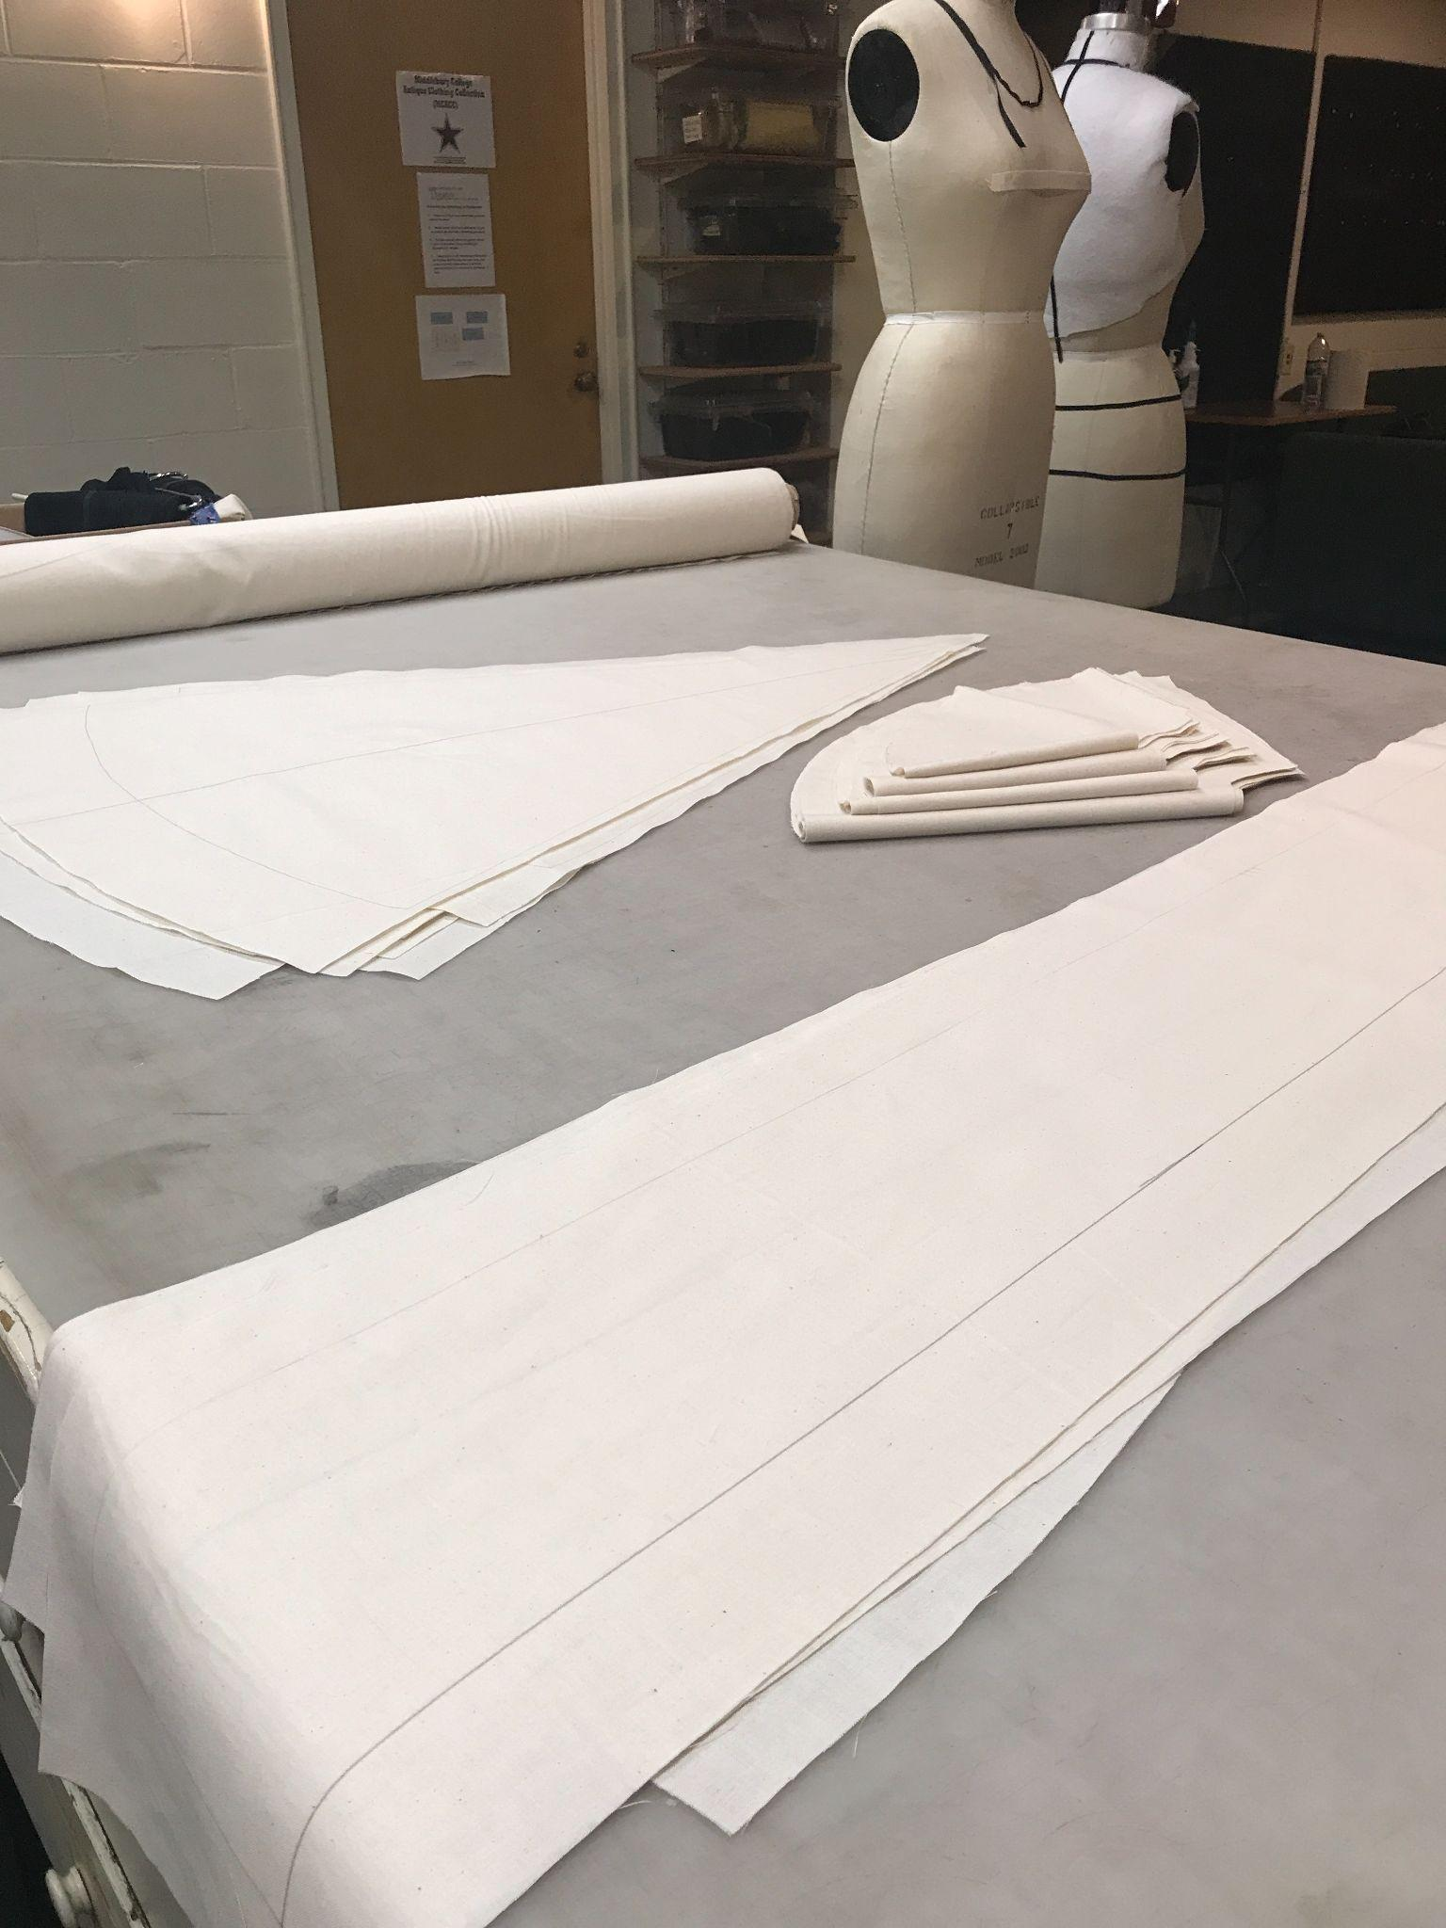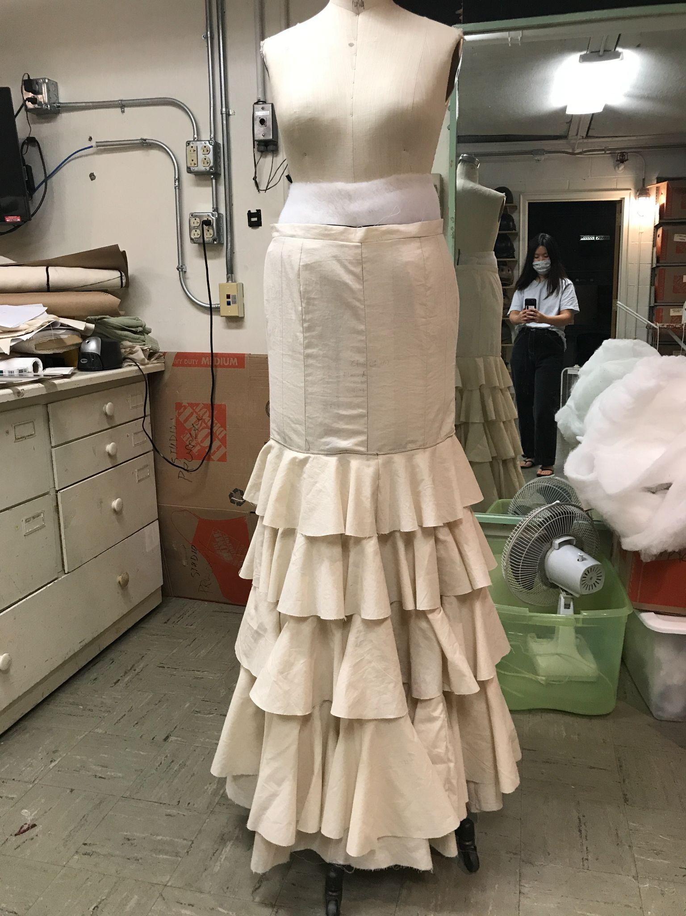

Before committing to actual fabrics, the pattern is made into a mock-up, or sample garment, to test its fitting on the actor’s body. After sewing the skirt’s pattern pieces together, inserting the gores, and layering the ruffles, the skirt was completed by adding on a waistband that helped hold the skirt on the body. This mock-up was then taken to the designer to see if it fits her vision, and tried on by the actor.

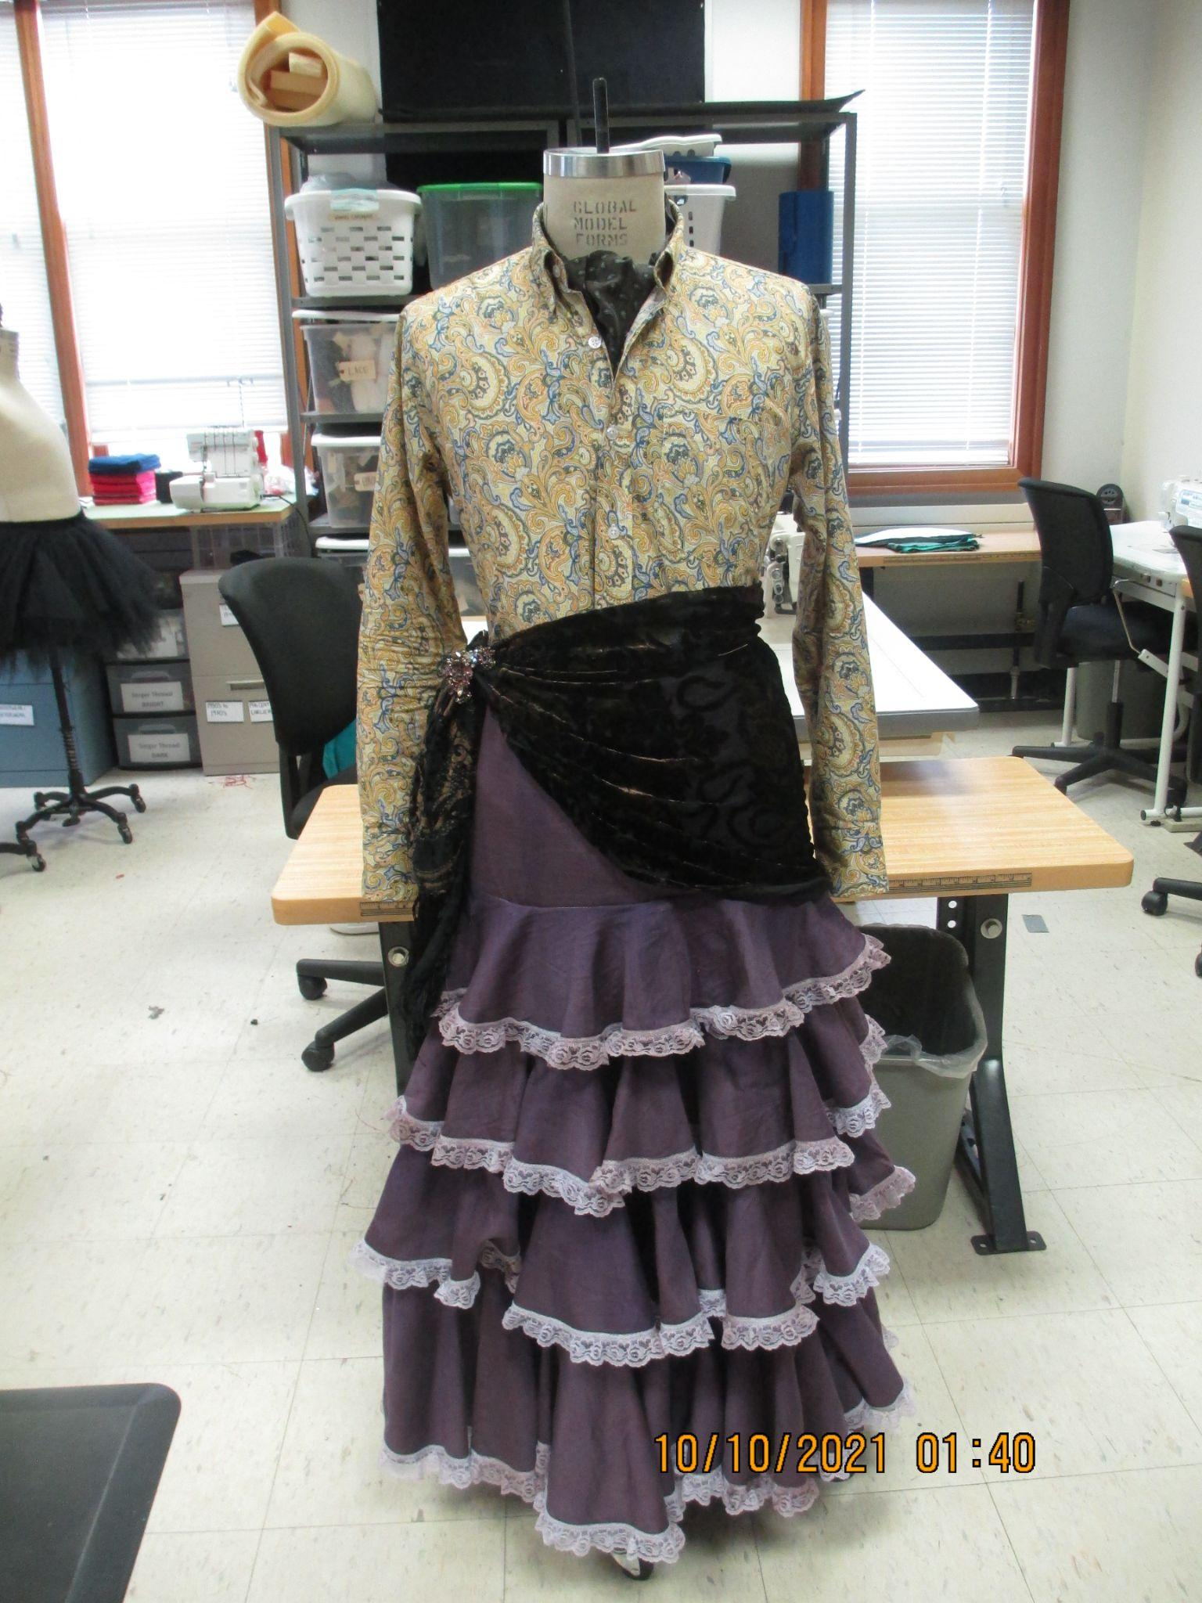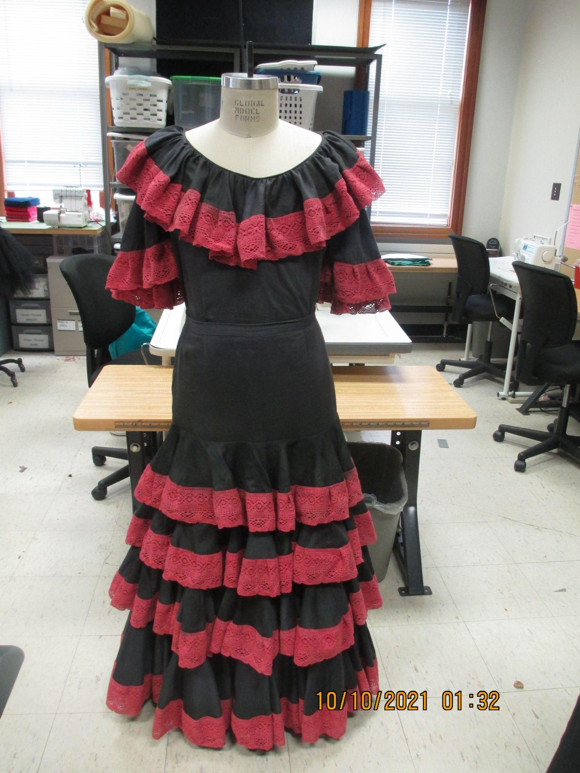
The most thrilling part is of course when the skirt is made into the final fabrics. In the show, the character wore two versions of the Spanish skirt. After multiple rounds of fittings, here were the final products.

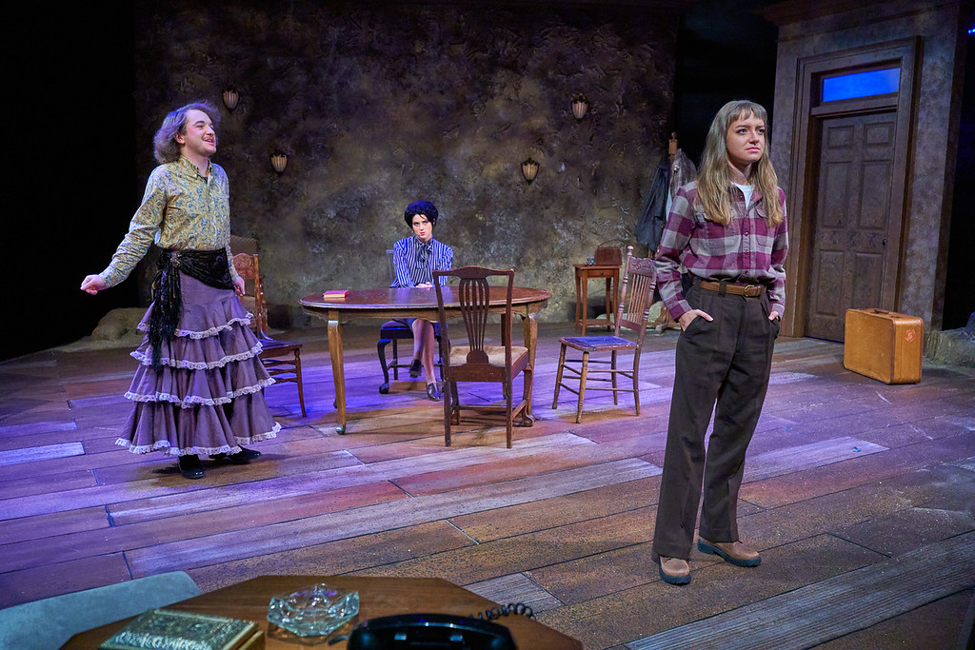
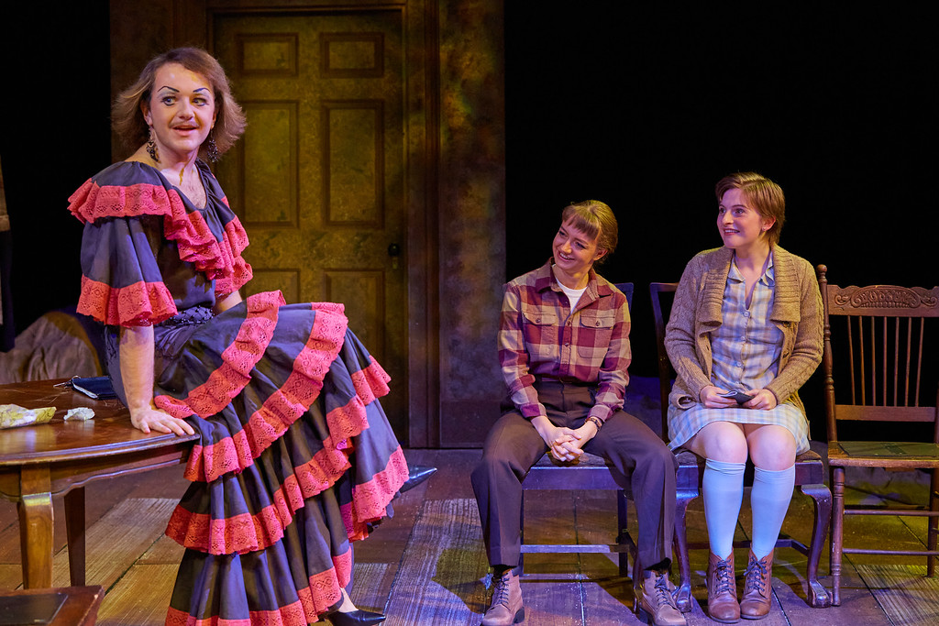
The Orphan Muses, Directed by Cláudio Medeiros
Actors are Jacob Raymond, Masha Makutonina, and Maddison Middleton (from left to right)
Photography taken by Todd Balfour

