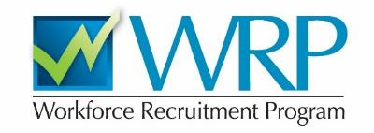
Are you a student or recent graduate with a disability seeking an internship or job?

A WRP Recruiter will be interviewing students from Middlebury this fall!

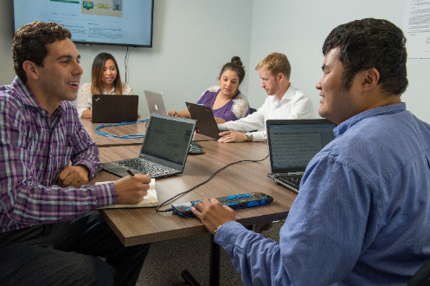

The WRP is a recruitment program for students and recent graduates with disabilities and serves as a primary pipeline for bringing new talent into the Federal Government. Applying is an excellent way to:
- Find an internship or permanent position at federal agencies
- Explore careers in the federal service
- Gain interviewing experience

Register and apply at WRP.gov
For more information, contact:
Tim Mosehauer in the CCI at Kitchel House, 152 College Street
tmosehau@middlebury.edu · 802.443.5105

