Middlebury College Snow Bowl
I’m on skis for the first time since I was like 12, and maybe second or third time ever. I go to school in Vermont now so I might as well learn to ski while I’m here. I look up at the steep slope of the cleared trail at the face of the mountain. I had first seen it on the drive up, about two miles before we pulled into the parking lot. It pretty much goes straight down. I’m intimidated. My buddy tells me that this is Allen, the run the febs ski down at their feb graduation or something like that. All I’m thinking is that there is no way I’m ever gonna go down that thing. Not a chance in hell. Skis still on, I waddle over to the bunny hill on the other side of the lodge.

Located on Worth Mountain, in the Green Mountain National Park, the Middlebury College Snow Bowl is one of the two college-owned ski areas in the United States. The Bowl is about 25 minutes away from the college campus, with ACTR shuttles making multiple trips a day. As such students at the school are afforded the opportunity to ski at reduced prices with easy access. Students make up the entire ski patrol, helping ensure safety and provide medical services on the mountain since 1946. The mountain itself was opened as the third ski area in Vermont with the original log cabin built in 1938. It now stands as the oldest base lodge still upright in the nation. The Bowl is located on land that was originally owned by Joseph Battell, who left it to the College in his will after he passed away in 1915. Since the trails were first cut in 1934, the Snow Bowl has expanded to offering more than 110 acres of terrain across 17 different trails. The Worth Mountain triple lift is the most frequented chairlift , allowing access to most of the trails on the Snow Bowl.

I’m about to hit the Allen run for the second time today. Third week of February and I’ve been skiing for a couple weeks now. I wouldn’t say I really know how to ski, but I can comfortably make my way down any trail that the Snow Bowl has to offer at this point. Lot of fun. I follow a pretty steady schedule whenever I’m here. I take a chair lift up the mountain, choose a trail, and get to the bottom as fast as I can. And then repeat till it’s time to go home.

I’m sitting on the Worth Mountain chair lift about halfway up to the peak, talking to my buddy next to me about some assignment I have to turn in. I look to my left and see the lake, frozen completely solid, with at least 2 feet of powdery snow on the surface. I stop mid sentence, unable to even finish my previous thought. The lake appears to be almost exactly halfway from the lodge to the peak of the bowl. How have I never noticed it before? I didn’t even know lakes could form in the middle of a mountain; doesn’t water accumulate at lowest point of elevation? Has it been there the whole time, I mean how have I never noticed it?

I wanna walk on it.

But how would I even get to it?

Telemark skiing started gaining traction in the United States in the 1970s and 80s after it was reintroduced in the United States in 1971. The ski binding on the telemarks binds the toe of the ski boot to the ski, while maintaining a degree of freedom at the heel. Thereby creating a skiing technique that combines elements of Nordic and Alpine skiing. Supposedly the methodology first originated in 1868, when Sondre Norheim demonstrated the technique in the Telemark region of Norway.

By allowing freedom in the heel of the boot, telemark skis offer a method of backcountry touring that allows the skis to stay attached to the boot while going both up and down the mountain. Telemark skiing started to gain popularity in the United States originally for this very reason. However, the technique has grown to the degree that it is now has an official sports committee and rules for racing as a downhill technique primarily.

The Free Heelers at Middlebury College are “a group of awesome people” who get together to enjoy the free heel life and rent telemark gear to students on campus for free. Finding telemark gear on the East coast to rent is otherwise near impossible, with Mad River Glen being the only ski area that offers telemark rentals in the East coast. Mad River Glen is often referenced as the fulcrum of the telemark community, having a large portion of telemark skiers and often hosts the North American Telemark Organization festival weekend.

I see my buddy doing a lunge on his skis; his heels are clearly not attached to his skis the same way mine are right now. The turn he makes down the hill is more gradual, slower. Peaceful even. Interesting.

My buddy tells me that I’ve gotta try it, and that I can even rent the gear for free from the telemark club on campus.

“Free your heel, free your mind.” I repeat after him.

The Long Trail in Vermont runs 273 miles through the entire state of Vermont, starting at the North at the Canadian-American border and ending at the Massachusetts-Vermont state line. It was first conceived by James P Taylor in March of 1910, as the first long distance trail in the United States. Work began on carving the trail through the Green State the same year and continued until completion in 1930. In addition to the 273 miles of trail that follow the ridge of the Green Mountains, there are over 170 miles of side trails that make up the entire Long Trail system.

I turn right into the woods following a trail sign that points to the Long Trail. I’m still on my skis, with skins at the bottom. This is the first time I have been on such a narrow trail. I hope I don’t have to go down a steep incline with the trail like this. Still though, this is beautiful, trees left and right, snow on the leaves, soft crunch of the snow under my skis. The trail is maintaining a consistent elevation in this part, with little uphill’s and down hills.

The long trail runs straight through the Middlebury College Snow Bowl, with one of the side trails leading to Lake Pleiad. There is no swimming allowed at Lake Pleiad, prohibited by the law. At an elevation of 2150 feet, it stands as the highest lake in Vermont. It remains, however, a relatively well-kept secret, known only to some of those who hike the Long Trail and ski at the Snow Bowl.

These mini hills are kinda fun, narrowly avoided a tree just there. Two signs, one sign points uphill, this other one is blue. Says this way for Lake Pleiad. Nice, thought I was gonna have to go all the way to the top and then try and find the lake. Guess I will just go this way instead.

Is that a little creek? I come to a full stop. This is gonna be a little tricky with the skis on.

Skis parallel to the stream, one ski on each side of the creek. One step left. Dammit, stepped into the stream with the right ski. Hobbes is pissed. Good thing it was a shallow creek.

Calvin and Hobbes, the daily comic strip, is often referenced as the last of the “great newspaper comics”. Running from 1985-1995, the comic has had broad and lasting influence in American culture. With 45 million copies of the Calvin and Hobbes books being sold, the vast majority of Millennials are familiar with the iconic comic.

The freeheelers at Middelbury College rent out a pair of black diamond telemark skis with alpine touring telemark bindings. The alpine touring telemark bindings allow the skier to switch to alpine touring mode, which give the heels complete freedom from the ski, thereby making it even easier go uphill with the skis on. The freeheelers have Calvin written across the left ski, and Hobbes written across the right ski. Calvin and Hobbes are known to be some of the most fun skis that the telemark club at Middlebury rents out.

Is that the lake? No way I’m already here. I move through the trees a little more.

Snow really makes everything prettier. Goddamn. This is beautiful. Kinda crazy that this is my first time at this place considering how many times I’ve passed it over the years.

Should I walk on it? I take of my skis and walk out maybe 30 meters, not quite to the center of the lake, but close enough. I’m not trying to fall through the ice with my ski boots on.

I’ve just been sitting on this rock looking over the lake for like 20 minutes at this point. Without a doubt the coolest place I’ve perched at in a while.

I could stay here all day if I had brought enough snacks, but the time has come to head down to the parking lot. I could make my way back through the trail that I took on my way in. Or I could see where this kind of a trail in the opposite direction takes me.

What are these blocks doing here? I’m still on my skis, and the “trail” is definitely not a trail anymore. Whatever, my sense of direction will take me back towards the car, and I can see where the woods end at this point. This next part is gonna be really steep though.

Made it to the car with all my limbs intact. I grab a map from the lodge to take another look at the trails I had taken. Apparently the path I had taken coming down from the lake is marked off as the “closed area”. Sweet.

In addition to the Middlebury College Snow Bowl, the College owns the Rikert Ski Center, as a sort of counterpart to the Snow Bowl offering terrain for Nordic skiers and snowshoers of all levels. Located at the Bread Loaf Middlebury campus, the Rikert Ski Center offers 55km of terrain to tour. As one of two ski touring centers in Addison County, it offers an easily accessible location and causal atmosphere creating a location for people in the Community and College to come together and enjoy the outdoors.

Located in the center of the green mountains, the Rikert Ski trails are also connected to the Catamount cross country ski trail, which currently stands as the longest back country cross-country ski trail, running the entire length of Vermont. The 300-mile long Catamount trail, not officially completed until 2008, is said to be the “younger, quieter and cooler” sibling of the Long Trail, both traversing the entire length of Vermont.

I ask my roommate if he wants to go on a backcountry skiing trip this weekend at Mansfield. His response is that his girlfriend is coming up for the weekend and he can’t. Instead he suggests we get some guys together go on overnight camping trip tomorrow night somewhere.

Maybe two hours have passed since my roommate went up back up to his room. Apparently he’s been doing some research. He shows me a link to make reservations to stay at an overnight lodge at the Rikert ski center. Less than two miles from the parking lot, we come to the conclusion that it shouldn’t take us more than an hour to hike up to it at night with snowshoes.
We grab all the necessary gear for the trip from the gear room the next day, and head out with two other buddies from the house. We pull into the parking lot at RIkert just before 9 pm.

In December of 2016, the Middlebury College opened the Burgin Lodge at the Rikert Ski Center in honor of Ian Burgin. Before the decommission of the Worth Mountain Lodge in 2011, Burgin saw the Lodge as a place students could escape from the institutionalism and pressures at the college to enjoy the landscapes and tranquilities found in the Green Mountains. During his time at the college, Burgin was known as a handy craftsmen and avid outdoorsman who worked hard to preserve the lodge at the top of the Snow Bowl for use by the students and the community.

The Burgin lodge was put forth by the Burgin Lodge Team (Phoebe Howe ’15, Jack Kerby-Miller ‘14.5, Larson Lovdal ‘16.5, Sarah Kaelin ‘15.5, Joseph Mutter ’15), with the intention that it would serve the same functions as the Worth Mountain Lodge had. Furnished with a woodstove and plenty of pre-cut firewood, it is said to be glamorous by any backcountry cabin standards. With ACTR shuttles multiple times a day from the Middlebury College Campus to the Rikert Center parking lot, it is easily accessible to any student or member of the Middelebury Community with or without a car. From the parking lot, it is less than a two-mile hike to the cabin, but it is still highly advised to leave at least one hour of daylight after the arrival at the parking lot to find the cabin.

I really don’t like snowshoes. This is my first time snowshoeing and I already know I’m never doing this crap again. They just keep falling off. And why did I bring so many clothes. I have three different heavy layers of clothing draped over my shoulder right now and I’m way too sweaty to try and put any of them on.

Goddamit, my snowshoe just fell off again. I can’t see anything. Where is this damn cabin?

Not to mention I’m carrying bongos as well on top of all this other crap. The idea was that it would be a 45 min, maybe an hour walk to the cabin and then we could chill out and play some music around a campfire. At this point I just want to get some sleep.

The map tells us that the cabin is in front of the trail intersection, but not directly on any trail. It should be 30 meters or so in the wooded area. So for the past hour or so we’ve been going in out of the trees in twos hoping to maybe find the cabin. No luck.

It is well past midnight. We’ve been going back and forth around this rock formation for almost an hour and half. We all reconvene. I’m exhausted, and should’ve brought more water. Time to make our way back to the car.

The trail we’re on does a big loop that starts and ends at the parking lot, so we can just continue along the direction we came from to get back to the car. We continue down along the trail. This is lame; I feel like finding the cabin shouldn’t be this hard.

“I found it!!”
“What, where?”
“Right there! Do you see that little flickering light?”

I look to where h’s pointing. I see a little fire burning…and then there it is. The cabin suddenly comes to view; it was less than 40 meters away. How did we miss it? Nighttime in the backcountry is very different. Even with headlamps on.

This fire is nice. Just woke up from a strangely deep slumber considering the hard floor I slept on. No time to make breakfast. Granola bars, what’s left of the trail mix and go. Gotta get back to Midd in time to get these kids to class.

Ha. The trail mix my buddy spilled made a nice pattern in the snow overnight. I can see the parking lot from here.

Mt. Mansfield stands as the highest mountain in Vermont, with a peak that rises to an elevation of 4393 feet. In combination with the secondary peaks, the mountain is said to have an appearance of a human profile, with a distinct forhead, nose, lips, chin and Adam’s apple. As such, each of the peaks are referred to as their role in the human profile. The summit for example, at 4393 feet, is referred to as “the Chin”.

Mansfield is known as having some of the best snow in the northeast and the oldest ski trails in the country. The Teardrop trail was cut on the west side of the mountain by the Civilian Conservation Corps of Vermont in 1937. A 3.6-mile in-and-out trail summiting at “the Nose” of the mountain, it is meant to be skinned up and skied back down to the Underhill State Park parking lot. The name is said to have been derived from the tears that develop from the skier’s eyes on the trail. Whether those tears come about from the speed while coming down or the grueling hike up is not entirely clear.

Skiing in the East once proclaimed it to be “one of the most thrilling trails in the East.” People from all around New England devote an entire day to this one trail. People from Quebec will often even make the trip across the border after a heavy snowfall to get one run down the incredible snow the trail has to offer.

My buddies are all super flakey. We had planned to try and do over-night ski trip on Mansfield and stay at one of the cabins at the mountain. Instead I’m driving out right now solo to Mansfield for a day trip on the Teardrop trail with only Calvin and Hobbes to keep me company. Oh well, maybe the hike will be more interesting this way.

Oh wow, that’s a big ass mountain. Maybe venturing out solo on my first backcountry ski trip wasn’t the best idea.

I pull into the unpaved road. The further up I go, the better the snow gets. The mountain got about a foot of snow these past 2 days, and the powder patches clearly here at the bottom of the mountain.

The teardrop trail is not marked, I think I read somewhere that this is to help reduce traffic on the trail. I see ski tracks leading off into what looks like may be a trail, I turn into the woods to start the hike. Another kid on skis passes by me but stays on the road. I ask him if this is the start of the teardrop trail.

“Nah man, not sure what that is. I remember it further up the road. I’m gonna take it so you can just follow me. ”

Damn, that was close. I get back on the road and follow him to the trail. He’s moving a lot faster than me so by the time I actually start the skinning up the trail he is already out of sight. No marking, signs or nothing indicating a starting point. Just a cleared path in the woods with a bunch of ski tracks. I read somewhere on the Internet that the teardrop trail is only meant for experienced backcountry skiers. I’ve never skied backcountry and barely know how to go downhill on these tele skis. Here we go.

This isn’t too bad of an incline, getting a little bit of up and down here and there. A couple of skiers and snowboarders have already whizzed past me. They’re absolutely shredding. I take out my phone to try and capture some footage of the scenery, there’s a girl around my age coming down. She zipps past me and apologizes for some reason, maybe cause I got her on camera.

She stops a little further down. I look back up the mountain and see a dude with some long hair flowing past his helmet just whipping it through the trees. He’s not even on the trail. He stops by the girl. They’re speaking in French, must be from Montreal or something. I keep going uphill.

I run into another older pair of women coming down the mountain. I ask them how long until the top. They laugh and tell me I’ve got a ways to go.

Oh man, this next part is really steep. I see the kid that showed me the trail opening coming down. He definitely knows how to ski. He tells me he turned at the CCC road and that I’m basically there after this next really steep part. I fall a couple times but I end up making it up to the CCC road. I stop and read the trail signs. What I do from here?

Oh look another person coming up. A lady maybe in her early 30’s. She makes it up that really steep part in less than a third of the time it took it me. She gets up to the road and we start talking, she works in Burlington. She takes out a trail map on her phone and says the trail continues up through here to the summit. The snow is up there she says. I’ll just try and follow her I guess.

Man, this second part of the trail after the road is really just all straight uphill. I’m sweating. I’m kind of keeping up with the lady from Burlington, but my skins are starting to fall apart. I stop to reattach them, lose sight of the lady. I continue, skins are starting to lose their stickiness after getting wet with snow. I stop again to reattach them. Damn this is hard. I keep going. I stop to reattach my skins again.

If I have to stop one more time for these damn skins I’m turning around. I stop again. The snow up here is incredible; I have never seen snow like this. I wanna keep going. I reattach my skins. I move up the mountain.

I’m moving really slowly now. The sticky parts of the skins at this point are completely soaked so even when I stop to try and reattach them they wont completely stay on the skis. My traction on the snow is very limited. I can tell I’m really close to the top though. This spot has a nice view though. I stop for water.

Two dudes skinning up pass me, they ask what’s up. I tell them about my skins. I’m pretty sure they can tell I have no idea what I’m doing. They tell me how we’ve all been there before, many times. They say I’m less than 15 minutes from the summit.

I decide I’ll leave the summit for another day, when I’m more prepared. Kind of a bummer. I start skiing down the trail. I knew the snow was special when I was skinning up, but I didn’t really know until I started skiing down. Powder. A special kind of powder.

After I pass the CCC road going downhill, the trail is significantly less steep. I stop to capture some footage. Set up the camera, go up the trail a little bit and ski down. The three friends I made that passed me while skinning up come down the trail together. They must’ve met up at the top. The lady from Burlington says she looked for me at the summit. I tell them I’m trying to capture some footage for class. They wish me luck, tell me to enjoy the rest of the trail down and continue shredding down the mountain.

Concluding Remarks.
I missed out on the summit, and some great views and perch spots up there. I was so close too. I never got to do the overnight ski trip I had been hoping to be able to do with some pals. Never got to play the bongos around a campfire jamming out with buddies when we did our overnight at Rikert, even though I carried that thing for more that 3 hours as we wandered. I might have missed out on some experiences I could have really enjoyed.

At the same time though, those struggles in their own way made the experience all the more enjoyable. I’m glad it took us so long to find that cabin in the dark. I’m glad I went by myself on the teardrop trail for my first backcountry skiing expedition. And I’m glad I struggled so much in the second part of the hike when my skins started falling apart. It gave all these little adventures a type of flavor that good planning would have taken away from. Sure it made it all a more difficult and daunting task, and things didn’t always go smoothly, but it all felt all of it felt totally organic and natural. No part of any of the experiences felt forced.

I came into this class with only one thing I wanted to do for certain. Spend more time in the outdoors surrounded by the snow. And I think I did just that, spending most of my time with Calvin and Hobbes.

Free the heal, free the mind.
Proceed as the way opens.

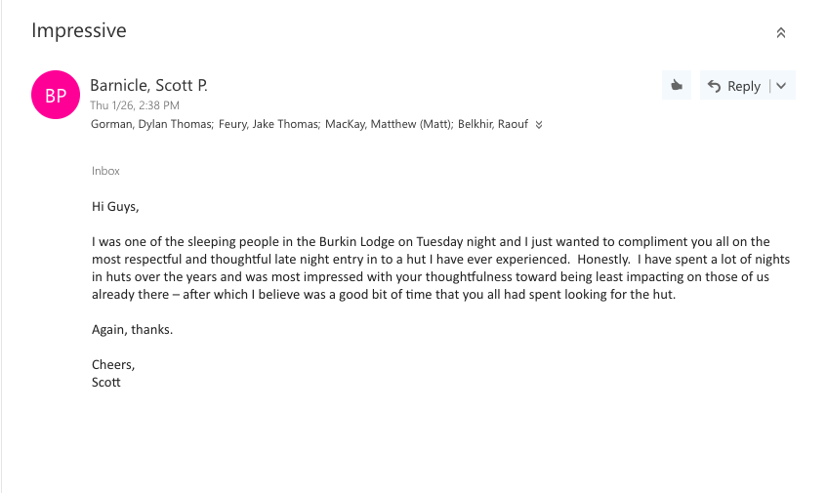
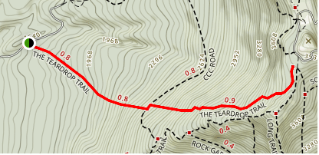
Where I turned around
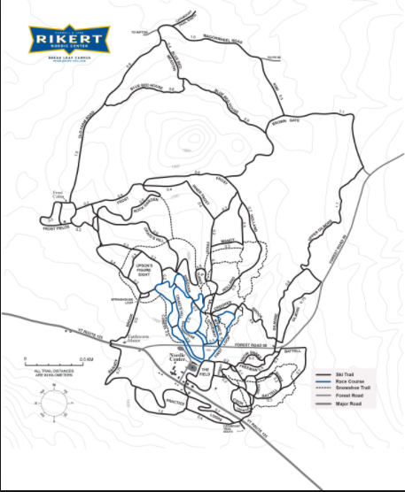
Where the lodge actually was

Where map said lodge was
X

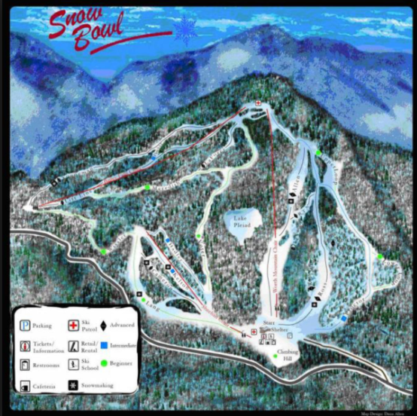
Orange line indicates path up

Yellow line indicates path down
Closed area

