Emilie Munson
1/30/13
INTD 1105
P. Lourie
Trekking the TAM
Silence. That’s what I noticed most as I set out on the trail. No doors slamming, toilets flushing, heaters groaning. No forks clattering and beers clinking. No voices whispering, chatting, shouting, laughing. No thumping bass penetrating my flimsy dorm room door. I was far from life at Middlebury College. Why was I out here?
I was seeking adventure.
When I think adventure, I think perilous. I think extreme, exciting, and big. Adventures are inspiring and teach you something. When you add winter to adventure, things take on a whole new level of adrenaline.
So how could snowshoeing in quiet Middlebury Vermont be a real winter adventure? Indeed, initially when I brainstormed winter adventures that I could tackle during J-term, snowshoeing did not come to mind. I first thought: hike and ski Tuckerman’s Ravine! But then I read online about the avalanches prevalent to Tuckerman’s and chickened out. Then I thought: traverse the Presidential Range in the snow! But then I remembered the biting sleet and brutal winds when I climbed Mount Washington this summer and decided that could be a miserable experience.
I began to doubt myself: maybe I’m not adventurer material. Why couldn’t I take a risk? Why couldn’t I man up and brave the elements? Why was I shying away from going big? I ski, I hike, I camp. What’s wrong with me?
But, I had to find something. I was feeling stifled and stir crazy, like college was merely classes and dorm life and not the world of opportunity I originally thought it was.
Well, I thought, what do I like? If I was going to work on this adventure for a month, I better enjoy it. I like being outdoors, I like people and I like Middlebury. How could I combine these things? And then I got it. I could snowshoe the TAM.
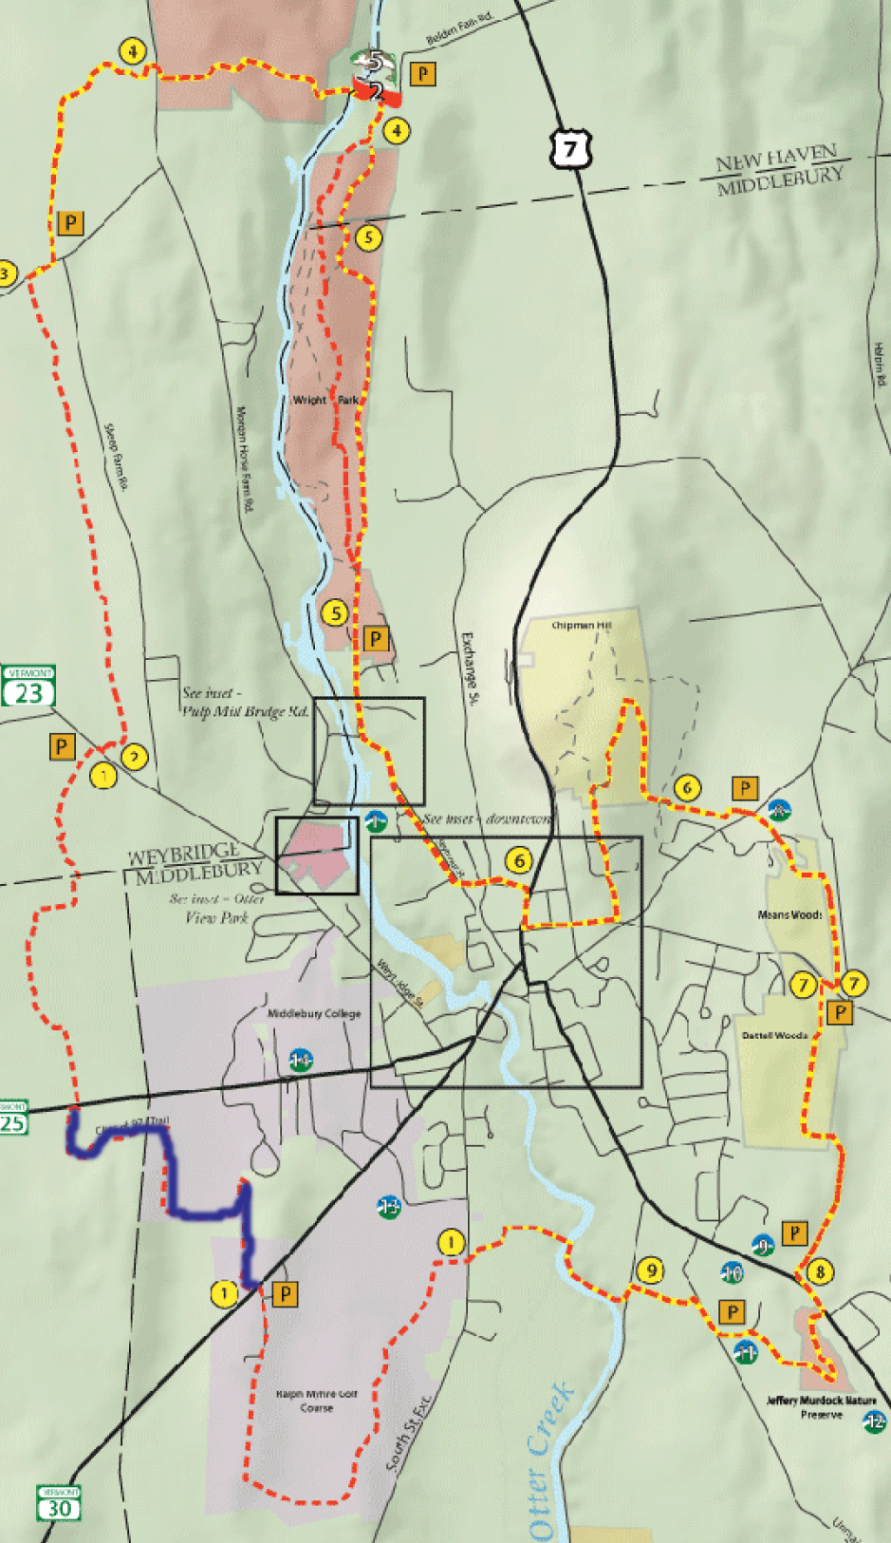
The TAM, short for Trail Around Middlebury, is the eighteen-mile trail encircling the quaint town of Middlebury. The trail crosses four townships, wooded glades, open meadows and local farmland. Over the course of eight years, Middlebury volunteers cut every mile of trail and built every bridge and walkway on the TAM. Today, the TAM is enjoyed by local families and Middlebury College students for various recreational activities like mountain biking, hiking, and cross country skiing. I had run sections of the trail previously and liked the sense it gave me of being completely alone, just me out on my own in nature. It gave me room to reflect and experience myself with no one else around to judge. It was a way for me to experience the remoteness of nature and yet, in learning about it and even using it, engage with the town of Middlebury, my home for the next four years. It was finally settled—a perfect adventure for me.
The adventure didn’t feel so perfect when I set out at nine AM on one Friday morning in January. Under the blue sky, it was a bone chilling zero degrees. I pulled my skiing neckwarmer over my nose and wiggled my fingers as I set out from the Mods onto the Class of ’97 trail, the section of the TAM that wraps behind the College. I would follow the TAM east, beginning at the College and ending at the College. The whole trail in one epic day.
I warmed quickly as I walked. Soon, my upper body was sweating but the breeze made my legs cold although I wore two pairs of leggings. I stopped minutes later and stripped off a fleece on top before struggling to tug on a pair of sweatpants over my clunky snow boots.
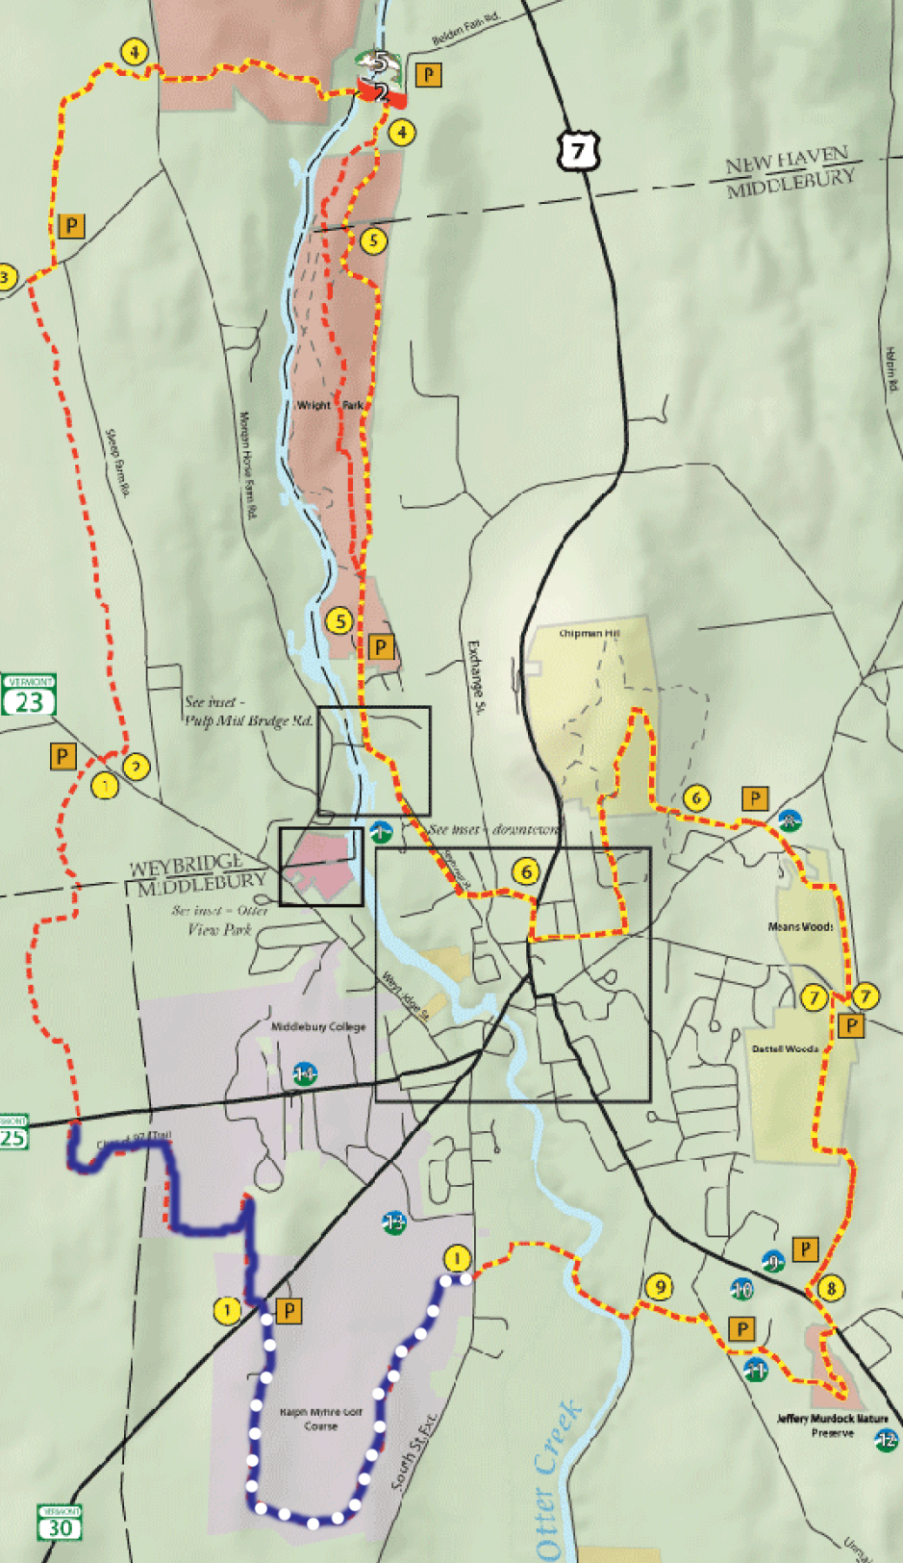
As I followed the trail behind Ralph Myre Golf Course, I noted the terrain was like a familiar friend. I trotted up and down the rolling hills remembering my huffing breath when I often ran them in the fall. It was with excitement that I learned of the TAM. In true freshman style, my running buddies and I would send each other detailed texts each time we discovered a new part of it. My heart beat with the same thrill when I thought about exploring the new sections of the trail I would see today. I walked behind the soccer field and the baseball field, and the land tinged with college life was gone. Ahead of me lay fresh snow and miles of serene woodsy trail.
I first came across the train tracks.
I imagined a train roaring towards me. The ground would shiver and the gravel at my feet would hop up to lick my calves. The whistle would blow and I would be unable to stop my hands leaping to my ears. The great black train would charge me like an enraged bull and at the very last moment, just before it ripped through the place I was standing, I would dive away.
I was in no real danger; no train was on its way. I stood on one rail and balanced, carefully placing one foot in front of the other like I saw characters do in movies. It was my first time ever on a train track. I relished the experience a minute longer and then scampered off down the TAM again.
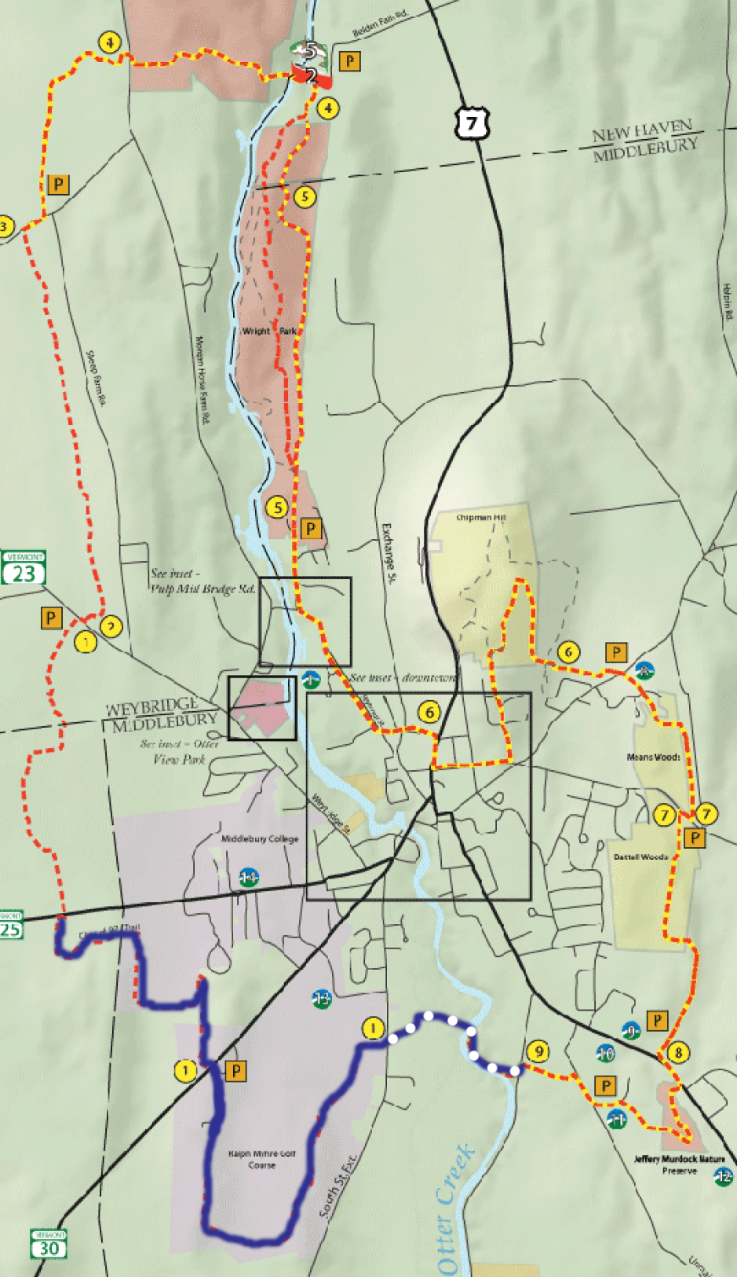
I reached the Boathouse Bridge not long later. Above the entrance, hung a sign saying “One machine on bridge at one time only. Abuse it- lose it.” Though my weight was insignificant to the bridge, unlike the snowmobiles that the sign was referring to, I tread softly across the bridge in my snowshoes. This was the hard work of John Derrick. I did not want to disturb it.
John Derrick, in his late sixties, has a gravelly voice that grabs you and makes you listen, the kind of voice that would thrive in country western saloons where men fresh off their horses clamor for a good story. From the photo he sent me of himself—him standing casually on top of a boardwalk he just built on the TAM, dressed in a work-shirt and holding chainsaw in classic Vermont outdoorsmen fashion—I could see Derrick is a fit man for his age with a tanned quietly lined face.
Since the age of twelve, Derrick, a New Jersey native, spent summers on his relative’s farm in Shoreham Vermont. He made the move to Vermont in 1969 and has lived in Middlebury every since. Derrick joined the TAM project a year and a half after its inception in 1989 and since his stint as executive director of MALT beginning in 1992, Derrick has been a driving force behind the Trail Around Middlebury.
“I liked the idea of conserving land and the idea of a trail around Middlebury sounded like a fun project,” explained Derrick.
Derrick remembers his days spent constructing the TAM as some of his favorite. His single most memorable day on the TAM was the one he spent working on the Boathouse Bridge, which traverses Otter Creek.
For a year, Derrick negotiated with the College to get permission to build the bridge located behind Middlebury High School. Finally, Derrick was able to hire an architect and in the winter of 1999, construction began. Derrick had to patiently wait for the playing fields to freeze before they could begin. When they eventually did, Derrick personally dug the first anchor hole and then called in the concrete company and all his volunteers who had been on call for days, anticipating this day.
“Everybody came together on that one day (…) and we decided it was a go. We had to do it,” recalled Derrick. “That was just a totally, totally high adrenaline day.”
In five hours, the crew poured forty yards of concrete, completing the base for one side of the bridge just before rain began to sprinkle down. All winter, Derrick and his volunteers built the 180-foot deck for the bridge in six-foot sections in Derrick’s shop in Shoreham. In the spring, the concrete for the base of the bridge on the other side of the river was poured (as that side could be accessed by road). Then, Derrick and volunteers labored to haul the deck they had constructed across the bridge bases using a cable system. On Tuesday afternoons and weekends, they toiled on this bridge until finally, in August of 2011, it was completed.
After the bridge, I bore right and walked along Otter Creek. I puzzled to myself why it was called a creek: creeks to me were small and babbling, a little flow of water that you could cross by hopping from protruding rock to protruding rock. Otter Creek in contrast was wide and deep and required a suspension bridge, like the Boathouse Bridge to cross. After doing some research, I learned that Otter Creek is actually a river and one of the largest in Vermont, in fact. Also, it is the only river to flow north.
Soon, I came to a road and followed some arrows pointing me to the right, continuing my walk along this unusual creek. I realized after about fifteen minutes of walking that none of the signs I had been following had the distinctive TAM logo on them (tall TAM letters on top of a mountain range), although they were all in the same black and yellow color scheme.
This would not be the first time I got lost following Otter Creek. Another trip I took on the TAM, I once took the wrong trail and walked along the Creek for a solid mile before remembering that, according to the map, I was supposed to simply cross the Creek at the Belden Bridge and not walk along it. After slapping my forehead a few times, I backtracked and found my way again not long later.
This time I flagged a truck that was driving down the dirt road that paralleled the creek. When the truck rolled to a stop next to me, the driver leaned over and popped open the passenger side door. This was a character that to me typified Vermont. He was an elderly guy with a salt-and-pepper crew cut and a weathered face. He wore a gray waffle shirt and on the floor on the passenger side sat a pair of tall camo Bog boots. A can of Coors Light shone in his cup-holder. I wondered if there was a shotgun in his truck bed. I was happy that a man like this was in the truck I stopped because, as a hunter, he was probably familiar with the trails I wanted to ask him about; maybe he even used them himself.
I had seen a few signs saying “slow speed” recently along my trek so I asked the man if I was on the TAM or the Vermont Area Snowmobile Trail (VAST). He replied that, like I suspected, I was on the VAST but if I walked through the corn field on the other side of the street, I would get to Route 7 and I could walk down that to get back to the TAM. I thanked the man for stopping, shut his door and was soon alone again with my trail.
I began hiking across the cornfield where foot tall corn stalks angled out of the earth at even intervals. In the distance was a farm with a tall grey silo. I walked and walked but was worried when after so long I could neither see nor hear Route 7. To my left, about a half mile off was a new neighborhood with homes under construction and at the intersection between my field and this neighborhood stood a woman with three large dogs playing around her.
I headed her way, wanting to ask her for some more directions. Her voice rasped as she called to the big brown dog (appropriately named Buck) as I neared them. When I got closer I could tell she was a chain-smoker from her yellowed, wrinkled skin, and dark gappy teeth. With her fur-lined hood covering her blond and grey curls, she told me that yes I would eventually reach Route 7 if I kept going the way I was headed but that it was a long ways off. I was better off cutting through this neighborhood and then rejoining the trail behind the middle school.
I began to walk through the neighborhood, ditching my snowshoes once I hit the road. The sound of drills filled the air here and startled me in its contrast to the quiet I had become accustomed to. Two men worked on the porch of a house under construction, banging on boards set up on a plane horse. The woods were all cleared in this area so that only brown grass stretched between the awkwardly spaced houses.
This area disturbed me. It reminded me too much of the over-developed suburbia that consumed most of the region of Massachusetts where I am from. Although the homes were tasteful and not Mcmansions, I was dismayed to see homes usurping the land instead of living in harmony with it like I was used to seeing in most of Vermont. I put my head down and tried not to think about how this type of development might be coming to the rest of Vermont in the future.
A car revved on the road next to me and I turned my head to see a black unwashed Jeep slowed to a stop. The smoker woman rolled down her window and her large dogs, which seemed to fill every inch of the car, barked at me. She pointed to the intersection a ways down the road and told me to take a left if I wanted to get to the Middle School. Before I could utter a word, she stepped on the gas and sped off.
I rejoined the TAM behind Middlebury Middle School. It was a relief to be back in the woods where I could forget about the cookie cutters houses and infinite mailboxes and how humans are ruining the landscape. In the woods, I could catch my breath and pretend that wilderness was as common as I wished it were.
I was also feeling anxious, though: not about the state of the planet this time but about my trip. In the back of my head, I worried if I would now be able to finish the entire TAM today with the extra time my detour added. I had forgotten my headlamp and I knew from experience how difficult it could be see the TAM markers in the dark. The thought of not being able to complete my journey was painful; the weight of failure choked me. Snowshoeing the TAM in one day had become a point of pride for me, in addition to a source of escape. I wanted to prove to myself, to my friends and to my professor that this was something I could do. Maybe it was the lingering fear that I was not an adventurer nagging at me. Realizing that my worry was probably counter-productive, I tried to thrust the unhappy thought of failure aside and focus on motoring on the next few portions of the trail to make up for time.
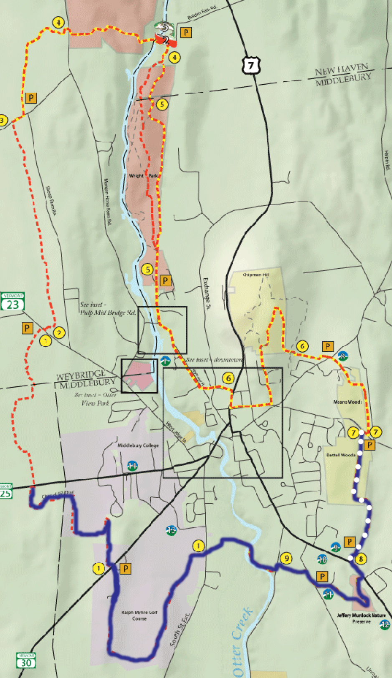
Quickly, I navigated Jeffrey Murdock Preserve until I came across a large fallen tree across my path. I made a mental note to call MALT and inform them of the tree’s position, and then forced my way through the brush around it down to Route 7.
Between the speeding cars, I dashed across 7 and headed up into the quiet of Battell Park. This is the first area MALT owned; it was given to the town of Middlebury by author, publisher, and trustee of Middlebury College Joseph Battell in 1915. This land, where small gray sparrows currently jumped from branch to branch near my head, was the birthplace of the TAM.
In the late 1980’s, the spirit of conservation swept Middlebury. In 1987, the town of Middlebury developed a conservation fund to identify and purchase lands for preservation, and the Middlebury Area Land Trust was born. Two years later, while working on a land conservation study for MALT, Amy Sheldon, a Middlebury College alum and conservation consultant, conceived of the TAM. Sheldon had been reading about park planning and the Emerald Necklace, a 1,100 acre chain of parks linked by path- and waterways in Boston MA, and realized how underutilized Middlebury’s natural resources were.
“I walked over Chipman Hill everyday and was like, ‘Nobody’s using this incredible thing; nobody knows about it,” said Sheldon.
Sheldon realized that a trail around Middlebury would be a great way to add to Middlebury’s current stock of conservation land and make land available for recreation. Sheldon convinced the MALT board of her idea and then set to work.
First, Sheldon worked to get trail cut to connect East Middlebury, including the Battell and Means Woods and Chipman Hill, areas where MALT already owned land and had to deal with few individuals. In West Middlebury, where MALT did not have the benefit of possessing swathes of land, securing leases so that the TAM could traverse various peoples’ property proved difficult. Property owners were nervous about having people walking on their land. At one MALT meeting discussing the TAM, Sheldon remembers a board member fretting that a trail linking the town would lead to increased crime. Sheldon was happy when the former fire chief stood and declared that his old town in Connecticut had had similar trails for years and they did nothing to affect crime. To ease worried nerves, MALT used ten-year leases instead of permanent easements, as is the standard, so that owners felt like they had a cushion if they didn’t like the TAM on their land.
Smiling, Sheldon pointed out, however, that today “People realize it’s an asset to their property and not a detriment.” People now advertise, when selling their homes, their proximity to the TAM.
By the time Sheldon moved to Oregon in 1996, leaving her brainchild to the capable John Derrick and Budd Reed, the trail wrapping West Middlebury was planned and leases with owners whose property the TAM would traverse were negotiated. When she returned to Middlebury in 1999, the TAM was finished.
I cruised through the Battell Woods, carried by my excitement to be back on the TAM once more. I passed a neat bivy that someone had constructed where a tree had fell over, exposing the underside of its large plate of roots. Branches had been laid against these roots creating a protected shelter and inside two small logs were set up as benches.
Farther down the trail, a large Burmese Mountain Dog trotted up to me. His tail wagged furiously but I called to his owner down the trail to ask if he was friendly before I engaged with him. His owner, nearly as shaggy as his dog, turned out to be my Commons Dean Jonathan Miller Lane who happily said, “Of course, he’s probably just wondering where your dog is.” This friendliness on the trail helped to lift my darker mood. I gave the fluffy beast a nice rub down and then continued on my way.
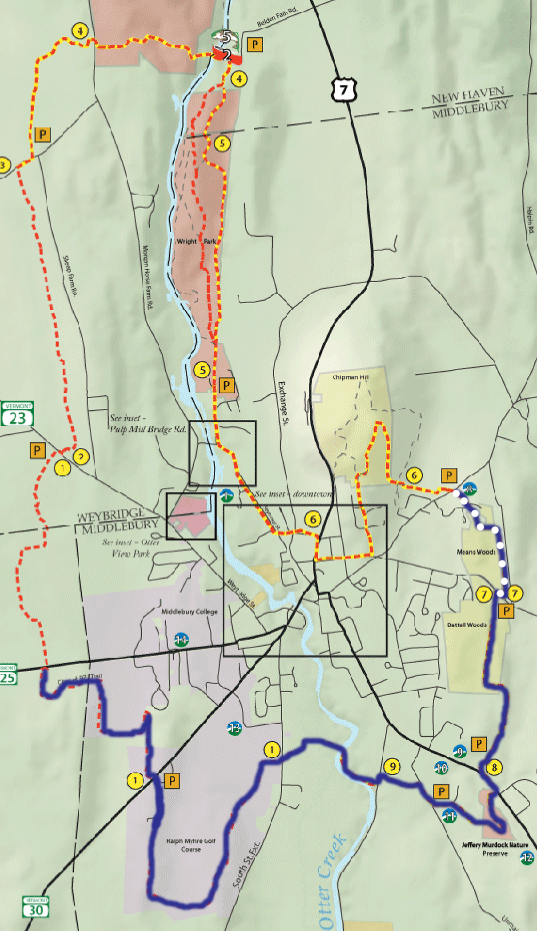
I kept up my pace through Means Woods and noted two more fallen trees to report to MALT. Just before exiting the woods, I passed behind the Aurora School. I remembered fondly how one night when snowshoeing the trail with a friend Julia, large white, smiling faces had greeted us through the darkness from this grove of trees. Snow faces, about three feet high, had been carefully crafted on about five tree trunks. I imagined the school kids carefully firing snowballs for each eye and then running up to the trees and smearing on mouths. Julia and I had weaved in and out of the trees, laughing and snapping photos.
This time no snow faces smiled at me from the trees. Middlebury had experienced a thaw since that last episode and no doubt the eyes and smiles had slowly slid down their respective trunks in the warm weather.
I stepped out of Means Woods and crossed the road into a field. Directly in front of me was Chipman Hill rising into the skyline. I could see easily in the daylight the TAM sign set about 500 feet away from me in the field. I remembered the difficulty Julia and I had had finding this marker in the dark, though.
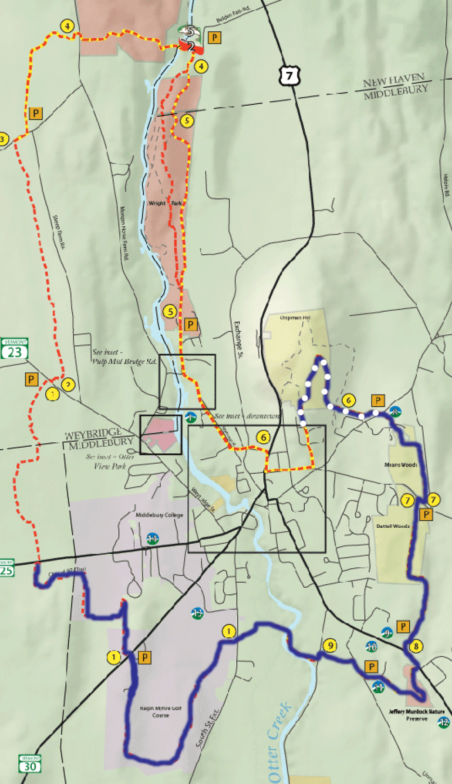
Looking for any sign of the trail, Julia and I had walked up and down the road, snowshoes in the crooks of our arms. We consulted the map multiple times and finally when we began to despair that we would have to either walk back to school, or set up camp and stew a raccoon for dinner, we found the trail. It had been right in front of us the whole time—as most things are when you lose them—and only the darkness prevented us from finding it.
After finding the trail, we began our ascent of Chipman Hill. In sharp contrast to the field we just struggled with, the backside of Chipman Hill is probably the one place on the TAM where it is impossible to lose the trail: at every turn and switch back, a bright yellow TAM marker points the wandering hiker in the appropriate direction.
I most noticed, in the dark on Chipman Hill, the feeling of the possibility of danger. On every other part of the TAM, I had felt extremely comfortable and safe but here in the dark, the town felt much farther away and the wild more present. The wind blowing in the trees could be an animal rustling leaves. Despite ourselves, Julia and I began discussing what we would do if we saw a bear. Would we make noise and try to seem big? Or would we be quiet and hope the bear didn’t notice us? We debated the pros and cons of all of the bear tactics we had heard over the years until we concluded that, more than anything, this conversation was just scaring us.
In the light of day, Julia and my discussion about bears seemed ridiculous. I could see the houses of town when I looked out from the hill. Also, the TAM is heavily used. A couple and their happy golden retriever puppy were in fact climbing Chipman Hill not far behind me.
I summited Chipman Hill at around one PM and stopped for lunch before continuing my trek. I looped through town until the trail resumed in Wright Park.
This is one thing that Sheldon hopes to change about the TAM: she wants to see the whole TAM consist of trails instead of some sections requiring you to walk on the roads. At her home in East Middlebury, she showed me a map of a possible route connecting Chipman Hill and Wright Park without walking through town. She said the only roadblock to starting work on implementing this idea right away is the railroad tracks. The railroad company does not want people crossing its tracks too often for safety reasons, and this new trail route make an additional crossing necessary. The other railroad crossing—where earlier in my day I had fooled around like a child of twelve—was allowed because the College owned the land on both sides of the tracks. Sheldon hopes that maybe the town can just set up an unofficial crossing and circumnavigate the railroad company altogether. If the trail ends on one side of the tracks and resumes on the other, said Sheldon, there’s nothing to really stop people from crossing them on their own. Personally, I would love an extension of the TAM’s woodsy trails to avoid town: it was impossible to feel like I was on a wilderness adventure when I was walking past Shaw’s and Middlebury Bagel and Deli to get to the next section of trail.
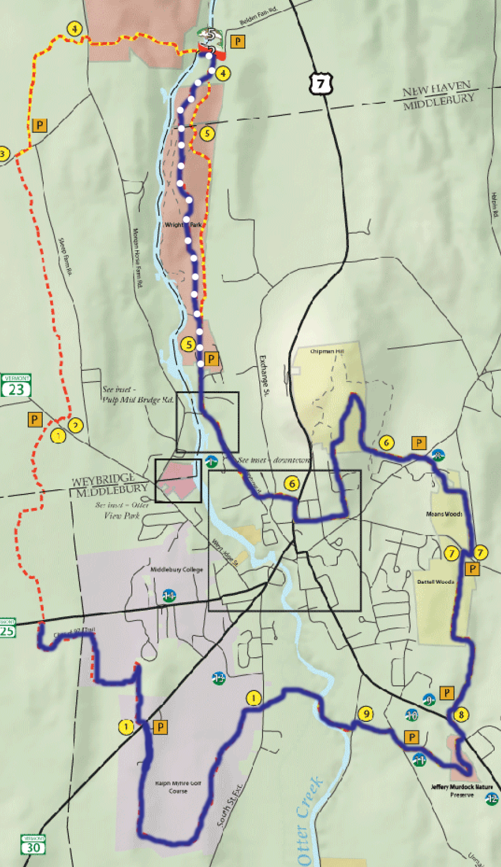
In Wright Park, I rejoined my old friend Otter Creek. A handmade wooden sign along it announced “Beaver Activity”. I shuffled to the creek’s edge in my snowshoes searching for beavers although I knew how futile it was because beavers hibernate all winter. A gnawed tree, clearly the handiwork of a hungry beaver, later on the trail gave me some sense of satisfaction though.
When a grouse flew out of the scrub not too long later and made me jump back about a mile, I really felt like, after that expedition in town, I had returned to the wild. I remembered how Amy Sheldon had called the TAM a travel corridor for animals because so many use it to get around.
“You don’t realize when you are putting in a trail for people, that it’s also gonna be a trail for the wildlife,” she said.
I also recalled how John Derrick had told me that there really were otters in Otter Creek—he had seen them and their slides before—and I once more scooted over to the water’s edge to see what I could see.
When I reached the Belden Bridge, stretching over Otter Creek, I was reminded why this is a popular favorite section of the trail. The creek flowed over a rippling waterfall, now coated in ice, on one side of the bridge and rushed away from me, north to eventually empty in Lake Champlain, on the other.
Amy Sheldon said this part was her favorite because she used to walk here so often when, in the past, she lived on Morgan Horse Farm Road. John Derrick loved the old forest in this area of the trail: it was he who told me that this region used to be part of the University of Vermont Beef Farm back in the day and has been a grove of uncut woods since. Middlebury College student and avid trail runner, Charlie Koch, said the Belden Bridge area was his favorite because it was the longest portion of trail uninterrupted by roads on the TAM.
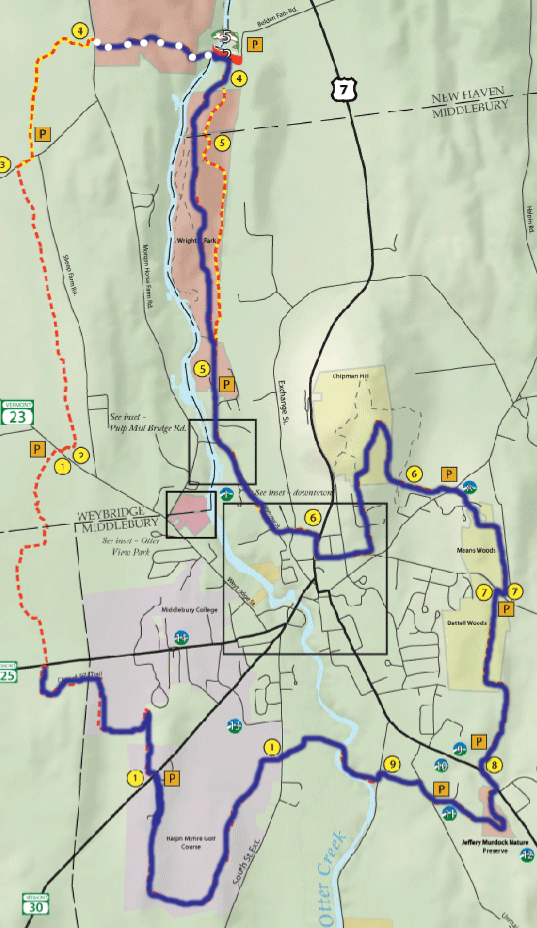
I felt a kinship with these people as I walked along. We shared a love, the TAM, and in that moment, that fact warmed me much more than my down jacket could.
Steps buoyed, I walked through the woods, passing another bivy, smaller than the one in Battell Woods, as I walked. Soon I reached an open pasture on the other side of which was Morgan Horse Farm Road and the rest of the TAM. Before stepping out of the trees, I looked right and left. Phew, no cows. Charlie Koch had told me a story about this pasture and a trouble-making cow.
“He might have just been curious, but he started running towards me while I was running. Cows weigh a lot so I was intimidated,” said Charlie. Chuckling he added, “It was probably a little more of a chase in my head than in reality. Luckily, I escaped unscathed.”
As I crossed the pasture, I inadvertently checked over my shoulder periodically, half expecting to see an overly eager cow bombing toward me. Safely, I reached Morgan Horse Farm Road and crossed into the woods on the other side. The path in here was windy and rocky but I quickly emerged out into a field on the other side.
When I looked to my right, I saw a pond that I once crossed on another TAM excursion. It had been a cold morning with much more snow than today. I was walking the TAM in the other direction and by accident I followed snowmobile tracks instead of the TAM (I guess I have a thing for getting lost on snowmobiles trails). When I backtracked, I surveyed the field and spotted a yellow TAM marker far down the field from me. Slowly, I made my way in that direction, sinking up to the tops of my boots in the deep snow. Soon, I came to realize that I was snowshoeing in reeds: the air pockets among them made my feet sink even more and I frequently had to stop and untangle myself from their brown grasps. Who maintains this field, I thought to myself. Why didn’t they plow up these reeds?
I felt relief when I emerged from these reeds; suddenly, the walking became much easier. My snowshoes sunk in much less and under the thinner covering of snow there seemed to be a hard surface. Then it hit me: reeds and a hard surface, I was standing on a frozen pond. I stopped short and listened for any signs of cracking. If I fell through the ice, no one was around to help me. I imagined the cold water hitting me like a punch, my breath spewing from my lungs with the force. I would grab at the ice but water from my splash would have made it slippery. My cold fingers would be numb and stupid, and with nothing to hold on to, I would be stuck. No one would think to look for me for hours. By then, it would be too late.
My heart beat faster as I walked the rest of the way across the pond, focusing on making myself light. Finally, I cut through the reeds on the other side and made it back to safe ground.
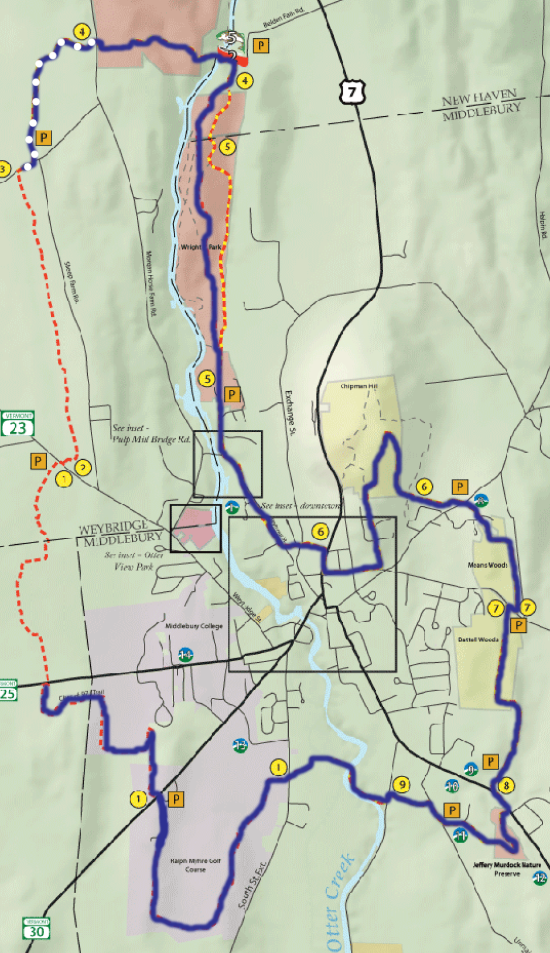
Today, with less snow, the pond was much more obvious. I skirted it warily and continued on my way. I crossed Hamilton Road and entered Jackson Woods. Once again, I was on familiar trail; in the fall, this portion of the TAM often been part of my running route. I traversed the hill that dominated this section with the light fading like my energy. I plodded slowly, feeling blisters rise on the bottoms of my feet. Finally, I rounded the corner and could see Weybridge street and in the distance, Bi-hall.
A smile broke my face once again. Nearly there! My pace picked up as much as it could with my aching feet. I soon passed the Trail to Prunier Road breaking off to my right, a new extension of the TAM added this summer.
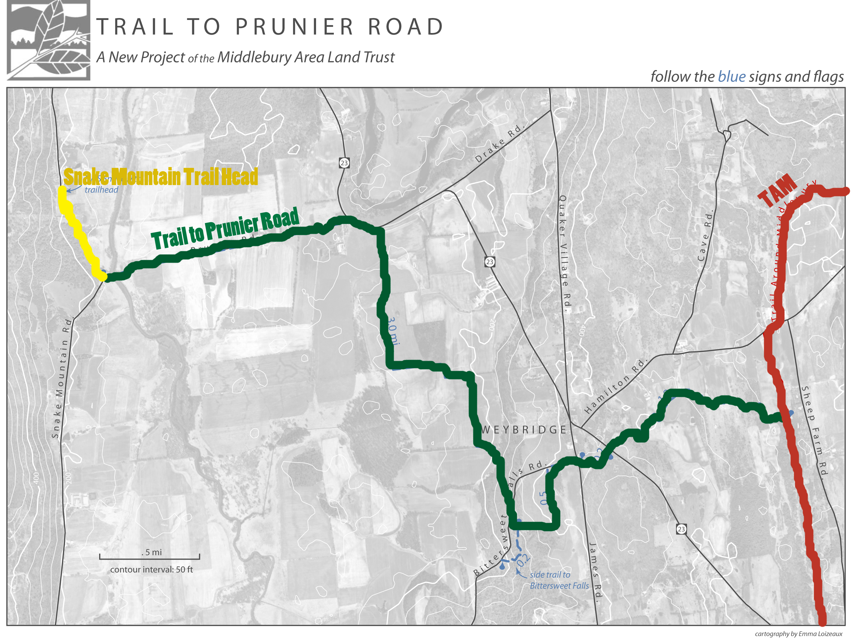
Recently, MALT has embarked on an effort to become part of the North Country Trail, a trail that traverses the entire northern United States. It is MALT’s goal to extend the TAM to the east and west in order to connect the Adirondack Mountains of New York to the Green Mountains of Vermont. In summer 2011, John Derrick worked with his intern, Middlebury student Emma Loizeaux, to cut a this new trail off the TAM, leading to Snake Mountain, northwest of Middlebury.
Derrick explained to me that the National Park Service maintains the North Country Trail, and therefore, Congress must approve funding for adding any additions to the trail. Currently, the effort to connect the Adirondacks and Green Mountains is stalled, waiting for Congress’s go-ahead. It’s Derrick’s plan, however, to continue cutting trail to the east and west of the TAM, like he did this past summer, to demonstrate the feasibility of new section of the North Country Trail to Congress.
Derrick is especially pleased about this work with the North Country Trail because it helps ensure the future of the TAM. MALT has recently become an affiliate of the North Country Trail so that it can now get some funding from the National Park Service for boardwalks and bridges. If for some reason MALT ceased to exist on some sad future day, the TAM, he told me happily, could continue to thrive as a chapter of the North Country Trail.
“That was a big plus for the whole trail,” he said. “I’m getting well into my sixties now so it’s a great thing to know it will be there. (…) I have felt until now that if I didn’t keep at it, we might lose it.”
Not everyone is as supportive of extending the TAM like this, however. Amy Sheldon said she didn’t picture people really using a trail connecting the Adirondacks and Green Mountains that much because the two mountain ranges have very different restrictions on recreaters (for example, one cannot ride a bike in the Adirondack Park like one can in the Green Mountains). She thinks that the trail to Snake Mountain was a good idea because that is a popular local spot but that instead of focusing on spreading the TAM, MALT should work on projects closer to home like getting the northern section of the TAM off Middlebury roads.
“It’s a community trail. It’s going to stay a community trail,” said Sheldon.
I don’t really think it matters if the trail is extended or not. There does not seem to be a high demand of people who are seeking a trail from the Green Mountains to the Adirondacks, but should such a trail exist, then people would have the opportunity to cross between the two ranges if they wanted to. To me, the specific form that the TAM exists in is not as important as the fact that it does.
Walking along, the fact that struck me most was the passion that these people have for the TAM that they are willing to put so much time and energy into it’s creation and maintenance. This trail seems to be the child of so many people—Amy Sheldon and John Derrick are just a few of its caretakers—and carefully, for years, they have raised and nurtured it. I wanted to go up to these people, these TAM lovers, and say thank you. I wanted to hug them and say I appreciate your fine work. All alone, I felt so connected to the people of Middlebury. The TAM was uniting: we maintained it and used it in common joy.
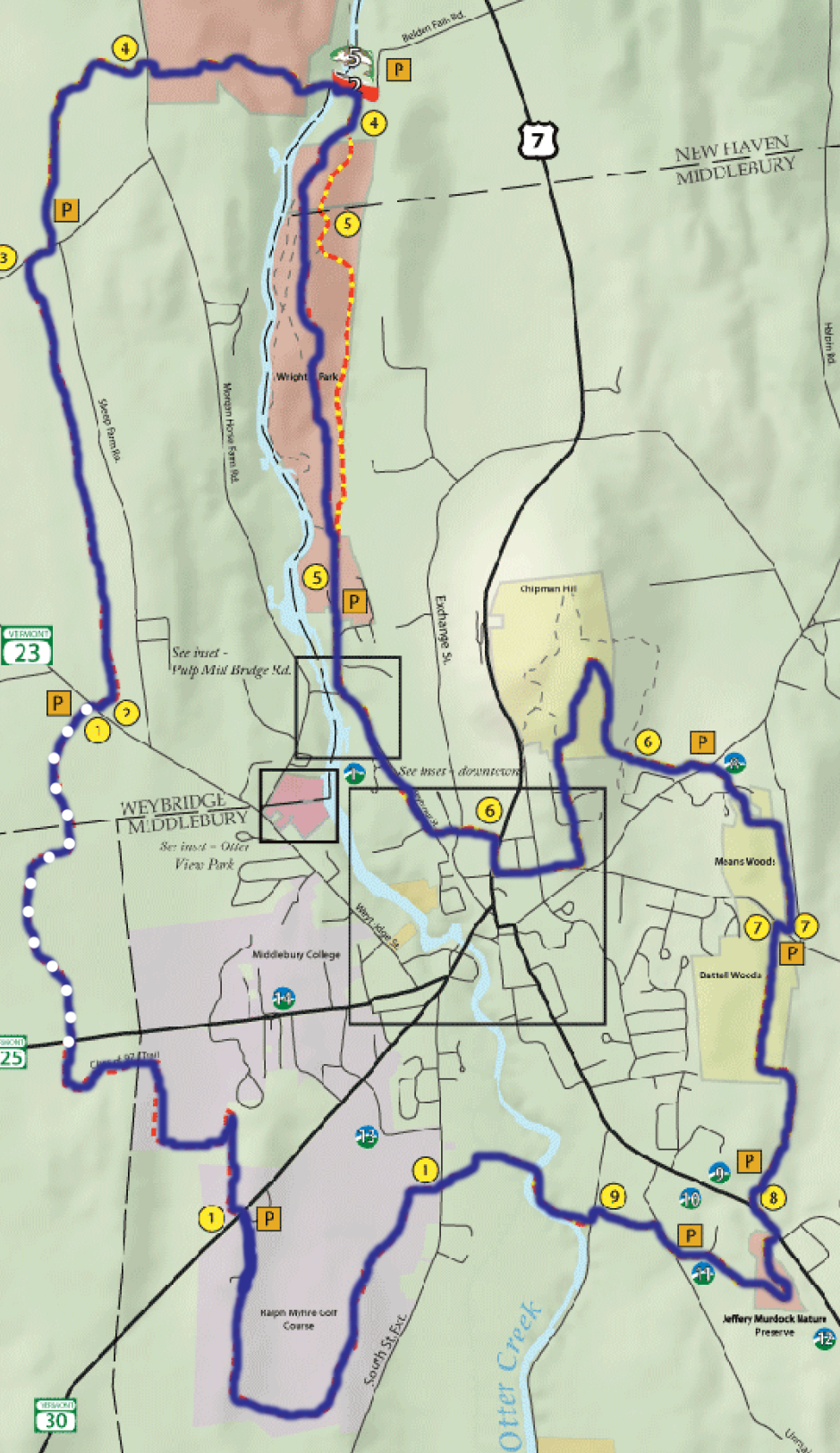
I was happy that with each step I was helping to maintain the TAM, each step of mine ensured that the next person to walk here would have an easier time of it. And I had taken a lot of steps. When I could finally see Middlebury’s organic garden, it was 5:45. I was dog-tired. I debated crawling back to my dorm but decided that would just take longer.
Soon my pride re-energized me, though. I felt giddy with my accomplishment. I had walked eighteen miles in one day—probably closer to twenty actually with my detour on the VAST trail. I wished I could see the glorious sunset to match my euphorious mood but gray clouds covered it.
I remembered reading Henry David Thoreau’s essay “Walking” when I decided to do this trek (I figured if I was going to walk so far, I’d better consult the experts). One quote stuck in my mind in particular. Thoreau says, “In Wildness is the preservation of the World.”
I thought about this as step by step, I inched closer to the end of my journey. “Preservation of the World” could be interpreted on many levels in relation to the TAM. There was the obvious of course: conservation of nature. MALT is at its most basic level a conservation organization and the TAM has largely been a tool to preserve more land.
“Preservation of the World” could also be people, community values. I remembered the small wooden signs I had passed in Murdock Woods which identified various trees along the route. These had been made by Middlebury Middle School students. The local schools often take students on nature walks for class; I passed a group that morning near the Boathouse Bridge. Summer camps explore the TAM too. Middlebury locals and college use the trail to walk, run, snowshoe, cross country ski and mountain bike. The TAM seems to keep people grounded in values like knowing the trees that are found in your backyard, venturing off the couch and out of the living room, learning a new recreational skill, breathing fresh air deeply.
It occurred to me that the “Preservation of the World” could be something even smaller. A single being. One person. Maybe the TAM was preserving me.
I looked up at the glowing lights of Ross and Bi-Hall and thought about my college experience thus far. As a freshman, a lot has changed for me in a short amount of time. I live in a totally new place, with new people, a new culture and a new life style. A lot about college resembles nothing of my life before it.
I have always been a person who has clung to the outdoors. I feel guilty when I am inside, and it’s sunny out. As a child, I would make tree forts in the woods and pretend to fish with sticks in the swampy pond behind my house. In middle and high school, I spent a lot of time hiking and trail running. In college, so much of life revolves around the indoors. I often feel like I am constantly glued to my computer screen, or trapped in the library, or claustrophobic in a boiling Atwater suite with the shades closed. The TAM’s quiet and open space and peeling birch filled that hole in me where I missed my interactions with nature.
Thinking about all this illustrated to me the power of the TAM to induce self-reflection, another habit that has been diminished in me during college. Every night, just before I went to sleep, I used to write about my day and my feelings in a journal. These moments I spent cataloguing my life helped me make sense of many periods of change in my life. And although it has been maybe the largest period of change for me, now that I am in college, I no longer journal. Something about being too busy is how it slipped away. I like though that the TAM made me think about my life and emotions simply by nature of isolating me with my brain. In my many hours on the trail, I feel I have made up for my lost time journaling in another way but one in which I was still evaluating my decisions and my morals and my happiness.
The winter breeze that crossed fields, hopped creeks and rustled branches, that swept all of Middlebury but swept this one spot too, it made me feel alive. I could face college again because the TAM gave me a renewed sense self, a knowledge that opportunities do lie around every bend in the path and many friendships with kindred spirits who appreciate wildness too.
I stepped off the TAM, shifted my pack on my shoulders, and walked back to school. I felt whole again. I felt preserved.

