Utilization per Resource of CTLR Tutoring Services
- 1170 students took advantage of CTLR tutoring services during the2014-2015 academic year, representing 46.32% of the student body.

- There were 5093 visits to CTLR tutors during the 2014-2015 academic year, including 4260 visits to peer tutors and 833 visits to professional tutors.
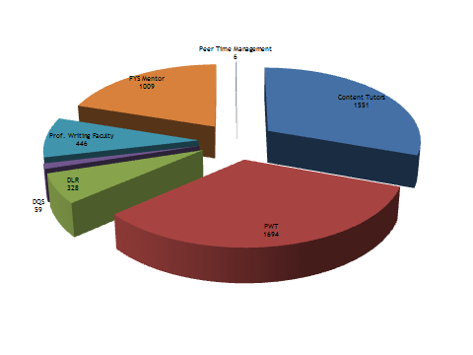
- Students who used utilized CTLR services during the 2014-2015 academic year had grade point averages up to and including 4.0.

Utilization of CTLR Tutoring Services by Class Year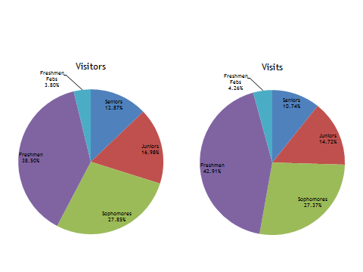
- 52.83% of visits to professional tutors, peer content tutors, and peer writing tutors were made by upperclassmen (visits to FYS Mentors excluded).
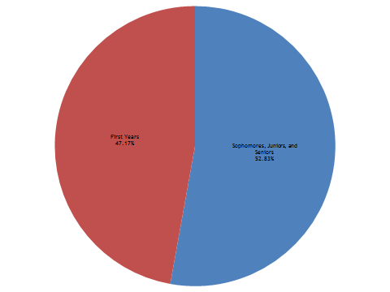
- 547 upperclassmen (sophomores, juniors, and seniors) met with a tutor or went to a study group at least once during the 2014-2015 academic year.
Male vs. Female Utilization of
CTLR Tutoring Services 2014-2015
- Female students make up approximately 51.62% of the student body; males make up approximately 48.38%.
- Approximately 53.76% of female students met with a professional or peer tutor over the course of the 2014-2015 academic year, compared with 44.44% of male students.
- For female students who used CTLR services, the mean number of tutor contacts was 4.24. Male visitors had a mean of 4.07 contacts.
