Alexandra Fields
Professor Beyer
11 November 2013
Forbidden Florentine Footsteps: The Secret Passageway of the Medicis
Although not regarded as one of the most popular tourist destinations in Florence, the Vasari Corridor, hidden and relatively unknown, is a passageway with an intriguing history and a collection of self-portraits of some of the greatest artists of all time. Stretching from the Palazzo Vecchio to the Palazzo Pitti, the Vasari Corridor is a symbol of power and isolation. Giorgio Vasari built the corridor for the influential Medici family in 1564 and it is one of the most distinct architectural symbols of their rule in Florence. It took approximately five months to complete the Vasari Corridor, an incredibly short period of time considering the complexity of the project. The skillful building of this extraordinary passageway is the result of Giorgio Vasari’s talent, as well as the enormous wealth of the Medici family during the Renaissance. The Vasari Corridor is ultimately a political and social symbol of the Medici power, as well as a physical memorial of Renaissance art.
In popular culture, Dan Brown has recently highlighted the Vasari Corridor in his latest novel, Inferno. The main characters of the novel, Robert Langdon and Sienna Brooks, quickly pass through the Vasari Corridor in order to escape the Italian police. Although Dan Brown’s Inferno may have brought the Vasari Corridor to the attention of many readers, it is highly unlikely that it will become significantly more popular amongst tourists. It is only available for tours by scheduling appointments in advance, taking tours in small groups, and was only recently reopened for viewing in 2010. Even so, this does not explain why such a powerful symbol in ancient Florentine history is unknown by so many. Dan Brown opens the eyes of many to this secret passageway, yet he fails to provide the fascinating history associated with the Vasari Corridor, which would likely be of interest to anyone interested in Florentine history and/or architecture.
To fully understand the mysteries of the Vasari Corridor, one must first explore the buildings that the corridor connects. The Vasari Corridor begins at the Palazzo Vecchio, which consists of “a maze of corridors, council chambers, and dungeons” (PBS). The Palazzo Vecchio was built in 1299 by Arnolfo di Cambio, as a residence for the Signoria in Florence. The Signoria was a “council of elected rulers” during the medieval and Renaissance periods that were chosen every two months (Ex Urbe). The Florentine citizens instantly viewed the Palazzo Vecchio as a place of political unity and stability. It was the site of imprisonment for some of Florence’s worst criminals, the place where Michelangelo’s David was destroyed, and the site where Cosimo I was elected Duke of Florence (Ex Urbe). The Medici family was able to rise to power as a result of the lack of experience among the Signoria, along with the extremely short ruling periods of the Signoria in the Palazzo Vecchio. Cosimo I commissioned Vasari to renovate the Palazzo Vecchio and his “treatment” of the Palace was seen as “paradigmatic” (Rubin). The Palazzo Vecchio had at last reached “grandeur and majesty” (Rubin).

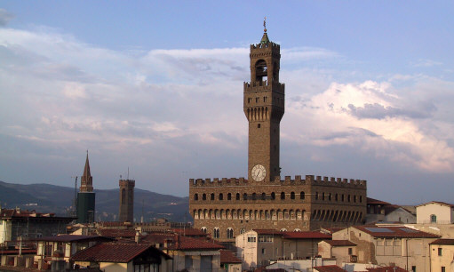Figure 1: The Palazzo Vecchio
The Medici family obtained their enormous wealth by being the
“official bankers to the Pope” (Ex Urbe). It was their job to “escort donations, church taxes, land rents, indulgence fees and every kind of income from every church in Christendom back to Rome, taking a healthy cut” (Ex Urbe). As one of the wealthiest families in Florence, the Medicis had a strong impact on the political scene. Cosimo I de Medici heavily influenced decisions made amongst the Signoria and his “unofficial rule” of Florentine politics led to great stability in Florence (Ex Urbe). By 1531 the Medicis eliminated the Signoria and had themselves crowned as Dukes. In 1540 the Palazzo Vecchio became the home to the Medici family. Nowadays the Palazzo Vecchio is known as the “old palace” because Cosimo de Medici decided to move his family to the Palazzo Pitti, the building that the Vasari Corridor connects to the Palazzo Vecchio (Florence Museums).
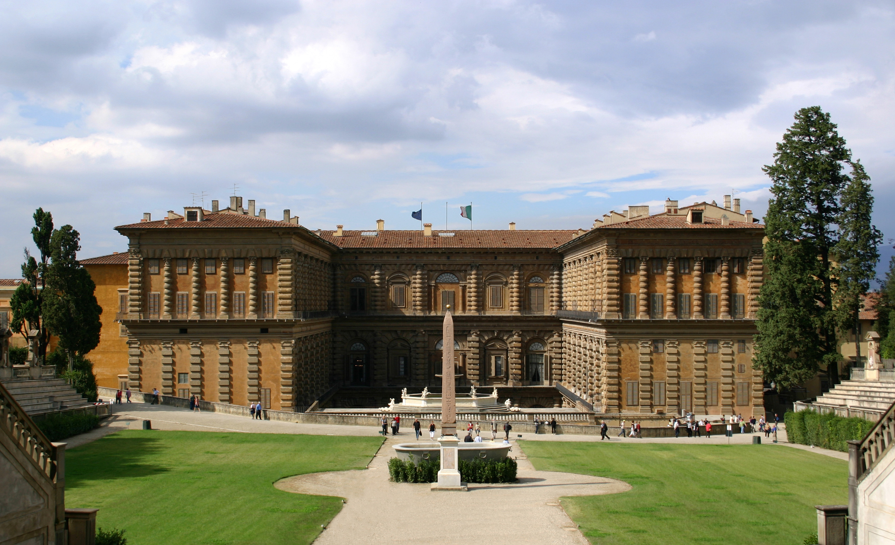
Figure 2: The Palazzo Pitti
The Palazzo Pitti was commissioned in 1458 by Luca Pitti, a Florentine banker. The Pitti family allegedly wanted to prove their wealth by building a palace more impressive than that of the Medici. The Pitti family’s finances went into a “disastrous state” in 1549 and the Palazzo Pitti was bought by Eleanora de Toledo, the wife of Cosimo de Medici (De Vries). At this time, the Palazzo Pitti was considered “the most opulent palace in Europe” (Hudson). It was initially utilized by the Medicis for official functions and to lodge guests (De Vries). The Palazzo Pitti became permanently occupied and “home” to the Medici’s art collection after the marriage of Ferdinando I (Eleanora and Cosimo’s son) and Johanna of Austria. Today the former royal palace of the Medicis is a state-owned public museum. It contains “several important collections of paintings, sculptures, works of art, porcelain, and a costume gallery” (Polo Museale Fiorentino). The Palazzo Pitti extends out to the Boboli Gardens, which are famous for their fountains and grottoes (Polo Museale Fiorentino).
In order to travel between these two extravagant palaces, Cosimo de Medici commissioned the building of the Vasari Corridor in 1564. This was a “bold” move by Cosimo because the “overground passageway” built by Vasari had to cross through several of Florence’s most important landmarks (Hudson). Some of these landmarks include the Uffizi galleries, the Ponte Vecchio, and the Boboli Gardens. The Mannelli family, owners of the Tower dei Mannelli, refused to have their tower demolished to make way for the corridor, thus the corridor had to “sweep awkwardly” around it (BBC).
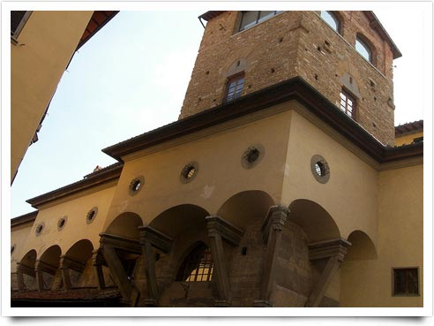Figure 3: Part of the Vasari Corridor that wraps around the Tower dei Mannelli
In his architecture, Vasari valued “good judgment and an exact eye” (Brittanica). Giorgio Vasari’s architectural style was greatly influenced by Michelangelo, whom he looked up to throughout his entire career. Vasari attributes the “pivotal role of both the restorer and the re-creator of orders” to Michelangelo, referring to his architectural style that “conquered those famous ancients” (Payne). Vasari’s style of paintings and architecture are known as “Tuscan mannerist” and have often been criticized for being “facile, superficial, and lacking a sense of color” (Brittanica). Mannerism is an art style in late 16th century Europe characterized by “spatial incongruity and excessive elongation of the human figures” (Merriam Webster). Vasari also is known for using the “serliana,” a motif of Palladian architecture where a “semicircular arch rests on freestanding columns” (Serliana). This style also includes a long rectangular opening, located on each side of the columns. Perhaps one of Vasari’s greatest architectural achievements was his design of the Uffizi gallery, where he “diverges from his theoretical adulation of Michelangelo” (Payne). His work here was not only innovative, but it was seen as the “new canon of Renaissance architecture” (Payne).
Another example of Vasari’s architectural genius was the elevation of the Vasari Corridor above the city of Florence and its “beautiful panoramic view” (Rubin). Cosimo I claimed that the construction of the Vasari Corridor was to “amaze” the guests of his son Francesco and Johanna of Austria’s wedding in 1565, though the primary reason for its construction was to allow members of the Medici to travel safely from their home in the Palazzo Pitti to the government city state, the Palazzo Vecchio (Rubin). Grand Duke Cosimo I had many enemies and did not care to walk amongst the commoners of Florence (Ex Urbe). By walking through the corridor, the Medicis could easily spy on the Florentine citizens through the small windows that overlook the center of the city and the Arno River, while remaining unnoticed.
The Vasari Corridor passes over the loggiato in the Chiesa di Santa Felicita; this is where the Medici family would observe mass without being seen by the public. The way that Giorgio Vasari designed the Vasari Corridor provided the Medicis with the privacy that they needed to remain in positions of political and social supremacy in Florence.
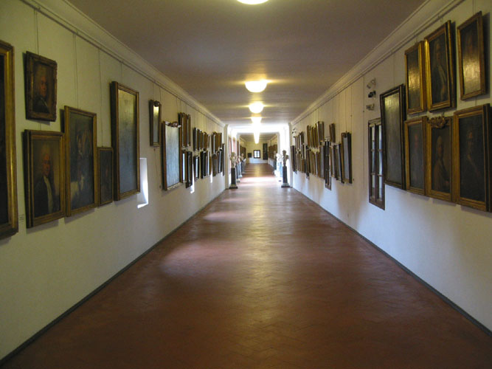
Figure 4: The Inside of the Vasari Corridor
In modern times, walking through the Vasari Corridor is said to be a unique experience because it is completely different from the rest of the Uffizi gallery. There are about 1,500 self-portraits in the Uffizi collection, 413 of which are currently displayed for viewing (Friends of Florence). The rest of the portraits are not on display due to lack of space in the Corridor. There are three different collections in the Vasari Corridor, and the collection of portraits is one of the most famous and complete collections in all of Europe. The first collection begins at the doorway to the Uffizi Gallery and ends as the corridor turns toward the Ponte Vecchio. It contains paintings completed by Italian and European 17th and 18th century artists including Guido Reni, Gerrit van Honthorst, Empoli, and Guercino. The second collection is a famous collection of self-portraits arranged chronologically beginning at the Ponte Vecchio. Cardinal Leopoldo started this collection in the early 17th century with 80 portraits and some of the early pieces collected by the Medici family were later added to Leopoldo’s collection. Some of the portraits currently on display in this section of the Vasari Corridor include those of Giorgio Vasari, Titian, Correggio, Rubens, Rembrandt, Van Dyck, Velasquez, Sir Joshua Reynolds, Antonio Canova, Delacroix, John Singer Sargent, and Carlo Levi. The last group of paintings in the corridor is displayed where the Corridor turns toward the Boboli Gardens, and is part of a collection of Medici and Hapsburg/Lorraine family portraits (Reavis). Perhaps the Medici family portraits are located at the end of the corridor to leave a final impression on all who walk through the Corridor, depicting their lasting influence on Florence today.
In addition to its renowned pieces of art, the Vasari Corridor remains a political symbol. During World War II, two large sets of windows were installed in the Vasari Corridor to allow Hitler and Mussolini to observe the view of the Arno River during their meetings in the Corridor in 1938. Hitler’s fondness for the enlarged windows in the Corridor facilitated the protection of the Ponte Vecchio and the Vasari Corridor from explosions during the Allied advance into Italy. It is said that Hitler was “so impressed” by the view of the Ponte Vecchio that “he ordered the bridge be saved from German bombing during World War II as they began their retreat from Florence. All the other bridges in Florence were destroyed” (Romeo). The Corridor also served to symbolize Florence’s most powerful family and is home to some of the most profound collections of art. The Vasari Corridor, once a “secret passageway”, is now a physical representation of Medici dominance in Florence, Italy (BBC).

Works Cited
"The Art Newspaper." The Art Newspaper. 11 Nov. 2013 <http://www.theartnewspaper.com/articles/Part-of-Vasari-Corridor-roof-collapses-in-Florence/30213>.
BBC News. BBC. 11 Nov. 2013 <http://www.bbc.co.uk/learningzone/clips/the-vasari-corridor-a-world-of-self-portraits/11635.html>.
"Florence-On-Line." Vasari Corridor Reservations : Florence On Line. 11 Nov. 2013 <http://www.florence-on-line.com/museums/vasari-corridor-reservations.html>.
"How to Tour the Vasari Corridor in Florence." About.com Italy Travel. 11 Nov. 2013 <http://goitaly.about.com/od/florenceattractions/ss/florence-vasari-corridor_3.htm>.
"Mannerism." Merriam-Webster. Merriam-Webster. 11 Nov. 2013 <http://www.merriam-webster.com/dictionary/mannerism>.
"Palazzo Vecchio." PBS. PBS. 11 Nov. 2013 <http://www.pbs.org/empires/medici/florence/pup/vecchio_signoria.html>.
"Polo Museale Fiorentino :: Sito Ufficiale." Polo Museale Fiorentino :: Sito Ufficiale. 11 Nov. 2013 <http://www.polomuseale.firenze.it/>.
"Serliana." Serliana. 04 Nov. 2013 <http://oxfordindex.oup.com/view/10.1093/oi/authority.20110803100456972>.
"Tuscan Mannerism (art)." Encyclopedia Britannica Online. Encyclopedia Britannica. 11 Nov. 2013 <http://www.britannica.com/EBchecked/topic/610515/Tuscan-Mannerism>.
"Vasari, the Palazzo Vecchio, and the History of Florence." Ex Urbe. <http://exurbe.com/?p=37>.
Payne, Alina. "Vasari, architecture, and the origins of historicizing art." Isites.harvard.edu. <http://isites.harvard.edu/fs/docs/icb.topic881335.files/articles/Vasari%20Arch%20and%20the%20origins%20of%20historicizing%20art%202.pdf>.
De Vries, Susanna, and Jake De Vries. "The Pitti Palace." Florence Buildings, Art, History. <http://florence-tuscany-italy.com/florence-architecture/the-pitti-palace/>.
Hudson, Shaney. "Florence's best-kept secret." BBC. <http://www.bbc.com/travel/feature/20130728-florences-best-kept-secret>.
Reavis, Ann J. "Walking in the Footsteps of the Duke." Slow Travel. 11 Nov. 2013 <http://www.slowtrav.com/tuscantraveler/vassari_corridor.htm>.
Romeo, Cristina. "Florence: The Vasari Corridor: Yesterday, Today and Tomorrow." Vasari Corridor in Florence:History & Brief Introduction to the Vasari Corridor. 11 Nov. 2013 <http://www.visitflorence.com/florence-museums/the-vasari-corridor.html>.
Rubin, Patricia Lee. Giorgio Vasari: Art and history. New Haven: Yale UP, 1995.

