Jamie K. McCallum
Distance Learning Assignment Sheet
Due May 12 on Canvas

Weekly Response Assignment: Not graded

A good way to keep up with the readings at your own pace is to post short weekly responses to our readings. I will post prompts on canvas for you to respond to, but feel free to go “off script” if you find something especially compelling from that reading. The first one asks you to simply reflect on the current state of affairs and the general discipline of sociology. You can see the discussion board here: https://middlebury.instructure.com/courses/5977/discussion_topics/59647

Graded Final Assignment

You will choose one of the following assignments, or propose an alternate assignment, including a group project, by speaking with me first, and complete it by May 12. The final project can take many forms but the prompt is more or less the same for each assignment: How can the sociological imagination help us to better understand the current coronavirus moment we are in? Within that general framework, many questions are possible. In a world driven by the search for community, what effects does “social distancing” have on our society? What are the possibilities and limitations of our individual and collective powers to stop the spread of coronavirus? What impacts do race, class, gender, and location have on the impacts of the virus? How might the virus impact our institutions, like schools, churches, sports teams, and community groups? How does your own current situation reflect sociological issues about your own vulnerability, anxiety, fear, confidence, and possibilities for success?

As you can see, these questions are necessarily speculative. They ask you to combine biography, history, and a few readings, to reflect on the present. While there are no right or wrong answers, there are ways to do it well. You can rely on class readings and outside sources. Your final project should be about the equivalent of a three page paper. If you choose to do a non-traditional project, feel free to include a statement of purpose that explains your choices and why the project is sociologically relevant and rigorous.

I’ve also provided a prompt below on the sheet that does not have to be coronavirus-themed, though it can be. See the final project listed at the end.

Please title your files SOCI105_YOUREMAILUSERNAME_FINAL. Upload your final graded assignments as a word document or mp3 to canvas site: https://middlebury.instructure.com/courses/5977

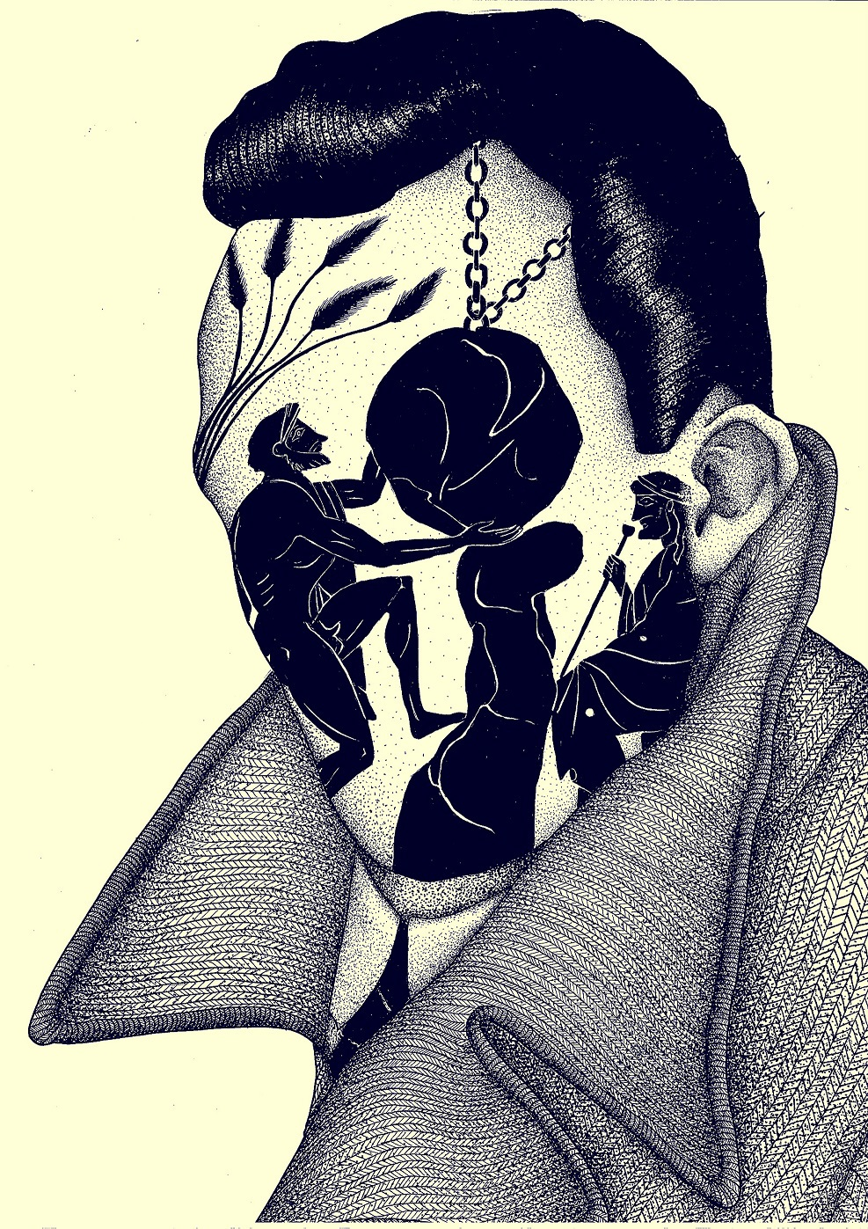

Assignment #1—Three Page Essay

This assignment is a three page paper that asks you to reflect on the coronavirus pandemic via sociological literature. Analyze themes and ideas relevant to this class so far as they are reflected in current events. Take a particular development—rising or falling cases, the racism of Trump’s nickname for the virus, cross-national comparisons, etc, and reflect on how readings for this class improved your understanding. For example, what might Durkheim say about social distancing? How might Mills explain the different national responses to the disease? How might inequality, poverty, welfare, and corporate domination, as we’ve discussed it, have a role to play in the disease. Why does Naomi Klein fear that disaster could mean delight for many at the top?

Think of this assignment as a glorified “response paper.” It should help you think through the material in a way that also illuminates the sociological nature of current events.

Assignment #2 – Make an Annotated Coronavirus Spotify Mixtape

You have been asked by a recording label to construct an annotated Spotify playlist of 10 songs revolving around the coronavirus pandemic.
Your assignment is to (1) create the playlist and follow it with (2) a 3 page analytic essay. The recording company insists that your essay must offer a compelling, precise, and clear evidence-based argument as to the relationship between song choice significance and class theme. In other words, the executives want to know what their customers can learn about the connections between sociology and coronavirus by studying the playlist you created and analytic essay. Your annotated tracks can form part of your evidentiary base, along with specific evidence from the texts, primary source readings, and lectures. You might include songs about contagion, isolation, fear, doubt, community, social change, etc.

Share the playlist link with me on top of your essay. You might want to organize your paper as if each song is self-contained.

Assignment #3—Podcast / Audio Diary / Dispatch from Distancing (with Music)

This assignment is a three minute audio diary or podcast that uses music to communicate a sociological view on coronavirus. Think of it kind of like the first prompt but in a different form. This assignment requires a working knowledge of some basic editing capability. Recording on your phone is fine. It should include one or more voices, and a little music or other kinds of sound, even if only as an intro and outro. Your piece should have a beginning, middle and end.

Here’s a good primer on how to do this: https://transom.org/2015/using-music-jonathan-menjivar-for-this-american-life/

Examples:
Modern Love: “The Tallest Man I Ever Loved” with Andrew Rannells 9/11/19 or
This American Life: 20 Acts in 60 Minutes Act 1 “Don’t I Know You” by Starlee Kine 7/11/03

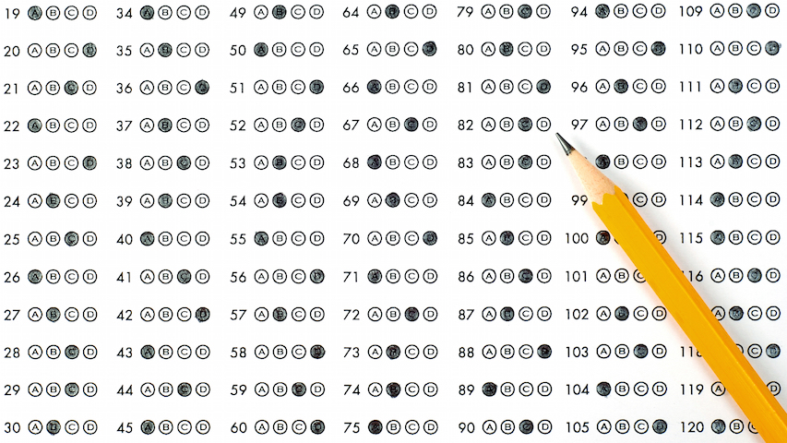

Write Your Own Exam (non-coronavirus themed assignment)

This assignment has three necessary parts.

Part 1:
Write a six-question exam for this class. Consider the following when you are developing questions. Exams should cover the major themes and questions we raised in class, should synthesize and make connections between readings, and should address the relevance of the theoretical ideas to the real world. Have an answer in mind when crafting your questions. Avoid redundancy, be clear, don’t make your questions too long and wordy.

I will evaluate the questions on the extent they ask us to critically and creatively engage the ideas of the class and how well they direct us to a possible answer. In other words, trick questions aren’t cool; clever ones are.

Part 2:
Write a seventh question you wish you could have answered after taking this course. In other words, what did we miss / leave out that should have been included? Keep in mind what we are interested in here—do not say that we neglected the debate on Pluto’s status as a planet. That is clearly outside the purview of the class. The difficulty here is to show you understand the contours of the class and can identify missing components that are just beyond the edge of our understanding.

Part 3:
Write a few paragraphs (one page maximum) as to why you feel your exam is a good one. Give insights into why you chose to focus on certain themes, and / or discuss how you think your exam captures the big ideas. Do not go through question by question, but rather offer a “rationale” to help explain your decisions and choices.
Here are some examples to guide you:

Weak question:
What are Marxʼs three forms of alienation?

First, Marx describes four forms of alienation. Secondly, it reveals nothing interesting about the topic. Instead, it merely shows that you know we read something about something called alienation. Moreover, this question asks only for a factual answer, requiring no interpretation. Good questions will require not just regurgitation but some sort of application of the course ideas.

Slightly better question:
What does Foucault mean by “speaker’s benefit”?

This is a marginal improvement over the first question but it’s boring. It’s also poorly worded. What’s most interesting about the concept isn’t what it “means” but what it “does.” The question forces the test-taker to focus on the least useful part of the concept.

Very good question:
According to Marx, the labor process produces our alienation from our species being, Yet, Freud says that civilization is only possible when our instincts are sublimated through work. Can we reconcile these seemingly contradictory viewpoints on the role of work in modern society? Please provide concrete examples to illustrate your answer. Make sure that you define the theoretical terms you use in your answer.

This question shows some basic understanding of the concepts, as well as how they relate to each other. Second, it specifies the area of interest—rather than some broad compare/contrast, it engages both a concrete point and a higher level of abstraction, asking for a synthetic treatment of the ideas. Last, it reveals the expected end point of the answer.

Super good question(s):
In A People’s History of the United States, Howard Zinn quotes the labor organizer Joseph Ettor: “They have nothing to do but fold their arms and the world will stop. The workers are more powerful with their hands in their pockets than all the property of the capitalists.” What does this quote imply about the nature of labor power? Why might he be wrong?

Excellent questions! These questions engage topical issues. They both make some reference to ideas weʼve discussed in class but offer a chance to interpret the examples broadly. Importantly, they provides an opportunity for a “second act” in the answer. One can both address a specific issue, in the first case a “labor question,” and comment on a “political question” about power.

