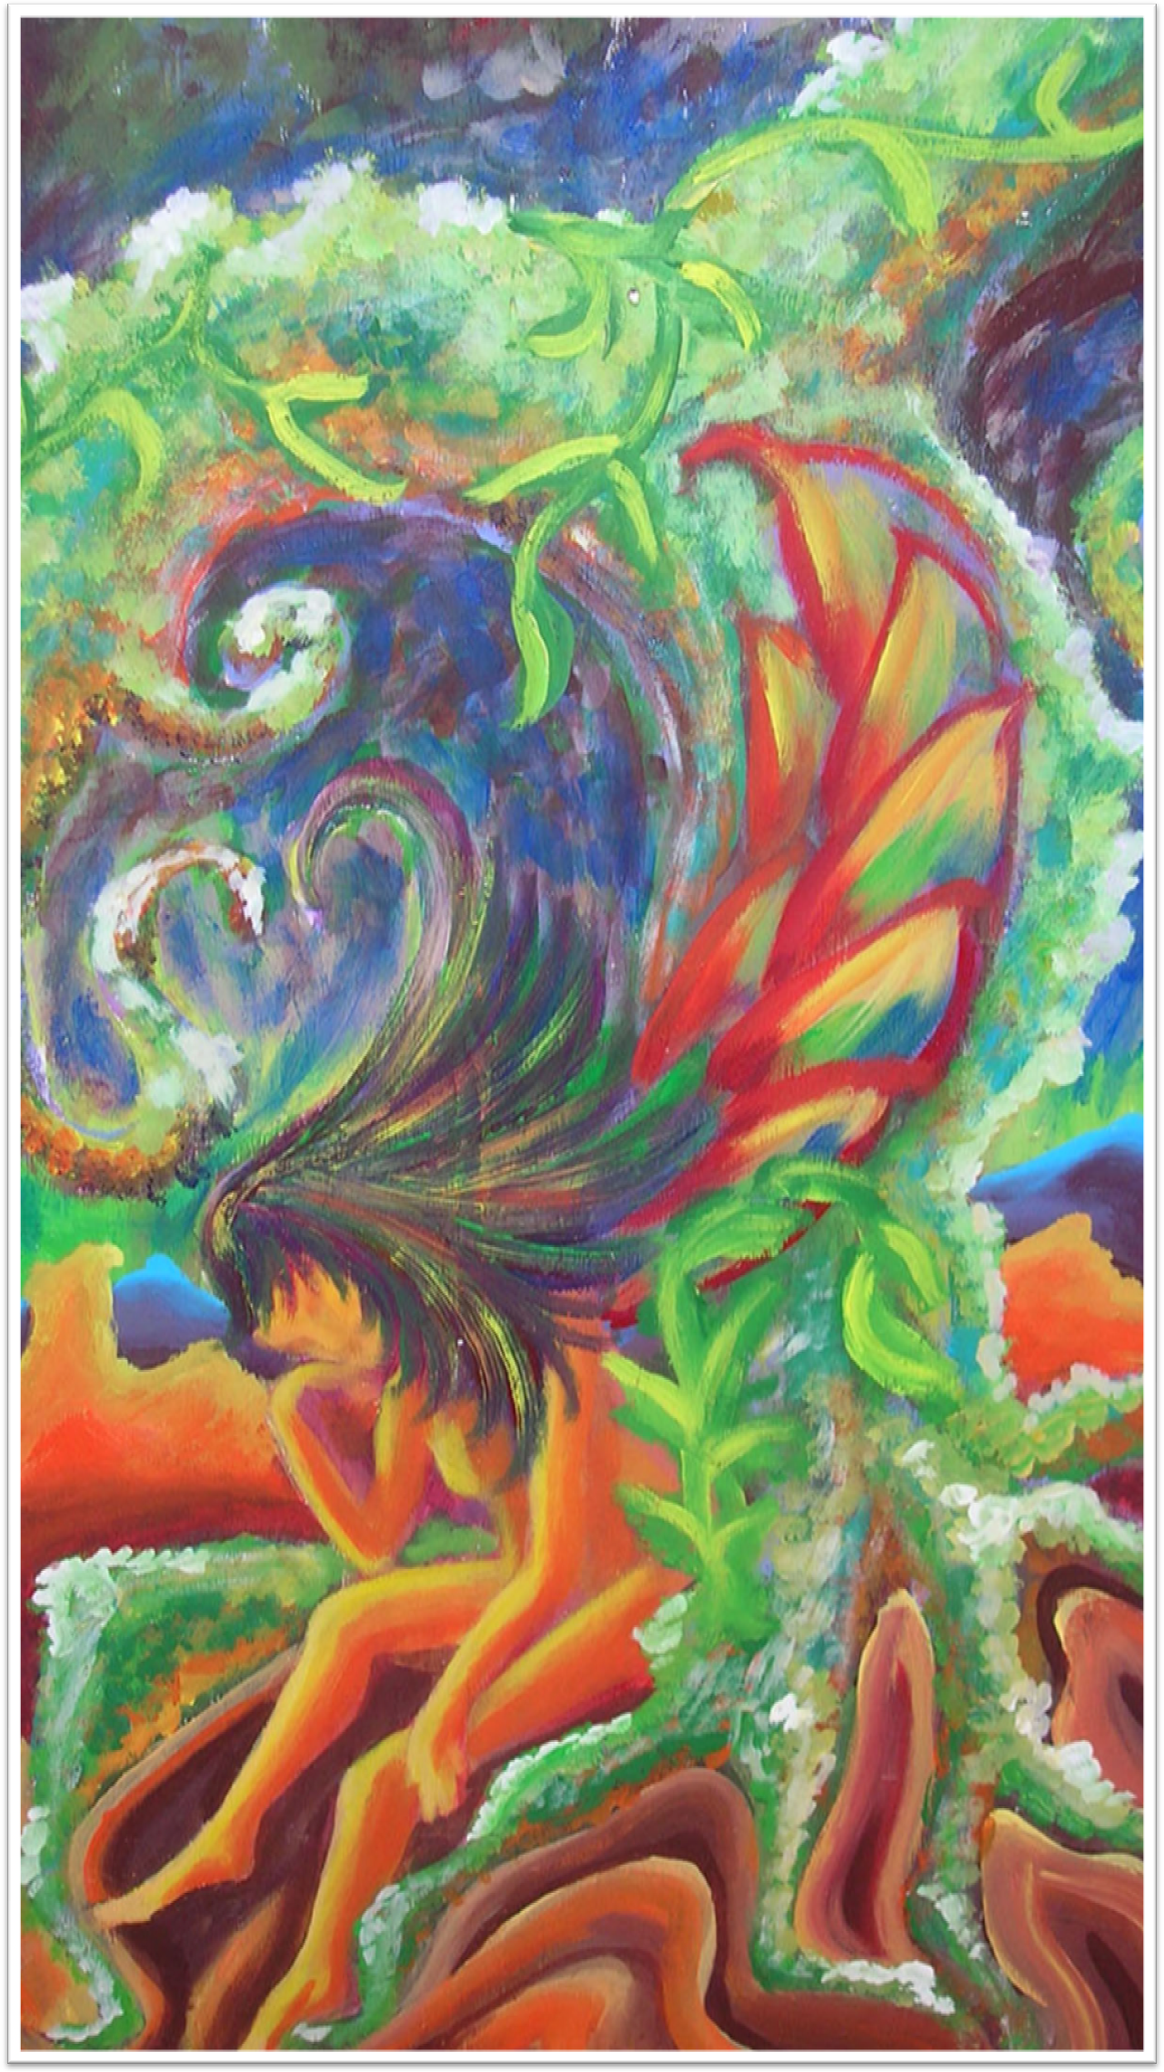
“EXH!BITED 2010”
LIS Staff Arts and Crafts
June 9 - 28, 2010
Middlebury College
Davis Family Library Atrium

Reception: June 9th at 4:00 pm

